Air! TCAD! TAWS-B! SiriusXM! ADS-B Out!
2006 Cessna 400 SL with G1000, GFC700
N7098C Ser#41631

1594 Total Time Since New
84 Since Continental Factory Remanufactured Engine (ZERO TIME)

Avionics:

Garmin G1000 Avionics (Fully Integrated EFIS System)
GMA-1347 Digital Audio Panel with Marker Beacon/ Intercom
Garmin GTX-335R Transponder with ADS-B Out
GDU-1040 Primary Flight Display (PFD)
GDU-1042 Multi-Function Display (MFD)
GIA-63 NAV/COM/GPS with Glideslope #1
GIA-63 NAV/COM/GPS with Glideslope #2
Ryan 9900BX Traffic Collision Alert Device (TCAD)
Terrain Awareness and Warning System (TAWS-B)
Garmin GFC700 Fully Integrated Two-Axis Autopilot
Garmin GCU 476 Keypad Controller
GEA-71 Engine/Airframe Computer
GRS-77 Attitude & Heading Reference System (AHRS)
GDC-74A Air Data Computer with OAT Probe (ADC)
GMU-44 Magnetometer
Electronic Checklist
Artex ELT-200 Emergency Locator Transmitter
Backup Airspeed, Altimeter and Attitude Indicator
Garmin SafeTaxi
Garmin SiriusXM Weather & Radio (GDL-69A)

Equipment:

Climate Control (Digitally Controlled Air-Conditioning and Heating)
Precise Flight Speedbrake System
Pilot and Co-Pilot Brakes (Heavy-Duty, Vented for Cooling)
Sport Seats-Fully Articulating and Height Adjustable
4-Place Intercom System
Factory Tinted Cabin Window
Dual Independent Electrical Systems
Tuned Induction System
Utility Category Airframe
Dual 60 AMP Redundant Alternators
Carbon-Fiber Dual Wing-Spar Construction
Rear Seat Audio Controls
Alternate Static Air Source
Complete Surface Certified Lightning Protection Carbon Monoxide Detector
Rosen Sunvisors
Three Blade Hot Prop
Built-In Oxygen

Exterior:
Matterhorn White with Flame Orange, Pewter, and Gold Fire Mist Stripes

Interior:
Leather: Gray Sidewalls, Center Console, Map Pockets and Armrests with Gray Leather Seat Surfaces

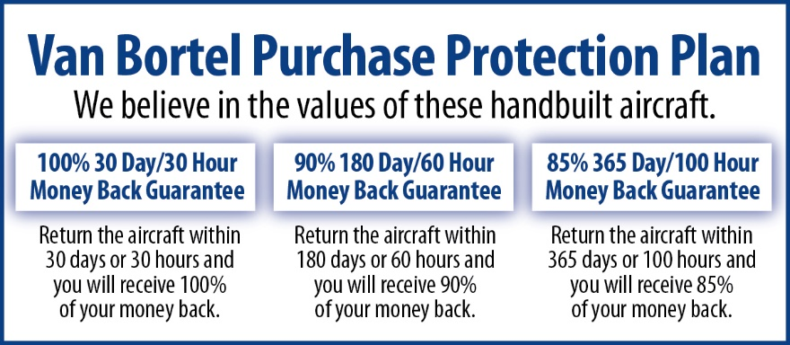

We fly the aircraft to your ramp for inspection by you and your mechanic at no cost or obligation to you.

All Specifications Subject To Verification Upon Inspection

Trades Welcome • No Damage History • Always Hangared • No Corrosion

