Air! FIKI! Active Traffic (TAS)! TAWS-B! SiriusXM! SVT! ESP! ADS-B Out!
2014 Cessna TTx T240 with G2000, GFC700, WAAS
N218RK Ser#T24002049

1023 Total Time Since New

Avionics:

GMA-36 Remote Digital Audio Panel with Marker Beacon/Intercom
GTX-33ES Transponder-Mode S with ADS-B Out
GDU-1400 Primary Flight Display (PFD)
GDU-1400 Multi-Function Display (MFD)
GIA-63W NAV/COM/GPS/WAAS with Glideslope #1
GIA-63W NAV/COM/GPS/WAAS with Glideslope #2
Synthetic Vision Technology (SVT)
Electronic Stability Protection (ESP)
Terrain Awareness and Warning System (TAWS-B)
GTS-800 Traffic Advisory System (TAS)
Garmin Terrain Awareness System (E-Prox+)
GTC-570 Touch Screen Controller
GCU-275 Primary Flight Display Controller
GEA-71 Engine/Airframe Computer
GRS-77 Attitude & Heading Reference System (AHRS) (Dual)
GDC-74A Air Data Computer with OAT Probe
GMU-44 Magnetometer (Dual)
GTP-59 OAT Probe
GMC-720 Auto Flight Controller System (AFCS)
GFC700 Autopilot System
- Go-Around Switch
- Electric Trim
- A/P Disconnect
- Control Wheel Steering Button
Artex ME406 Emergency Locator Transmitter
Emergency Locator Transmitter Remote Mounted Switch
Pitot System - Heated
Static System
Alternate Static Source
Dual 12-Volt, 2-Amp Auxiliary Power Outlet
ESI-1000 L-3 Trilogy (Backup Airspeed, Altimeter and Attitude (Electric) Indicator)
Garmin SafeTaxi & FliteCharts (Both Provide Geosynchronous Positioning)
Garmin SiriusXM Weather & Radio (GDL-69A)

Additional Equipment:
Automatic Climate Control with Air Conditioning
TKS De-Icing System (FIKI)
Oil Cooler Mod with New Vernatherm Winterization Kit
Oregon Aero Sport Seats
Reiff Turbo XP Engine Preheater
Tanis Cabin Heater
Precise Flight Speed Brake System
CO Detector/Pulse Oximeter
Rosen Sunvisors
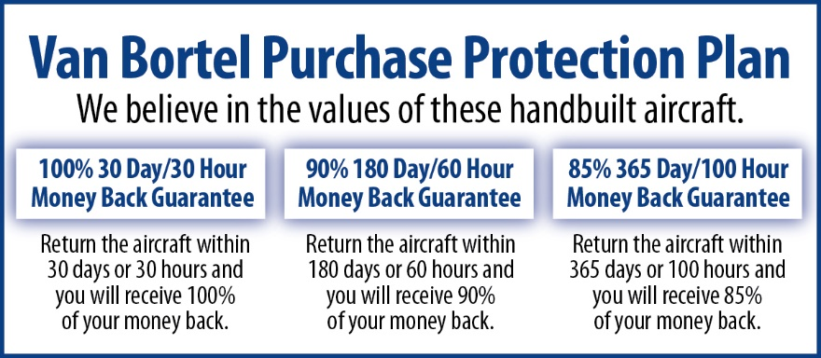
Hot Prop
Built-In Oxygen

Exterior:
Matterhorn White with Phantom Gray Pearl and Calypso Orange Stripes

Interior:
Leather: Black Leather Seat Surfaces with Alcantara Inserts; Black Leather Wrapped Side Stick Controls

We fly the aircraft to your ramp for inspection by you and your mechanic at no cost or obligation to you.

All Specifications Subject To Verification Upon Inspection

Trades Welcome • No Damage History • Always Hangared • No Corrosion

