1978 MERLIN IIIA
Serial Number T-286
Registration N505GM

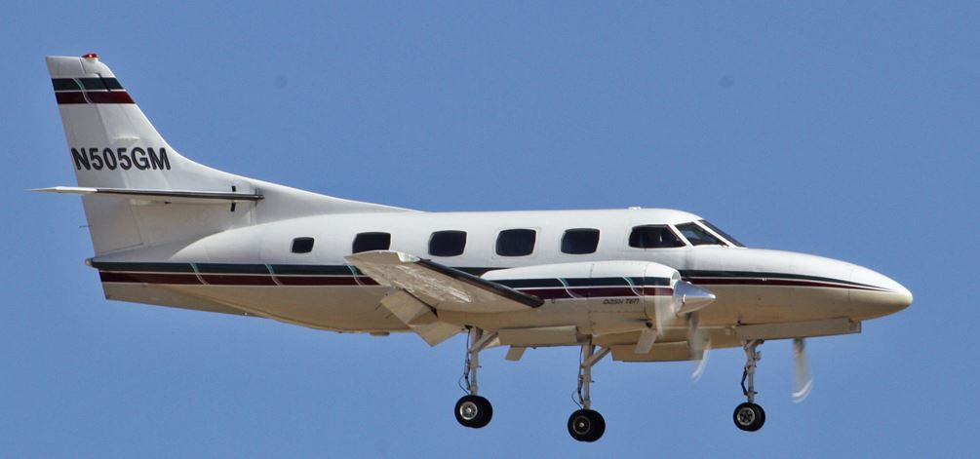

AIRFRAME:
7075 Total Hours 4352 Landings

ENGINES: TPE331-10UA-511G 5000 TBO
Left Engine Number P-54911RC Right Serial Number P-54282C
759 Hours Since Overhaul 759 Hours Since Overhaul

PROPELLERS:
Left: Serial Number BAU7708 Right: Number BAU6596
356 Hours Since Overhaul 356 Hours Since Overhaul

ADDITIONAL:
True -10 Engines (Not Converted), Variable Authority Hydraulic Nose Wheel Steering, Lead-Acid Batteries

MAINTENANCE: Enrolled and fully paid-up on Propulsion International's GMP which covers 100% of all future scheduled/unscheduled maintenance, including future ADs, Mandatory SBs, hot section inspections and overhauls. In 5/00 a Bird strike on left wing Repaired by Factory, the 1989-1993 Airframe Log Missing (All other logs present) A, B, C & D checks complied April 27 2023.
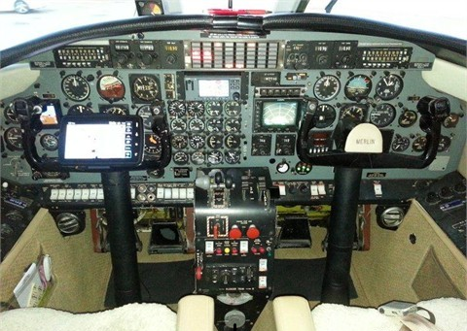

AVIONICS: ADS-B Out
Comms: Garmin GTN-650; Garmin GTN-750 PS Engineering Intercom (cockpit)
GPS: Garmin GTN-650; Garmin GTN-750 SATCOM
Navs: Garmin GTN-650; Garmin GTN-750 Transponder: Dual Garmin GTX-345
Emergency Locator Transmitter Primus 300SL Radar
Garmin GPS-400W WAAS GPS Navigator Landmark LG8000 TAWS-B
M-4D Autopilot w/ Flight Director & Yaw Damper

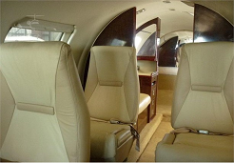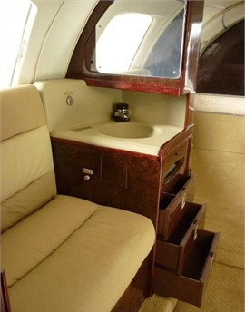

INTERIOR:
Executive Configuration in Light Tan Leathers, with four individual seats, a three place sofa, and hardwood cabinetry, Flushing Potty (belted) & Vanity Sink with Privacy Divider, Tinted Window Inserts

EXTERIOR:
White Upper with Beige Lower, Dark Metallic Green & Maroon Stripes White Upper with Beige Lower, Dark Metallic Green & Maroon Stripes

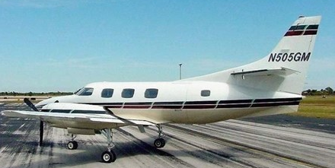
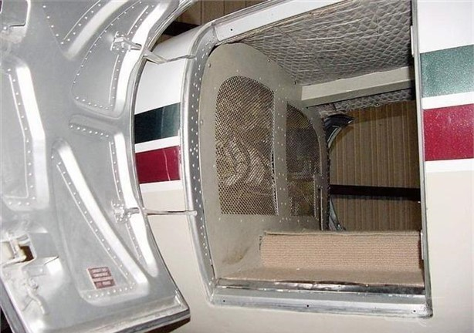
AVAILABLE IMMEDIATELY, Call Maria +1 941-586-6345
maria@flightsource.com

