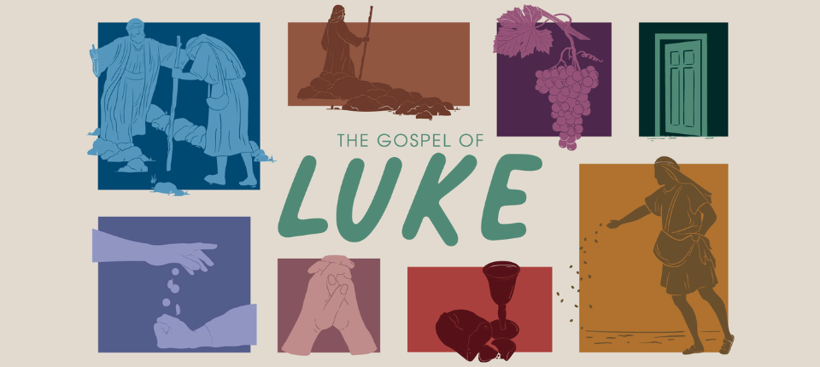
p

Luke 16

Sermon Reflection Questions

Observe & Interpret
Read: Luke 16. Summarize the passages in your own words.

1. It’s important to note that Jesus was not commending the steward’s dishonesty (v.8). What was He commending instead? Why do we think Jesus taught this parable?

2. How does Jesus’ teaching (v.10-13) challenge our culture’s views on responsibilities such as wealth, relationships, or other areas of life?

3. What does Jesus’ statement in verse 17 convey about the authority and permanence of God’s word?

4. What does verse 31 hint at?

Apply

If people who didn’t know you were able to look at your life, which master would they say you served, God or money?
In the story of the rich man and Lazarus, we see that both men’s fates were sealed after death. How often are you living your life with eternal consequences in mind? Does this remind you of the importance of sharing the Gospel with others before they pass away and it’s too late?
Prayerfully determine the main biblical truth or principle that God revealed to you during your study. A few questions to ask are: Am I trustworthy with very little? Have I been trying to serve two masters? Am I pursuing what is highly prized by men or God?

Memorize: Luke 16:17 “But it is easier for heaven and earth to pass away than for one tiny stroke of a letter in the law to become void.”

