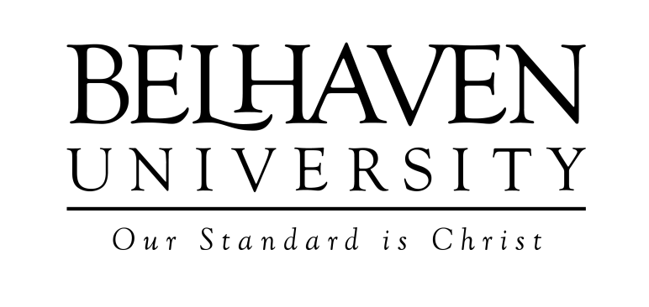

**FOR IMMEDIATE RELEASE**

Contact: David Sprayberry, Web Writer/Public Relations Associate

601-968-5930

**Atlanta Opens its Doors to New Belhaven University Adult Education Campus**

Atlanta, GA - Belhaven Atlanta is the newest addition to the Belhaven University branch campuses, and is one of only two Christian universities in the Atlanta area.

Audrey Kelleher, Vice President of Adult and Graduate Marketing and Development, said ”Our new campus gives students in Atlanta the opportunity to achieve their higher educational goals and dreams by experiencing Christian-based adult education at its best.”

For 25 plus years Belhaven’s Adult Studies program has served adult students, and Belhaven Atlanta now offers accelerated degree programs for a Bachelors of Science in Management, Bachelors of Arts in Social Services, Bachelors of Health Administration, and Masters in Business Administration.

“These degrees in business prepare students for new careers or higher level positions within their current organizations,” adds Kelleher.

The new campus is centrally located in the heart of Atlanta at 4151 Ashford Dunwoody Road, making commutes easier on students.

Amirah S. McGrone**,** Director of Admission and Student Services, said ”Belhaven Atlanta boasts of small classes where one-on-one interactions with experienced professors are the norm, and where students from all walks of life can come to seek out their purpose.”

Belhaven Atlanta is the only university in the area that includes the cost of books with tuition. Along with the brand new facilities, the classrooms are state-of-the-art and utilize current technologies for a better learning experience. The streamlined admissions process at Belhaven makes starting a degree easier by paying and requesting transcripts, and adjusting student's busy schedules. Since the adult education classes at Belhaven meet only once a week, it provides adult students with the flexibility to earn their degree while working.

Belhaven University was founded 1883 in Jackson, Mississippi and serves over 3,000 students in Jackson, Memphis, Orlando, Houston, Chattanooga, Online, and now in Atlanta.

For more information contact: Amirah S. McGrone**,** Director of Admission and Student Services [amcgrone@belhaven.edu](mailto:amcgrone@belhaven.edu), 404-425-5590

###