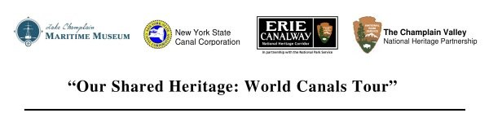

The New York State Canal Corporation, a subsidiary of the New York State Thruway Authority, is responsible for the maintenance, operation, preservation, and promotion of the 524-miles of interconnected waterways known as the New York State Canal System. The New York State Canal System is comprised of four historic waterways: the Erie, the Champlain, the Oswego and the Cayuga & Seneca Canals. Since 1992, following State legislation transferring the Canal System from the New York State Department of Transportation to the Thruway Authority, canal operating and maintenance activities have been supported by Thruway toll revenue. For more information about news and events along the New York State Canal System, please call 1-800-4CANAL4 or visit www.canals.www.ny.gov .

The Erie Canalway National Heritage Corridor, established in 2000 by an Act of Congress, spans 524 miles across the full expanse of upstate New York. It encompasses the Erie, Cayuga & Seneca, Oswego, and Champlain canals and their historic alignments, as well as more than 230 canal communities. The Corridor's commission and staff, in partnership with the National Park Service, work through public and private partnerships to promote historic preservation, recreation, education, tourism, and economic revitalization throughout the corridor. Visit www.eriecanalway.org .

Champlain Valley National Heritage Partnership, encompassing the Champlain Canal, Vermont and New York's Lake Champlain, and Quebec's Richelieu River, was created to help share the story of the region's interconnected waterways and link its communities through programs that highlight cultural and environmental history and stewardship. Visit www.champlainvalleynhp.org .

Lake Champlain Maritime Museum brings to life the stories of Lake Champlain and its people through nautical exploration, hands-on exhibits, and learning adventures for all ages. Its mission is to preserve and share the rich history of Lake Champlain, and through its nautical archaeology research and outreach programs, that of other regional waterways. For more information on the Lake Champlain Maritime Museum, please call (802) 475-2022 or visit www.lcmm.org .

####

