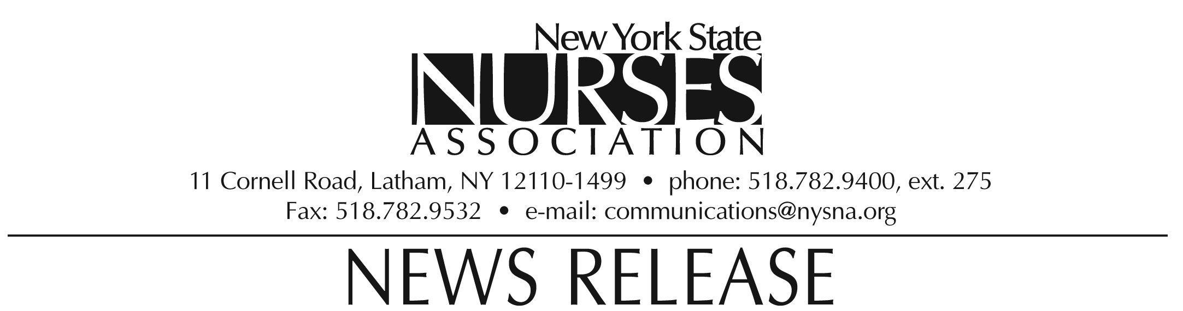

MEDIA ADVISORY:
Nurses Association to Hold Rally to
Protest Proposed Executive State Budget
WHAT: The NYS Nurses Association will hold a rally at the Capitol to protest $1 billion in cuts to healthcare in the proposed Executive State Budget.
DATE: Monday, March 8, 2010
TIME: 11:30 a.m.
WHERE: West Capitol Park, Albany, NY
CONTACT: Erin Silk, NYSNA Communications, 782-9400, ext. 224
Legislative speakers include: Assemblyman Richard Gottfried, Assemblywoman Susan John, Senator Diane Savino, and Senator Tom Duane.
Nurses Association speakers include: NYSNA President Karen Ballard; National Federation of Nurses President Barbara Crane; President, NYSNA Delegate Assembly Rod Rocca; President, Local 436 AFSCME Judith Arroyo; Sharon Dennish, RN & CEO, St. Catherine's Medical Center, Christopher Berner, Vice President of Labor & Employee Relations, Montefiore Medical Center; and Sondra Olendorf, RN, Maimonides Medical Center of Brooklyn.
Interviews & photo ops with attendees from your region can be arranged.
Please contact NYSNA's Communications Department at 518-782-9400, ext. 275, or e-mail erin.silk@nysna.org.
Hospitals, nursing homes and public health programs face a combined reduction of more than $562 million in payments for services and $250 million in increased assessment on services delivered. These cuts have the potential to severely limit access to care and endanger patient safety.
The current proposal also cuts funding by $143,100 to programs to expand SUNY nursing education; severely diminishing the state university system's ability to meet the needs of the nursing workforce over the next decade.
The Nurses Association appreciates the complexity of allocating public funding during such dire financial times. However, the state's fiscal crisis cannot be allowed to result in an unprecedented healthcare crisis in the name of a balanced budget.

The New York State Nurses Association is the voice for nursing in the Empire State. With more than 37,000 members, it is the state's largest union and professional association for registered nurses. It supports nurses and nursing practice through education, research, legislative advocacy, and collective bargaining.

