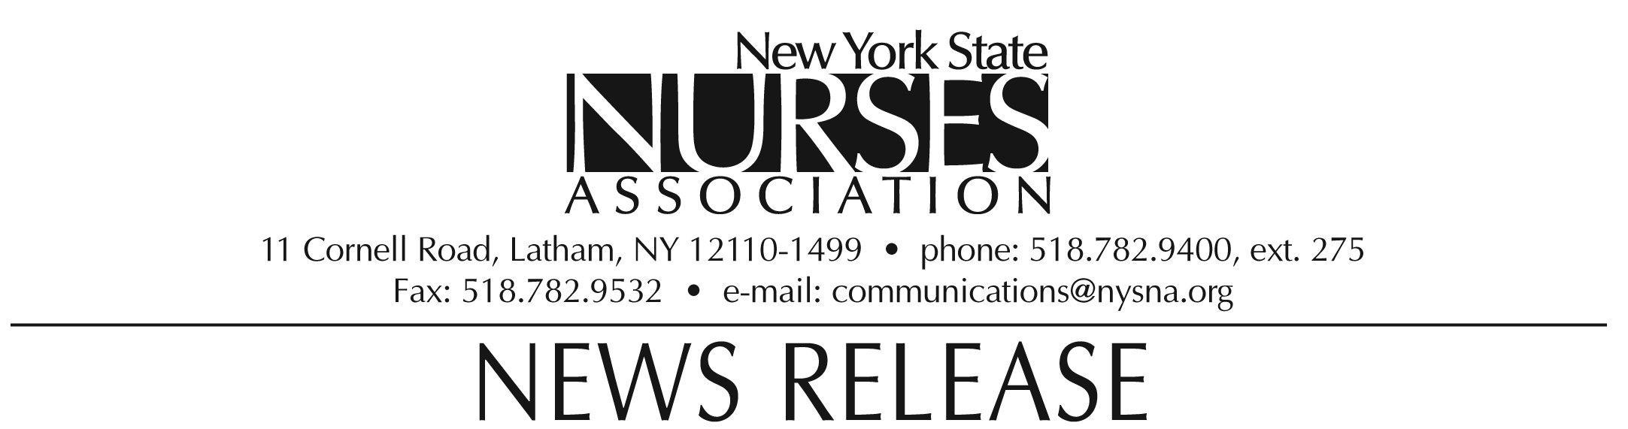

For immediate release: Oct. 19, 2009
Contact: Erin Silk, 518-782-9400, ext. 224.

Nurses association honors Julie Yeh
with Nursing Student Leadership award

Julie Yeh, nursing student at New York University College of Nursing, was awarded the Nursing Student Leadership award by the New York State Nurses Association at its biennial convention on Oct. 10.

The award is presented to the student whose leadership and professionalism have been demonstrated by membership in a student nursing organization and who actively support efforts to recruit others into the profession.

Yeh is currently the president of the NYU undergraduate nursing student organization where she is responsible for representing her fellow nursing students and advocating on their behalf. Yeh tutors and recruits high school students and organizes workshops for new nurses. Many students in her program consider her to be a resource for advice on how to approach their own clinical studies.

Yeh will graduate with a bachelor of science degree in nursing in May 2010 and lives in Valley Stream, NY.

Note: photograph available upon request.

The New York State Nurses Association is the voice for nursing in the Empire State. With more than 37,000 members, it is the state's largest union and professional association for registered nurses. It supports nurses and nursing practice through education, research, legislative advocacy, and collective bargaining.

