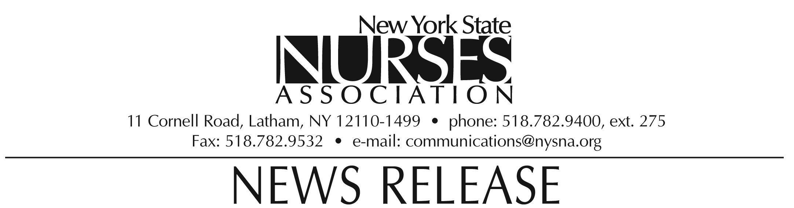

For immediate release: Oct. 19, 2009
Contact: Erin Silk, 518-782-9400, ext. 224.

Nurses association honors David Keepnews
with Media award

David Keepnews, associate professor at Hunter-Bellevue School of Nursing, was awarded the Media award by the New York State Nurses Association at its biennial convention on Oct. 10.

The award is presented to the association member whose contribution effectively conveys the contribution of nurses and nursing to the public health and welfare.

As editor-in-chief of the journal Policy, Politics & Nursing Practice, Keepnews has played a key role in articulating the influence of the nursing profession in health policy. His editorials provide an important forum for addressing policy and health systems issues that directly affect nursing practice and health care.
Keepnews lives in Forest Hills, NY.

Note: photograph available upon request.

The New York State Nurses Association is the voice for nursing in the Empire State. With more than 37,000 members, it is the state's largest union and professional association for registered nurses. It supports nurses and nursing practice through education, research, legislative advocacy, and collective bargaining.

