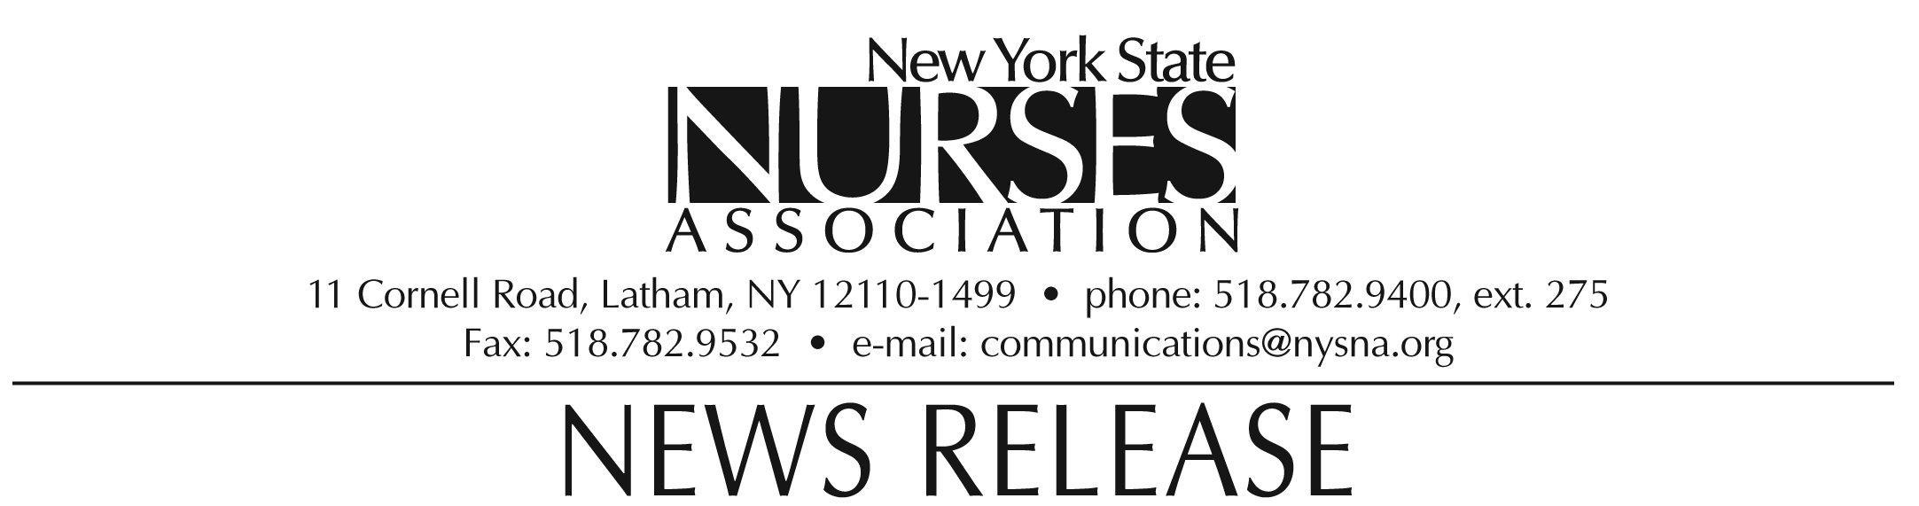

For immediate release: Oct. 19, 2009
Contact: Erin Silk, 518-782-9400, ext. 224.

Nurses association honors Connie Jastremski with Nursing Service Administration award

Connie Jastremski, chief nursing officer and vice president of patient services at Bassett Healthcare in Cooperstown, NY, was awarded the Nursing Service Administration award by the New York State Nurses Association at its biennial convention on Oct. 10.

The award is presented to the member whose contribution promotes access to professional nursing services through innovative delivery systems.

Jastremski is a committed supporter of higher education and has collaborated with educational institutions to secure career development opportunities for her staff. Through her service on local college boards of directors, she has successfully advocated for the expansion of educational programming for nurses in her area. Jastremski is a past president of New York Organization of Nurse Executives (NYONE) and District 4 of the New York State Nurses Association.
Jastremski lives in Richfield Springs, NY.

Note: photograph available upon request.

The New York State Nurses Association is the voice for nursing in the Empire State. With more than 37,000 members, it is the state's largest union and professional association for registered nurses. It supports nurses and nursing practice through education, research, legislative advocacy, and collective bargaining.

