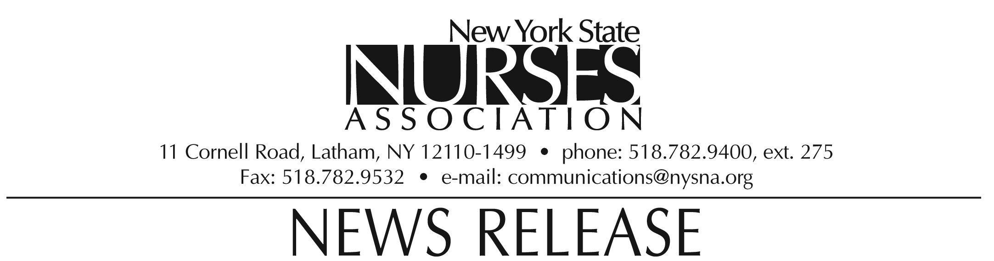

For immediate release: Oct. 19, 2009
Contact: Erin Silk, 518-782-9400, ext. 224.

Nurses association honors Barbara Krainovich-Miller with Membership award

Barbara Krainovich-Miller, assistant dean and coordinator of the Academic Initiatives Program, Nursing Education Master’s and Advanced Certificate Programs, New York University College of Nursing, was awarded the Membership award by the New York State Nurses Association at its biennial convention on Oct. 10.

The award is presented to the member who promotes the membership and active involvement of other nurses in the affairs of the association.

Krainovich-Miller encourages nursing students to join the association upon graduation and has set an example as a consistent contributor and active member of the association for 35 years. She serves as chair of the association’s Council on Nursing Research, member of the association’s continuing education review team, Membership Committee and as a Legislative District Coordinator.

Krainovich-Miller lives in Westbury, NY.

Note: photograph available upon request.

The New York State Nurses Association is the voice for nursing in the Empire State. With more than 37,000 members, it is the state's largest union and professional association for registered nurses. It supports nurses and nursing practice through education, research, legislative advocacy, and collective bargaining.

