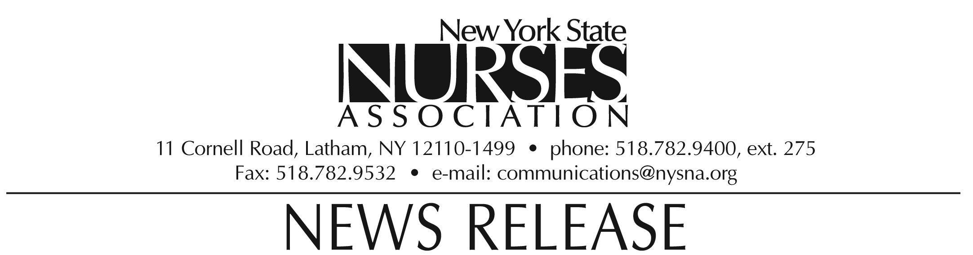

For immediate release: Oct. 19, 2009
Contact: Erin Silk, 518-782-9400, ext. 224.

Nurses association honors Linda Kosits with Nursing Practice award

Linda Kosits, clinical faculty member at Montefiore Medical Center in the Bronx, was awarded the Nursing Practice award by the New York State Nurses Association at its biennial convention on Oct. 10.

The award is presented to the association member whose contribution distinctly and uniquely illustrates the nature and scope of nursing practice and clearly reflects the standards of practice set forth by the profession.

As a clinical nurse leader, Kosits has spearheaded performance improvement initiatives that include application of e-learning, simulation, audience response, and technologies that facilitate the transfer of research-based clinical information to patient care. Her recent doctoral dissertation focused on the effects of interruptions on nursing practice, revealing information that can be used to improve the delivery of nursing care.
Linda Kosits lives in Somers, NY.

Note: photograph available upon request.

The New York State Nurses Association is the voice for nursing in the Empire State. With more than 37,000 members, it is the state's largest union and professional association for registered nurses. It supports nurses and nursing practice through education, research, legislative advocacy, and collective bargaining.

