 | NEWS RELEASE  DEPARTMENT OF MILITARY AFFAIRS  ILLINOIS ARMY AND AIR NATIONAL GUARD  1301 North MacArthur Boulevard  Springfield, Illinois 62702-2399  ng.il.ilarng.list.staff-pao@mail.mil |  | 
NEWS RELEASE # 080-08072018 |  | TEL: (217) 761-3569
DATE: August 7, 2018 |  | FAX: (217) 761-2988
CONTACT: Public Affairs Office

Illinois National Guard Soldier Helps Save Woman from Submerged Vehicle
Cpl. Nathan Jennings said ‘a weird calmness’ helped him react

Huntley, Ill. – An Illinois Army National Guard corporal helped save a woman’s life by diving into the murky water of a retention pond and pulling her from the overturned submerged vehicle, according to the Illinois State Police.
Nathan Pratt Jennings, 26, of Machesney Park was one of about 10 people who helped after the Aug. 3 single-vehicle accident off Interstate 90, the police said. Jennings was driving home from work on Interstate 90 at around 3 p.m. Friday (Aug. 3) when he spotted a “big splash” in a retention pond from the corner of his eye, he said. “I hunt geese, so I knew whatever made that splash had to be big.”
He stopped, put his car in reverse, and ran to the pond where he saw a car on its roof sinking into the water. There were a couple of other men there who had also stopped. “I asked them if they saw anyone come out. They indicated that they hadn’t, it was then that I realized that someone had to be in the car.”
So he ripped off his suit jacket and went into the murky dark water. “The water was up to my chest, and I’m six (feet), two (inches). You couldn’t see anything in the water, but I managed to get the passenger side door open.” Another guy got into the water and Jennings asked him to hold his feet while he entered the car. “I groped around looking for a seat belt thinking maybe they were strapped in. I couldn’t see anything. It was like swimming in a big bowl of gravy. There wasn’t anyone on the passenger side. Then my hands grazed something and I realized it was someone floating in the car.”
He managed to get his hands on the driver, 26-year-old Joanna Girmschied, by the ankle and, with some difficulty, pull the unconscious woman out of the car and then with help from others get her to the side of the pond. Other people had stopped and as soon as Jennings got Girmschied out of the pond, they started CPR on her. “I thought she was dead,” Jennings said. “It seemed like she was underwater for about five minutes.”
As some people were taking turns performing CPR, others went back into the water to ensure no one else was in the car. After a little while, Jennings said Girmschied started to moan and move. When paramedics arrived they took over the emergency care of the accident victim. “One of the EMTs, opened the door to the ambulance before they took off and yelled that she was conscious and knew who she was. I couldn’t believe it,” Jennings said.
Jennings credited his military training with his ability to react in a stressful situation. “This weird calmness took over. One of the other guys there even said, ‘Man, you were so calm.’ I think the military training does help you keep your head in emergencies.” Jennings is an intelligence expert in the military and is part of the Bloomington-based 176th Cyber Protection Team under the 65th Troop Command, Illinois Army National Guard. In his civilian life, he is a broker for U.S. Energy Company in Itasca, Ill.
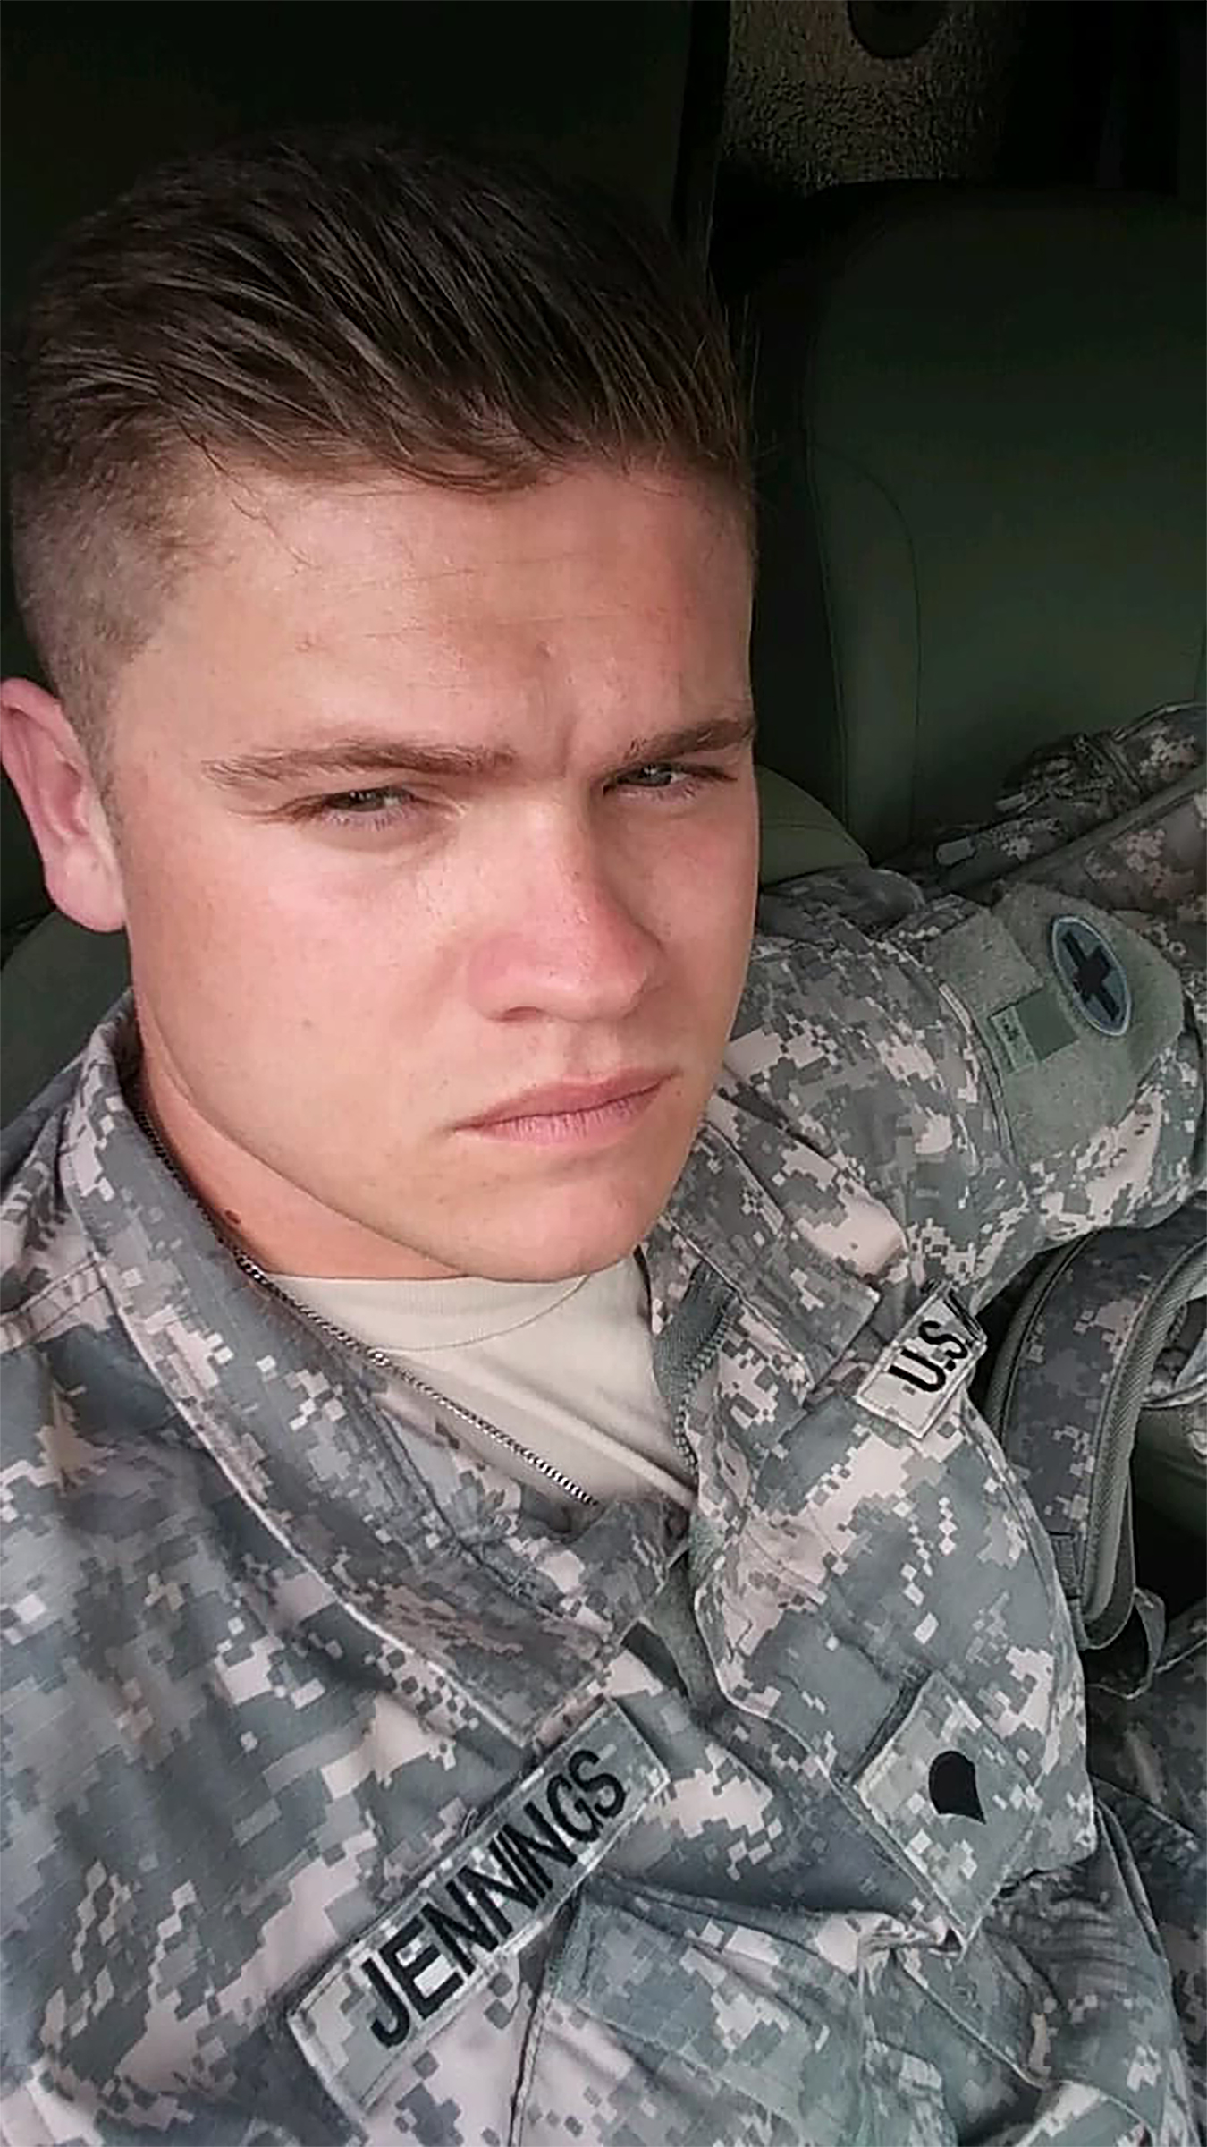
Cpl. Nathan Jennings of Machesney Park, pictured, pulled an unconscious woman out of a submerged overturned vehicle and carried the woman to the side of the pond where other rescuers performed CPR after a single car accident on Aug. 3 in Huntley, Ill..

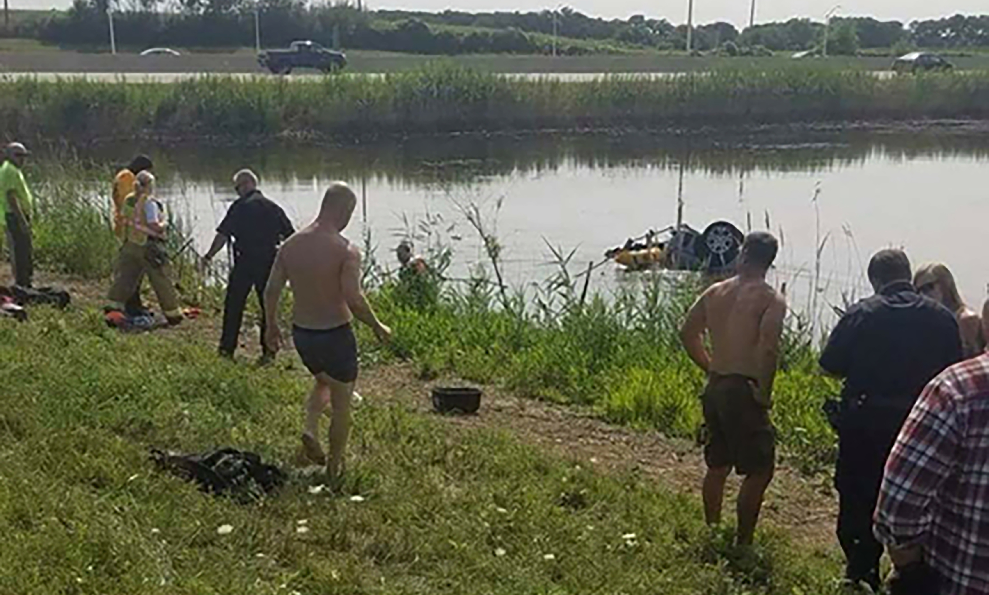
Cpl. Nathan Jennings of Machesney Park pulled an unconscious woman out of a submerged overturned vehicle (pictured) and carried the woman to the side of the pond where other rescuers performed CPR after a single car accident on Aug. 3 in Huntley, Ill..

Video footage can be found at the following link:
http://multimedia.illinois.gov/ioci_vid/Archive/2018/Uplinks/THA/082918-GoodSamaritan/I90WaterRescue.wmv
Become our Facebook Fan!
www.facebook.com/illinoisnationalguard
-30-

