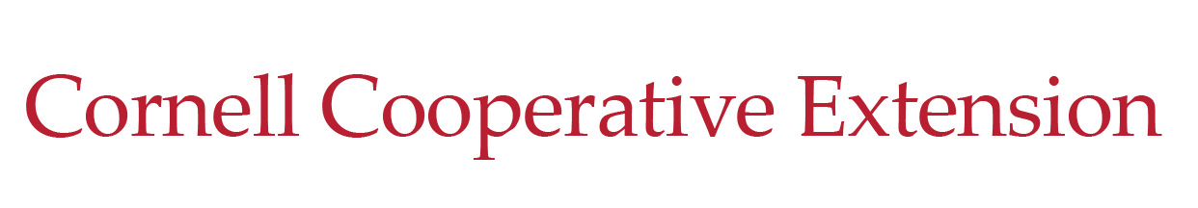  Rockland County | 10 Patriot Hills Lane  Stony Point, NY 10980  t. 845 429-7085  f. 845 429-8667  e. rockland@cornell.edu  www.RocklandCCE.org

Rockland County 4-H
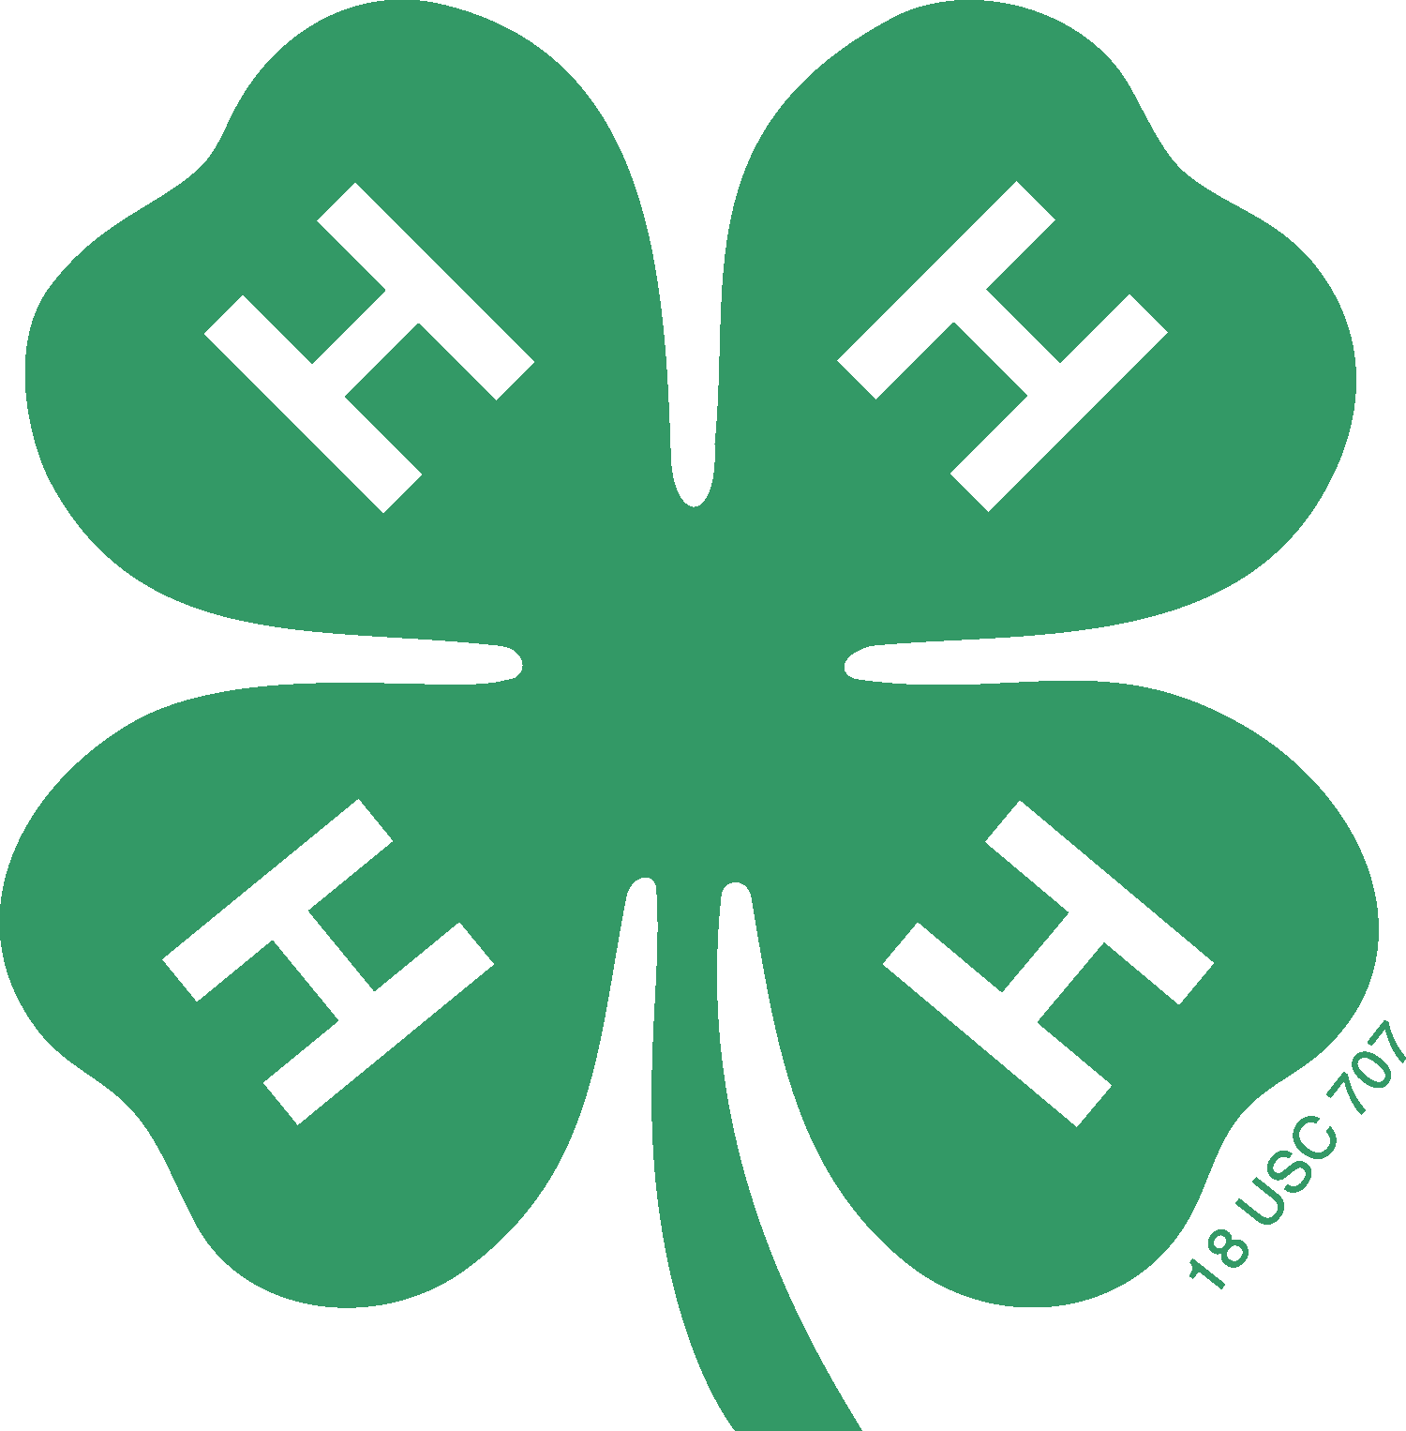

Awards and Recognition Guide

2026

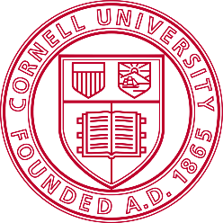
Building Strong and Vibrant New York Communities
Diversity and Inclusion are a part of Cornell University’s heritage. We are a recognized employer and
educator valuing AA/EEO, Protected Veterans, and Individuals with Disabilities.

Contents
The National 4-H Recognition Model 4
Beliefs about Recognition 4
The National 4-H Recognition Model 4
Glossary of Terms 5
Club Awards 6
Banner Club Award 6
Community Service Award 6
Marketing Award 6
Public Presentation Award 6
Club Award Application 7
______ Banner Club Award 7
______ Community Service Award 8
______ Marketing Award 8
______ Public Presentation Award 8
Individual Awards 9
General Criteria 9
4-H Year Pin 9
Junior Awards (for youth ages 8-12) 9
Junior Bronze Certificate 9
Junior Silver Certificate 10
Junior Gold Certificate 10
Senior Awards (for youth ages 13-19) 10
Senior Bronze Certificate 10
Senior Silver Certificate 10
Senior Gold Certificate 11
Individual Awards Application 12
General Criteria 12
Club Officer Awards 13
Honor President/Vice President 13
Honor Secretary 13
Honor Treasurer 13
Honor News Reporter 13
Honor Choose Health Officer 13
Honor Photographer 13
Honor Historian 13
Club Officer Recognition Award Application 14
Cloverbud Club Awards 15
Cloverbud Individual Awards 15
1st Year Cloverbuds 15
2nd Year Cloverbuds 15
3rd Year Cloverbuds 15
Cloverbud Application for Awards 16
Level 1 Candidates (3-6 activities) 16
Level 2 Candidates (7-12 activities) 16
Level 3 Candidates (13-18 activities) 16

About this Guide: The Rockland County 4-H Awards and Recognition Guide is designed to provide clear and consistent achievement guidelines, which will empower 4-H members to set and realize personal goals and reach their fullest potential. It also enables the Rockland County 4-H Program to provide accurate and appropriate recognition to all deserving members. This guide is based on the principles of the National 4-H Recognition Model and is modified from the Orange County 4-H Awards Information Booklet.

The National 4-H Recognition Model
Recognition is an acknowledgment and affirmation of the personal growth in an individual. It can be public or private. It can be within the individual or provided by others.
Recognition in 4-H is the encouragement and support for learning. It comes as a result of participation in educational experiences.
4-H uses recognition as one strategy to help youth become more capable and competent. It does this through recognizing and appreciating each person's effort and providing positive reinforcement to continue participating in learning activities. 4-H'ers experiences must be structured so as to incorporate opportunities to build positive esteem and self-reliance.
Our goal is self-directed learners.

Beliefs about Recognition
The Recognition Model is a dynamic model for planning, implementing, and developing 4-H programs. Several beliefs underlie the principles of the model:
- Recognition is a basic human need with security, new experiences and responses.
- Recognition should be a part of all 4-H learning experiences.
- Appropriate recognition takes many forms.
- Respect for individual differences is essential.
- Recognition must be structured to build positive self-esteem.
- Opportunities for self-assessment and reflection allow youth to learn.
- A range of opportunities and challenges provide choices to meet individual needs.
- Adult support is essential in youth learning and recognition.
- Everyone should be recognized at some level.
- A balance between all elements of the model is essential.

The National 4-H Recognition Model

The National 4-H Recognition Model includes five types of recognition. It is important for adults who work with 4-H'ers to provide appropriate recognition to all participants.
- Participation: This type of recognition program emphasizes the importance of acknowledging young people who have been involved in 4-H educational experiences as a first step in building a positive self-concept.
- Progress toward Self-Set Goals: Parents and other adults can help youth set realistic goals. Recognition for progress toward self-set goals, no matter how small, is an integral part of this type of recognition.
- Achievement of Standards of Excellence: Standards of excellence are established by experts in a given area. By measuring personal progress against standards of excellence, youth can gain insight into their own efforts and abilities.
- Peer Competition: This type of recognition subjectively identifies, in a concrete time and place, the best team or individual. It is a strong motivator for some youth but is inappropriate for youth under age eight.
- Cooperation: Learning and working together promotes high achievement. Cooperation may take advantage of all the skills represented in the group, as well as the process by which the group approaches the learning task/goal. Everyone is rewarded.

Glossary of Terms
4-H Project: A project is planned series of learning experiences or activities that culminates in an end product. The project will help youth develop skills, knowledge, and character and reflect the ‘learn by doing’ philosophy. The best practice recommendation from USDA is six hours of programming to count as a project.
Project Record: Record-keeping worksheet that promotes reflection and knowledge application. A project-specific project record (i.e. rabbit project record) should be used when available; otherwise, a 4-H General Project Record may be used.
4-H Achievement/Record Book: A collection of items assembled to demonstrate involvement in projects and activities during current 4-H year. It should have an attractive cover and title page, a table of contents and/or the use of section dividers, and content that reflects involvement in 4-H experiences such as leadership experiences, marketing/public relations, exhibits, projects, community service, presentations, and other activities completed in the current 4-H year. All items such as ribbons, certificates and pictures displayed in the book should be labeled to reflect what experiences they relate to. For review at the end of the year, the book must contain a story that summarizes the accomplishments and skills learned throughout the current year in 4-H. The inclusion of activities that are not 4-H related is acceptable but should be kept to a minimum, keeping the focus on 4-H work.
4-H Educational Events/Programs: Workshops and project offerings that provide an added and unique educational experience. Examples include:
- Cornell Cooperative Extension Workshops
- Conferences
- Animal Bowl Contests
- Public Presentation Workshop
- Animal Judging Contests
- New York State Fair
- Regional 4-H Events
- Community Events/Workshops related to your 4-H Project (i.e. Babysitting Course, Pet CPR, First-Aid, Hunting and Fishing Day)
4-H Community Service: Providing assistance that benefits someone outside of the member’s family. (Note: Parades are not considered community service; they are considered 4-H Marketing.)
4-H Marketing: Providing public awareness and information about the 4-H Program. Examples include parades, Tractor Supply Paper Clover Fundraiser, club booths, window displays, newsletter articles, etc.
4-H Leadership and Service Activities: Providing direction and guidance for 4-H programs or other members. Some examples include:
- Teen Evaluator or Teen Assistant at an Educational or Evaluation Event
- Club Officer
- Leading a project within your 4-H club or another 4-H club
- Assisting a project leader within your 4-H club
- Serving on the Rockland County 4-H Advisory Committee
- Develop a program or resource that will continue to be used in the future.
- Plan, promote, and evaluate a countywide Community Service project for all 4-H clubs.
- Act as an instructor/educator at 4-H or other community event

Club Awards
The same event or activity can NOT be used in multiple categories, even if they meet the criteria of many.

Banner Club Award
Any club that completes all of Part 1 and four (4) of the five (5) activities in Part 2:
Part 1: Meetings: 6 Club meetings were dedicated to learning a new skill or project
Part2: Four (4) of the five (5) must be completed:
- Educational Field Trip: One member more than 50% of entire enrolled club roster attended at least one (1) Field Trip.
- Community Service Activity: One member more than 50% of entire enrolled club roster took part in an activity to benefit their community. Please note that there is no credit for donations unless your club is hosting a donation drive in the community, such as collecting donations for an animal shelter.
- Marketing 4-H: One member more than 50% of entire enrolled club roster took part in an activity to provide public awareness and information about the 4-H program. (i.e. Parades, Information Booth, Newspaper Article, etc.)
- Countywide 4-H Event Participation: One member more than 50% of entire enrolled club roster attended/participated in at least one (1) countywide 4-H event (i.e. Awards and Recognition Event, 4-H Public Presentations, 4-H workshop, etc.)
- The Rockland County 4-H Project Showcase: One member more than 50% of entire enrolled club roster MUST have EXHIBITED during the Rockland County 4-H Project Showcase (Static Judging and/or Animal Shows).

Community Service Award
One member more than 50% of the entire enrolled club roster donated a service or participated in an activity for the benefit of the public. A minimum of 35 member hours (i.e., 5 members work on a project 2 hours each, total number of member hours equal 10) are required. Please note that there is no credit for donations unless your club is hosting a donation drive in the community, such as collecting donations for an animal shelter.
To reach 35 Member Hours:
5 members at 2 hrs/ea. = 10 hrs at Pet Clinic
5 members at 3 hrs/ea. = 15 hrs at Senior Home Singing
5 members at 2 hrs/ea. = 10 hrs at Park Clean-Up Day

Marketing Award
One member more than 50% of entire enrolled club roster took part in 3 activities to provide public awareness and information about the 4-H program (i.e., Tractor Supply Paper Clover, parades, information booth at community events, bulletin board display, etc.). Please contact the 4-H Educator for approval before conducting activities.

Public Presentation Award
One member more than 50% of entire enrolled club roster participated in County Level Public Presentations (scheduled make-ups count).

Club Award Application
Due October 1
Club Name: _________________________________________________
Leader Name: _______________________________________________
Phone: __________________________ Email: ___________________________
Check off and complete all required information for each Club award.

______ Banner Club Award
Part 1: List the 6 skills/projects:
  - ________________________________________________________________________________________
  - ________________________________________________________________________________________
  - ________________________________________________________________________________________
  - ________________________________________________________________________________________
  - ________________________________________________________________________________________
  - ________________________________________________________________________________________
Part 2: Must complete four (4) of the five (5) activities
- Educational Field Trip (Location(s) and how many participated):

- Community Service Activity (Project/Event/Activity and how many participated):

- Marketing 4-H (Activity/Event and how many participated):

- Countywide 4-H Event Participation (Event and how many participated):

- Rockland County 4-H Project Showcase (How many participated and number of exhibits):

______ Community Service Award
The Community Service events your club participated in and the total number of member hours:

______ Marketing Award
Please list the THREE events your club participated in:

______ Public Presentation Award

Individual Awards
The Individual Award is an opportunity for a 4-H member to highlight their achievements over the program year. It is the sole responsibility of the youth to collect and present the appropriate paperwork in order to substantiate their hard work. Depending on the program or event, community service or marketing, an Educator, Leader, Committee Member, or sign-in sheet/paperwork will be used for verification. For example, the County Level Public Presentations will be substantiated by the sign-in sheet.
Learning in 4-H is an active, intentional, and reflective process where young people develop understanding, skills, and new habits. The nature of the experiences can be vastly different in 4-H, but the underlying process and educational philosophy should reflect the same core principles. 4-H learning experiences are carried out in a variety of delivery modes, teaching methods, project and topic areas, and local adaptations. This individual awards criteria was designed to reflect the diversity we have in 4-H and to highlight the successes of our members who are engaged in 4-H club settings or who are experiencing 4-H through programs and activities.
Any questions regarding the Individual Award criteria or paperwork, please call the 4-H office.
Award paperwork will be due in the 4-H office by October 1st.

General Criteria
4-H Members are eligible for one Individual Award in addition to the 4-H Year Pin. Please read each description carefully and apply for the HIGHEST level award for which you qualify. The same event or activity can NOT be used in multiple categories, even if they meet the criteria of many. You must be able to substantiate by completing the award levels paperwork and including all supplemental materials. Presentations and event participation/experiences will be verified with the Educator responsible for each event/experience. Please note that these awards are only for youth ages 8-19.

4-H Year Pin
- 4-H Story
The 4-H Story summarizes the accomplishments and skills learned throughout the current year in 4-H. It can be a written summary, photos/illustrations with captions, digital presentation, or other creative format.
- County, District, or State 4-H Program/Event

Junior Awards (for youth ages 8-12)

Junior Bronze Certificate
Will receive a 4-H Year Pin and Certificate when they complete/participate in:
- 4-H Story
- County, District, or State 4-H Program/Event
- 4-H Junior Activity Report
And three of the following:
- County Level 4-H Public Presentation
- 1 Project entered in the Rockland County 4-H Project Showcase
- 2 hours of Community Service
- 1 Educational Event/Program (separate from the identified County, District, or State 4-H Program/Event)
- 1 Marketing Activity
Reminder: The same event or activity can only be counted once. Ex: A County Level Public Presentation cannot be considered a County, District, or State 4-H Program/Event if it is fulfilling the presentation requirement.

Junior Silver Certificate
Will receive a 4-H Year Pin and Certificate when they complete/participate in:
- 4-H Story
- County, District, or State 4-H Program/Event
- 4-H Junior Activity Report
And four of the following:
- County Level 4-H Public Presentation
- 2 Projects entered in the Rockland County 4-H Project Showcase
- 5 hours of Community Service
- 2 Educational Events/Programs (separate from the identified County, District, or State 4-H Program/Event)
- 2 Marketing Activities
- 1 Leadership Activity

Junior Gold Certificate
Will receive a 4-H Year Pin and Certificate when they complete/participate in:
- 4-H Story
- County, District, or State 4-H Program/Event
- 4-H Junior Activity Report
- County Level 4-H Public Presentation
And all of the following:
- 3 Projects entered in the Rockland County 4-H Project Showcase
- 8 hours of Community Service
- 4 Educational Events/Programs (separate from the identified County, District, or State 4-H Program/Event)
- 3 Marketing Activities
- 2 Leadership Activities

Senior Awards (for youth ages 13-19)

Senior Bronze Certificate
Will receive a 4-H Year Pin and Certificate when they complete/participate in:
- 4-H Story
- County, District, or State 4-H Program/Event
- 4-H Senior Activity Report
And three of the following:
- County Level 4-H Public Presentation
- 1 Project entered in the Rockland County 4-H Project Showcase
- 5 hours of Community Service
- 1 Educational Event/Program (separate from the identified County, District, or State 4-H Program/Event)
- 1 Marketing Activity
Reminder: The same event or activity can only be counted once. Ex: A County Level Public Presentation cannot be considered a County, District, or State 4-H Program/Event if it is fulfilling the presentation requirement.

Senior Silver Certificate
Will receive a 4-H Year Pin and Certificate when they complete/participate in:
- 4-H Story
- County, District, or State 4-H Program/Event
- 4-H Senior Activity Report
And five of the following:
- County Level 4-H Public Presentation
- 2 Projects entered in the Rockland County 4-H Project Showcase
- 10 hours of Community Service
- 2 Educational Events/Programs (separate from the identified County, District, or State 4-H Program/Event)
- 2 Marketing Activities
- 1 Leadership Activity

Senior Gold Certificate
Will receive a 4-H Year Pin and Certificate when they complete/participate in:
- 4-H Story
- County, District, or State 4-H Program/Event
- 4-H Senior Activity Report
- County Level Public Presentation
And all of the following:
- 3 Projects entered in the Rockland County 4-H Project Showcase
- 15 hours of Community Service
- 3 Educational Events/Programs (separate from the identified County, District, or State 4-H Program/Event)
- 3 Marketing Activities
- 2 Leadership Activities

Individual Awards Application
Must be received by October 1st

Name: ___________________________________________________________________________________________
Club(s) or Program(s): _______________________________________________________________________________
DOB: __________________________________
4-H Age (age as of January 1): __________________________

General Criteria
- Were you an enrolled 4-H member Age 8-19 during the award year? Yes No
- Did you participate in a County, District, or State 4-H Program/Event? Yes No
- Did you create a 4-H Story? Yes No
- I am aware that CLOVERBUD years DO NOT count toward individual award years. ___________ (initial)
- What Award(s) are you applying for? ________________________________________________________________
- In the space below, please list the award(s) criteria and the events, activities, hours, and/or projects you completed to fulfill them:

Club Officer Awards

Honor President/Vice President
(Will be recognized together since their duties are connected)
The President/Vice President must submit 6 completed agendas signed by the officer/officers (President or President/Vice-President or Vice-President) who participated in the meeting and the 4-H Leader who supervised the 4-H meeting. These signed agendas must be to the 4-H office by the end of the year deadline (October 1st).

Honor Secretary
The Secretary is to send in monthly reports to the 4-H Office by the 10th of the month following that month reported (i.e. November report due by December 10th). Reports should be submitted for all months even if there is no meeting. The 4-H Office must receive 6 monthly reports on time (by or before the 10th of the following month) and submit an up-to-date Secretary’s Book with complete minutes and attendance record for the year.

Honor Treasurer
The Treasurer must submit a 4-H Club Financial Statement signed by the Treasurer and 4-H Leader assisting the Treasurer. These must be submitted to the 4-H office by the end of the year deadline (October 1st).

Honor News Reporter
Any 4-H Club News Reporter who has had at least 6 articles about their 4-H club activities printed in the CCE Newsletter, newspaper, or broadcast over TV and/or radio will be eligible for this award. Each news reporter will need to submit copies of print newspaper articles and copies of TV/Radio spots they submitted along with the dates they were to the 4-H office by the end of the year deadline (October 1st). We understand that articles submitted to newspapers are not always run - please submit the article submitted along with the date sent and name of newspaper.

Honor Choose Health Officer
The Choose Health Officer is to lead the club in a "Get Up and Move" activity as well as encourage healthy snacks at meetings. Each Choose Health Officer must submit the Choose Health Report (last page of the Choose Health Officers book) to the 4-H office by the year-end deadline (October 1st).

Honor Photographer
The Photographer must submit 6 photographs taken at different club meetings/activities. Please include date, location, participant names, and a description of the activity with each photograph.
Please respect member preferences regarding the taking and publishing of photographs. Members in photos need to sign a photo release, which is included in the health form.

Honor Historian
The Historian must submit a scrapbook that tells the club’s story for the year. It should follow the guidelines as described in the NYS 4-H Youth Building Premium List.

Club Officer Recognition Award Application

Applicant’s Name: _______________________________________________________
Leader’s Name: _________________________________________________________
Club Name: ____________________________________________________________
Youth Signature: ______________________________________________ Date: ______________________
Leader Signature: _____________________________________________ Date: ______________________
Check the Officer Position that you are applying for and submit all supporting documents by October 1st.
______ Honor President
______ Honor Vice President
______ Honor Secretary
______ Honor Treasurer
______ Honor News Reporter
______ Honor Choose Health Officer
______ Honor Photographer
______ Honor Historian

Cloverbud Club Awards
For members age 5 - 7
- As a team, the members must do two of the following three:
  - Create and do a performance presentation (song/rhyme/rap/dance/skit etc.) about the value of something learned during a learning activity (minimum 5 verses - documented on video - option to perform the piece at the 4-H Office)
  - Create a visual presentation (collage, quilt, poster, banner, etc. with art work and/or photos) about the value of something learned during a learning activity for exhibiting. (Size limit 4'x4')
  - Create a written journal with reflective writings from all members on a minimum of 3 learning activities for exhibiting
- Participate in an educational field trip. (Documented by photos at the location.)

Cloverbud Individual Awards
For members age 5 - 7

1st Year Cloverbuds
Level 1: Participate in 3-6 Cloverbud learning activities.
Level 2: Participate in 7-12 Cloverbud learning activities.
Level 3: Participate in 13-18 Cloverbud learning activities.

2nd Year Cloverbuds
Level 1: Participate in 3-6 Cloverbud learning activities.
Level 2: Participate in 7-12 Cloverbud learning activities.
Level 3: Participate in 13-18 Cloverbud learning activities.

3rd Year Cloverbuds
Level 1: Participate in 3-6 Cloverbud learning activities.
Level 2: Participate in 7-12 Cloverbud learning activities.
Level 3: Participate in 13-18 Cloverbud learning activities.

Cloverbud Application for Awards
Return this form by October 1st

Club Name: ___________________________________________________________
Coordinating Leader_____________________________________________________
Phone: _______________________________
Email: ________________________________
Mailing Address: ________________________________________________________
Please list all Cloverbuds who qualify for each award. Individual Cloverbuds will receive either a Level 1, Level 2, or Level 3 award based upon the minimum criteria. Awards are for meeting the requirements during the October 1 to September 30 program year. Please print and be certain to enter the correct spelling of the member's name. You are on the honor system as you apply for awards.

Level 1 Candidates (3-6 activities)
Please write each youth’s name and year(s) in Cloverbuds

Level 2 Candidates (7-12 activities)
Please write each youth’s name and year(s) in Cloverbuds

Level 3 Candidates (13-18 activities)
Please write each youth’s name and year(s) in Cloverbuds

