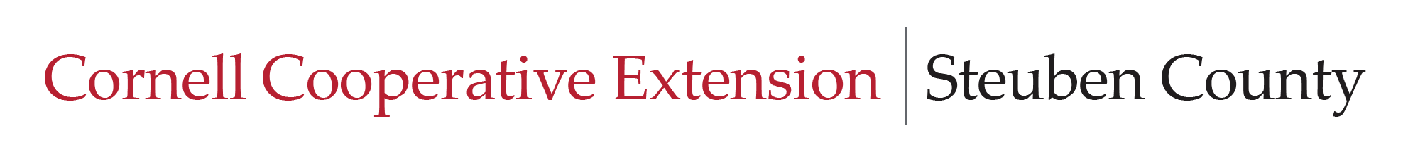

Board of Directors Meeting
August 27, 2026
4:30-6:00 pm

Agenda

- Call to order – 4:30 p.m.

- Period for Public Comment – Not to exceed 10 minutes

- Approval of Minutes - Board of Directors – July Meeting – 4:40 – 4:45 p.m.

- Reports – 4:45 – 5:15
- State Extension Specialist
- Financial Report
- Agriculture and Natural Resources (April 13)
- Community Health and Wellness (August 4)
- Youth Development (May 22)
- Executive Director
- Strategic Planning (Next meeting is October)
- CCE Chemung

- Old Business -5:15 – 5:20

- New Business 5:20 – 5:45

- Annual Dinner and Achievement Night
- Nominating Committee – Recommendations for Bill, Lisa and Walter replacements. Also need two replacements for Ag and NR and 2 for Youth Development.

- Other business, comments, concerns, questions 5:45 – 6:00

- Next BOD meeting date – September 24, 2026 4:30

- Adjourn

