2026 Allegany County Fair Youth Sheep Show Results
Lynn Bliven, Agriculture & Natural Resources Issue Leader
Monday, July 20th youth exhibitors showed off their sheep projects at the Allegany County Fair. The contest is an opportunity to be rewarded for the months of hard work caring for and training their animals.
In the Senior Showmanship division, Sarah Wilson Dansville, NY received a blue ribbon along with a photo frame sponsored by Bob & Donna Wilson, Canaseraga, NY. Second blue to Jeffery Wilson Dansville, NY followed by Collin Wilson Dansville, NY.
For Junior Showmanship Faith Wilson topped the class followed by Brendon Wilson both from Dansville, NY; Garrett Ploetz and Beverly Ploetz from Cuba, NY; all receiving blue ribbons. Faith received a photo frame sponsored by Bob & Donna Wilson, Canaseraga, NY. Brendon received a manure fork sponsored by the Peirce family.
Novice Lillian Gessel Arkport, NY received a blue ribbon along with a photo frame sponsored by Bob & Donna Wilson. Also receiving blues Ruby Zang and Bodhi Zang from Belmont, NY.
The top from each division competed for Grand Champion Showman. This year’s grand winner Sarah Wilson and Reserve Grand Champion Showman, Faith Wilson. Both received a photo frame sponsored by Bob & Donna Wilson, Canaseraga.
In the market lamb divisions, with all exhibits receiving blue ribbons, first place was awarded to Sarah Wilson, followed by Faith Wilson, Brendon Wilson, Collin Wilson, and Ruby Zang. Grand Champion Market Lamb sponsored by the Alco Federal Credit Union exhibited by Sarah Wilson. The Reserve Grand Champion Market Lamb sponsored by Bugman & Sons Inc. was awarded to Faith Wilson. Best Bred & Owned by exhibitor cash award in the market lamb class presented to Sarah Wilson.
In the breeding sheep division, an excellent group of blue-ribbon stock exhibited by Lillian Gessel, Beverly Ploetz, Garrett Ploetz, Brendon Wilson, Collin Wilson, Faith Wilson, Jeffery Wilson, and Sarah Wilson. Grand and Reserve Grand Champion Ewes exhibited by Sarah Wilson. Grand Champion Ram exhibited by Jeffery Wilson, Reserve entry of Sarah Wilson. Grand Champion Flock of Southdowns’ exhibited by Sarah Wilson, Reserve Champion awarded to Jeffery Wilson’s flock of Dorsets. Each of these championship classes received a photo frame sponsored by Bob & Donna Wilson, Canaseraga, NY. Champions and reserve champions also received a cash award sponsored by the Empire Sheep Association. Sarah’s Grand Champion Ewe was also selected in the Open Sheep Show to represent Allegany County in the first annual Empire Supreme Ewe Championship in September.
This year’s judge for the show was Kirby Palmer from Cowlesville, NY. Owner/operator of Palmer Land & Livestock along with her family. They raise and sell crossbred and Southdown show sheep to youth across the east coast.
Youth shows at the fair are one of many programs offered by the 4-H Program through Cornell Cooperative Extension of Allegany County (CCE-Allegany). The association is part of the national cooperative extension system, an educational partnership between County, State, and Federal governments. As New York’s land grant university Cornell administers the system in this state. For more information, call 585-268-7644 or visit our website at www.cce.cornell.edu/allegany. Cornell Cooperative Extension provides equal program and employment opportunities.
Photo Credit: Lynn Bliven
Photo Caption: (left to right) Judge Kirby Palmer, Reserve Grand Champion Showman Faith Wilson, Grand Champion Showman Sarah Wilson.
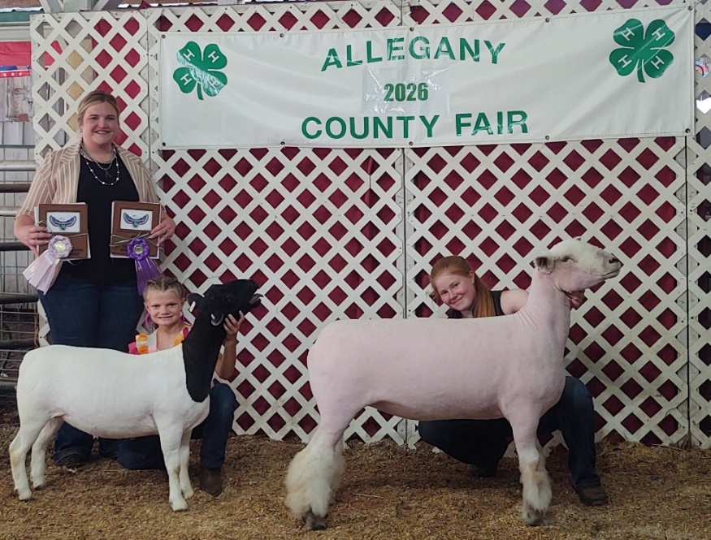
Photo Caption: (Left to right) Reserve Grand Champion Market Lamb exhibitor Faith Wilson, Judge Kirby Palmer, Champion Market Lamb exhibitor Sarah Wilson. These lambs will be sold at the Annual Youth Market Animals Sale at 6 PM on Thursday, July 23rd.
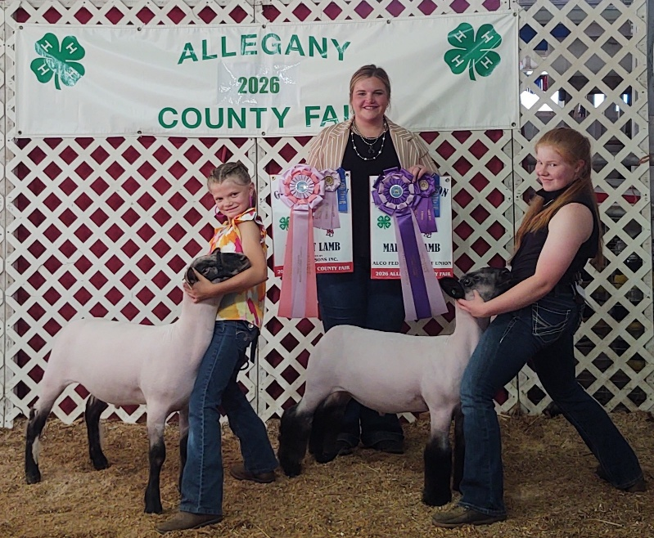
Photo Caption: Grand Champion Farm Flock Drive (Left to right) Flocks exhibited by Garrett Ploetz - Hampshire, Brendon Wilson - Doper, Sarah Wilson - Southdown, and Jeffery Wilson - Dorset.
