Gardening in Difficult Spaces, June 30, 2026
- This class focuses on three common gardening problems and issues: dry spaces, curbsides and shady spaces vulnerable to deer. The class introduces plants found in three CCE Tompkins County Demonstration Gardens that often succeed in spaces like these.
- Plant lists and copies of today’s handout are available here: https://ccetompkins.org/gardening/demonstration-gardens
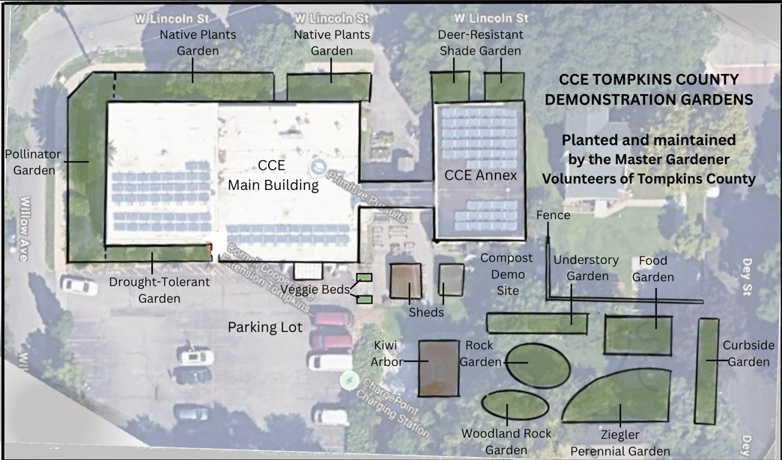
Deer Resistant Shade Garden
[Grab your reader’s attention with a great quote from the document or use this space to emphasize a key point. To place this text box anywhere on the page, just drag it.]

Drought Tolerant Garden

Curbside Garden

Reliable Deer Resistant Shade Garden Plants: Bloom Time |  | Resources
Early spring |  | Useful Tompkins County Cooperative Extension Plant Lists  - Full plant list for the Deer Resistant Shade Garden: https://plantmaster.com/presents/?id=65df7d0dcfe05  - Top Plants for New York Gardens: https://ccetompkins.org/gardening/home-gardening/lawns-ornamentals/top-plant-lists-for-new-york-gardens  - Deer Resistant Plants (Tompkins County Cooperative Extension): https://ccetompkins.org/gardening/help-with-home-gardens/deer-resistant-plants  Lists of Deer Resistant Native Plants  - Wild Ones Native Plants and Deer: file:///C:/Users/16072/Downloads/26-HANDOUT-Deer-2.pdf  - Finger Lakes Native Plant Society Deer Resistant Plants: https://flnps.org/articles/2356/deer-resistant-plants  - Native Plant Trust Plantfinder: https://plantfinder.nativeplanttrust.org/Plant-Search  Note: To use this site, be sure to select filters for Exposure, Tolerance and Eco Region in addition to other filters you may be interested in.  - The Plantsmen: Herbaceous and Woody Plants Less Favored by Deer: https://www.plantsmen.com/_files/ugd/e44642_f28b604b5e954296b8483ed9f8c8ea48.pdf  Books Focused on Deer Resistant Native Plants  - Deer Resistant Native Plants of the Northeast, Ruth Rogers Clausen and Gregory D. Tepper  Note: Available at Tompkins County Public Library  - Plant This Not That, Elise Howard  Note: Not all plants in this popular new book are deer resistant. Consult the author’s detailed lists of plant characteristics for exposure and deer tolerance information.
- Lenten Roses, Hellebores
- Daffodils, Narcissus
- Bishop’s Cap, Epimedium
Late spring
- Primroses, Primula
- Bugloss, Brunnera
- Allium
Summer
Early | Corydalis
Early | Bigroot Geranium, Geranium macrorrhizum
Early | Amsonia
Mid | False Spirea, Astilbe
Mid | Iris
Mid | Allium
Late Summer
- Yellow Waxbells, Kirengeshoma
Fall
- Monkshood, Aconitum
- Autumn Crocus, Colchicum
- Lobelia, Lobelia siphilitica
- White Pearl Snakeroot, Actaea matsumurae
Ongoing foliage
- Carex
- Alum Root & Coral Bells, Heuchera
- Japanese Forest Grass, Hakonechloa
- Ferns
- Grasses
- European Ginger, Asarum
- Lady’s Mantle, Alchemilla
- Perennial Geraniums

