ONTARIO COUNTY
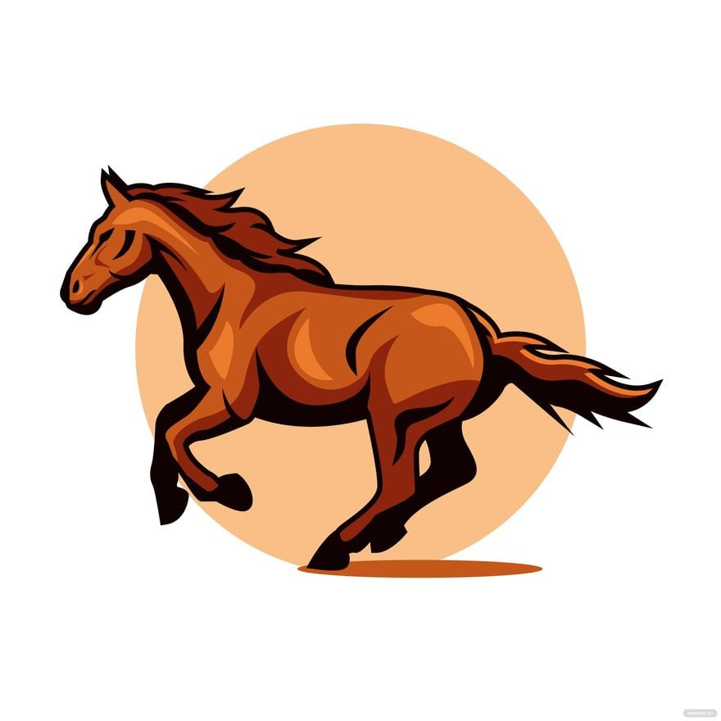
4-H HORSE PROGRAM
HANDBOOK
2026

Sarah Wilhelm, 4-H Resource Educator
sab432@cornell.edu, 315-552-7262
GENERAL RULES AND REGULATIONS

A. Registrations Requirements
- Members must be enrolled with the Cornell Cooperative Extension 4-H Office by January 1st.
- Exhibitors must meet age and membership requirements as specified for all NYS Fair Dept. L participants.

Junior - Youth who are at least eight years of age by January 1st of the current club year and in the third grade or higher should enroll as a 4-H member. Junior contestants must not have reached their 14th birthday prior to January 1st of the current club year.

Senior - Senior contestants must be at least 14 years of age by January 1st of the current club year. Youth who have reached their 19th birthday before January 1st of the 4-H club year may not enroll as a 4-H member.

- Horse Certificates are due June 1st.
- Horse Health paperwork (Coggins and Rabies) are Due July 1st.
- Fair Entries are Due July 1st.

- Rider Level Evaluations are due July 1st – All riders at the County, Regional or State level mounted 4-H horse events be evaluated by the NYS Horse Program Riding Level Evaluation Form. Educator and volunteer chosen by educator need to be present and evaluation must take place at one of the clinic opportunities offered unless special arrangements are made. A youth that was previously evaluated and approved does not need to be re-evaluated to enter the same level a subsequent year. To move up a level or riding a different horse, a youth must be re-evaluated. After two successful walk/trot/canter level evaluations, riders may forgo future evaluations on subsequent horses. However, the judge or educator has the right to deny the horse/rider pair if there are concerns about safety.

- Clover Bud youth must be evaluated using the “Clover Bud” on the Ground Skills Evaluation Form, been involved in riding experiences and demonstrate their ability to ride safely before they are involved in county sponsored programs and events. Forms must be filed at the county 4-H Office.

- Once the rider chooses to ride 3 gaits at the 4-H show/fair, they may not return to the walk/trot class.

- No 4-H member may participate on any animal other than the one(s) designated in his or her name in a qualifying 4-H show.

- A substitution may be made for a 4-H designated equine only if said animal is disabled or in the event of death. The substitution must then be used for the remainder of the season. A veterinarian’s certificate must be submitted to the Cornell Cooperative Extension Office with the new registration, Coggins and Rabies Certificate.

- Only current year or prior year Coggins papers may be presented with the horse registration papers by June 1st. Coggins papers must be legible and show specific markings and/or tattoos on horse. Submitting a side view picture of each horse is strongly recommended. A current rabies certificates (not a receipt showing the rabies vaccine was given) is also required.

- A member may enroll and show 1 horse per division at Ontario County Fair and a maximum of 2 horses.

- All horses must be at least 24 months old to be shown in Fitting and Showmanship Classes; however, horses must be a least 3 years old to be driven or ridden.

- All male horses must be gelded 3 months prior to 4-H use.

B. Show Rules
- All Ontario County 4-H horse shows shall be held at the Ontario County Fairgrounds unless otherwise announced.
- Ponies must be measured before their first class at the first show of the season by a designated show committee member and the Ontario County Fair. Qualified ponies will be re-measured at New York State Fair.
- SHOWMANSHIP IS MANDATORY FOR ENGLISH AND WESTERN.
- All classes shall be conducted as provided in the Revised New York State 4-H Rules Book. Copies of the New York State 4-H Show Rule Book may be found on the NYS website. We strongly encourage all 4-H families to print off a rule book.
- No one may approach the Judge without permission from the Show Steward. At the Judge’s discretion, exhibitors may be excused from the class and/or remainder of the show for unsportsmanlike conduct.
- Horses outside the show ring shall be hand walked, except in the designated warm up area. No horse is allowed beyond the east end of the 4-H horse barn.
- Riders are expected to be at the in-gate when the class is called. There will be no waiting for late arrivals. If you need to change tack, notify the announcer in advance.
- Patterns for trail and jumping classes will be posted in the barn during County Fair.
- In Gymkhana classes and Mounted Games, exhibitors must enter at a walk and must dismount before leaving the show ring.
- We will split mounted games teams by W/T and W/T/C. They will not be combined.
- W/T/C classes may be combined when there are fewer than 4 riders in a class.
- Unmanageable and/or unsound equines will be dismissed from the ring or the grounds. This decision will be made by the Judge or the 4-H Educator.
- All judges shall be selected by the 4-H Staff.
- All clubs must participate in set up/take down of 4-H stalls. Each 4-H member must make arrangements for their stall to be set up and taken down. Each club area in the barn is to be kept clean during County Fair and then cleaned by each club member at the end of County Fair.
- All fitting, grooming and care of a project horse should be done by the 4-H member when age appropriate.
C. Barn Rules
- All riders must wear approved helmets at all times when mounted and in fitting and showmanship classes. Chin straps must be properly secured. Helmets must be checked prior to showing. The helmet must be ASTM 1163 Approved.
- Proper footwear (closed toe) must be worn at all times around horses. Riders must wear boots with a distinguishable heel.
- All youth must have adult supervision by a parent or guardian.
- No riding in the barn or sitting on equine in the stall.
- No riding double.
- No bareback riding.
- For public safety during County Fair, horses are not allowed out of the barn and riding area unless they are being bathed or measured.
- Equine must be led to and from the wash rack.
- Equine is to be ridden in the warmup and main ring only during the County
- Fair.
- No parking or riding east of the 4-H Building or Horse Barn.
- Inhumane treatment of equine will NOT be tolerated.
- No vulgar language will be allowed.
- Tack stalls are assigned. No tack is allowed in the aisle. Keep your area neat! (Rake aisle, pick up tack and clothes. Check stall for hay and water a must.)
- All horses staying in the barn must remain until 8pm Saturday night. You may leave Friday night only if you stall is going to be occupied by an open horse. You must make sure that the person using your stall plans to stay until at least 8pm Saturday night and that they will completely strip the stall when they leave. Make sure you pick someone that you trust so that your premiums are not affected. Otherwise, plan to stay until Saturday evening, in order to be eligible for fair premiums.

- Have fun at the Fair!!

C. State Fair
1. Ontario County may send up to 4 entries in each division to the state competition. End of day champions for pony, junior, and senior division are guaranteed first choice of going to state fair. Others are welcome to attend if approved by the educator and judge. Please just ask if you would like to be considered for state fair.

Teamwork Items for Fair Week

- Stock and monitor and clean bathrooms during the day.
- Sign up to be announcer, ring crew to remove jumps, barrels (etc.), 2 gate people all day, ring steward, bookkeeper and ribbon person.

- Wash racks – periodically check and pick up if necessary.

- Close barn at 10 p.m. Turn off barn, arena and booth lights, close all
entrances to the barn.

- Keep manure area picked up.
- Experienced operators are asked to assist with arena maintenance.

2026 Horse Show Class List
Tuesday, July 21, Hunt Seat Horse Show, Judge: Tara Defendorf

- Showmanship, Senior
- Showmanship, Junior
- Showmanship, Pony
- Showmanship, W/T
- Hunt Seat Pleasure, Senior
- Hunt Seat Pleasure, Junior
- Hunt Seat Pleasure, Pony
- Hunt Seat Pleasure, W/T
- Hunt Seat Equitation, Senior
- Hunt Seat Equitation, Junior
- Hunt Seat Equitation, Pony
- Hunt Seat Equitation, W/T
- Hunter Under Saddle, Senior
- Hunter Under Saddle, Junior
- Hunter Under Saddle, Pony
- Hunter Under Saddle, W/T
- Hunter Seat Disciplined Rail, Senior
- Hunter Seat Disciplined Rail, Junior
- Hunter Seat Disciplined Rail, Pony
- Hunter Seat Disciplined Rail, W/T
- English Command, Senior
- English Command, Junior
- English Command, Pony
- English Command, W/T
- English Trail, Senior*
- English Trail, Junior*
- English Trail, Pony*
- English Trail, W/T*

*To take place 1 hour in afternoon, will be announced
Wednesday, July 22, Cloverbud Classes, Miniature Horse Show, Mounted Games

Cloverbud Show 10:00am
- Cloverbud Pleasure
- Cloverbud Horsemanship
Miniature Horse Show, 10:30am
- Showmanship, Senior
- Showmanship, Junior
- Jumper in Hand, Senior
- Jumper in Hand, Junior
- Cloverleaf In-Hand, Senior
- Cloverleaf In-Hand, Junior
- Trail in Hand, Senior
- Trail in Hand, Junior
- Trail Driving, Senior
- Trail Driving, Junior
- Pleasure Driving, Senior
- Pleasure Driving, Junior
- Cloverleaf Driving, Senior
- Cloverleaf Driving, Junior
Mounted Games Show, immediately following mini show
Classes TBD, as many as time allows
Costume Class, 3:30p

Thursday, July 23, Western Horse Show, Judge: Bill Skellet

- Showmanship, Senior
- Showmanship, Junior
- Showmanship, Pony
- Showmanship, W/T
- Stock Seat Equitation, Senior
- Stock Seat Equitation, Junior
- Stock Seat Equitation, Pony
- Stock Seat Equitation, W/T
- Western Pleasure, Senior
- Western Pleasure, Junior
- Western Pleasure, Pony
- Western Pleasure, W/T
- Western Horsemanship, Senior
- Western Horsemanship, Junior
- Western Horsemanship, Pony
- Western Horsemanship, W/T
- Western Road Hack, Junior
- Western Road Hack, Senior
- Western Road Hack, Pony
- Western Road Hack, W/T
- Western Command, Senior
- Western Command, Junior
- Western Command, Pony
- Western Command, W/T
- Western Disciplined Rail, Senior
- Western Disciplined Rail, Junior
- Western Disciplined Rail, Pony
- English Trail, Senior*
- English Trail, Junior*
- English Trail, Pony*
- English Trail, W/T*

*To take place 1 hour in afternoon, will be announced

Friday, July 24th, Gymkhana Horse Show, Judge: Kylie Hill

- Pole Bending, Senior
- Pole Bending, Junior
- Pole Bending, Pony
- Pole Bending, W/T
- Straight Line Barrels, Senior
- Straight Line Barrels, Junior
- Straight Line Barrels, Pony
- Straight Line Barrels, W/T
- Texas T, Senior
- Texas T, Junior
- Texas T, Pony
- Texas T, W/T
- Cloverleaf Barrels, Senior
- Cloverleaf Barrels, Junior
- Cloverleaf Barrels, Pony
- Cloverleaf Barrels, W/T
- Quadrangle Barrels, Senior
- Quadrangle Barrels, Junior
- Quadrangle Barrels, Pony
- Quadrangle Barrels, W/T
- Hourglass, Senior
- Hourglass, Junior
- Hourglass, Pony
- Hourglass, W/T
- Butterfly, Senior
- Butterfly, Junior
- Butterfly, Pony
- Butterfly, W
- Keyhole, Senior
- Keyhole, Junior
- Keyhole, Pony
- Keyhole, W/T

Equine Educational Sessions

The horse education program will offer an ongoing and comprehensive opportunity for all interested 4-Hers to learn about horses. As the program matures, we hope that it encompasses many avenues for learning – guest speakers, field trips, slides and lectures, group projects and clinics. Preparation for various educational competitions will be folded into the program. Some may choose to attend only when we are exploring a specific topic that they are interested in. Others may try to attend on a more regular basis and may choose to attend competitions. This program is open to all. Parents are always welcome to stay; any help that they might offer to the program will gratefully appreciated.

It is our hope that Equus will fulfill several functions. For those horse-crazy 4-Hers who do not have an equine of their own, this will be place for them to indulge their passions and perhaps prepare for the various competitions, which are not dependent upon horse ownership. For those who are contemplating the plunge into horse ownership, the activities in this program will help them to prepare for this great responsibility of caring for these beautiful animals in a way, which will keep the horses healthy and happy and the owners safe and satisfied. 4-H’ers with horses may be surprised by how much they do not really know about their animals and how best to care for and train them. We hope to provide a program, which will not overwhelm the novice, but will also be interesting and meaningful for the more experienced horse person.

Normally we begin holding meetings in October, possibly on an every other week schedule. The meeting schedule will be expanded as we head into the educational competition season. It is important to know that attending these activities does not mean that you must enter competitions – it is an option for those who would like to participate. While we think that most 4-Hers would enjoy one or more of these educational contests, we realize that it is not for everyone and that is ok. In the end, we would like the entire horse program to hang together, to flow together from one season to the other. We hope that many of you will participate and that the program will grow and mature, with new ideas and new people enriching it as we go along. There is potential to compete at regional, state and national levels.

Competitions available:

Horse Bowl: Horse Bowl is a type of quiz bowl team competition which tests the knowledge of all things equine. Question categories include stable management, breeds, anatomy, diseases, unsoundness, parasites and tack, among other things. Each team consists of four players who buzz in when they know the answer. Questions are given one on one and also as toss ups to the whole group.
Hippology: Hippology is simply the study of horses. Hippology competitions are among the most challenging and the most fun of all the educational events. There are many different parts to the average Hippology competition. They include:
    - Written test – covers just about anything, similar to things asked in
      - Horse Bowl;
    - Horse Judging – at least two classes with no “reasons;”
    - Stations – may be interactive, questions related to tack, anatomy and conformation, disease unsoundness, parasites, breeds, feeds. The stations may involve drawings, pictures and objects;
    - Identification – tack, equipment and feeds may be displayed on tables to identify;
    - Slides – color, breed, gaits and activity must be identified;
    - Team problem – members work together to present the solution to a problem; problem subjects might include farm management, behavior, breeding, giving lessons, conditioning, etc.

Horse Communications: Horse Communications is an opportunity for 4-Hers to develop the very important skill of public speaking. It is a skill which, once learned, can be used for the rest of your life in many different ways. Many people rise to leadership roles in their businesses and communities because they are confident and capable when speaking. This is an area where practice is very important because each time you speak you will get a little better. There are several different events which are a part of the Horse Communications competition; you can only compete in one event each year.
- Individual demonstration – one person presents a topic with props
- Team demonstration – two people present a topic with props
- Public speaking – one person speaks on a topic with no props

Horse Judging: Horse Judging is simply comparing the members of a group of horses, or horse and riders, and placing them in order from the best to the worst. The horses, in groups of four, are usually of similar breed, age, and sex and are judged according to the standard for that breed type—conformation being the most important gauge in halter classes. In riding classes, either the horse or the rider may be judged, depending on the type of class and the horse’s way of going or the rider’s equation will be the determining factor. In some classes, the contestants must not only place the horses, but also give their reasons for doing so.

