

2026 Ontario County
4-H
Animal Exhibit Fairbook



Updates and Information
Dear 4-H Member/Parent/Leader:
This is your copy of the 4-H Animal Science Book for the Ontario County Fair 2026. Please keep it in a handy spot for reference. Read carefully to avoid errors. If you are looking for information about exhibit hall projects, please reference the Project Fairbook.

Pre-entry is required for all 4-H entries (both animal and projects). Entries are now only available via the FairEntry system. Directions on how to register are available in the first section of this Fairbook. ALL ENTRIES ARE DUE BY JULY 1.

LEASE POLICY: An exhibitor may request to lease up to three animals. If an exhibitor owns his or her own animals, they may still choose to lease up to three animals. THIS IS A COUNTY DECISION ONLY. State fair will still only allow youth to lease and exhibit one animal and only if youth do not already own an animal of his or her own. Standard lease paperwork must still be turned in with a project record book for each leased animal. Project record books may be obtained by requesting a copy from your educator. Forms and lease paperwork can be found at this link: http://4h.ansci.cornell.edu/resources/project-animal-forms/

Fair cleanup will be Thursday July 9th, 2026 starting at 5:00 PM, and everyone who is taking part in the fair either as an animal exhibitor or in the exhibit hall must attend this set-up date. If you are unable to make this day, please let the 4-H educator know at least two weeks ahead of time so we can set up an alternate time for you to fulfill this requirement.

We look forward to seeing you at the Ontario County Fair. Exhibiting 4-H projects provides youth with valuable learning experiences and recognition. Exhibits also provide a venue for which the public can gain a sense of breadth and depth of 4-H projects and activities. If you have any questions about exhibiting at the fair, contact the 4-H office.

Table of Contents
Directions of How to Register in FairEntry 6
4-H ANIMAL SCIENCE RULES AND REGULATIONS 14
4-H ANIMAL SCIENCE GENERAL ANIMAL SCIENCE PROJECTS 18
4-H BEEF 20
4-H Cavy 21
4-H DAIRY 22
4-H GOATS 21
4-H HORSE 24
4-H Pet Show 25
4-H POULTRY 25
4-H RABBIT 28
4-H SHEEP 32
4-H SWINE 33
4-H Dog 34

Ontario County 4-H & Open Class Exhibit Fair Schedule
FRIDAY, JULY 17
4-H Club Booth Setup and 4-H Club Project Judging at Wolcott Park |  | 5:00 PM – 8:00 PM
SUNDAY, JULY 19
Poultry Science Contest | 2:00PM – 4:00PM
Rabbit Decathlon | 4:30 PM – 5:30 PM
MONDAY, JULY 21
Barns Open for Superintendent Animals |  | 3:00 PM
Barns Open for Animal Exhibits |  | 3:30 PM
TUESDAY, JULY 22
Barns Open for Animal Exhibits |  | 7:30 AM
4-H Horse Show – English |  | 10:00 AM
4-H Goat Show |  | 12:30 PM
Open Swine Show |  | 6:00 PM
Open Class Rabbit and Cavy Show |  | 6:00 PM
WEDNESDAY, JULY 23
Poultry BBQ Contest |  | 10:00 AM
Livestock Challenge –Test Phase |  | 10:00 AM – 5:00 PM
4-H Horse Show Cloverbuds |  | 10:00 AM
4-H Beef Show |  | 10:00 AM
4-H Mini Horse Show |  | 10:30 AM
4-H Mounted Games |  | 11:30 AM
Open Class Dairy Show |  | 1:00 PM
Open Draft Horse Halter |  | 2:00 PM
4-H Sheep Show (Under tent) |  | 3:00 PM
4-H Horse Costume Class |  | 3:30 PM
Open Sheep Show (Under tent) |  | 4:00 PM
Open Draft Driving |  | 4:30 PM
Swine Skillathon |  | 5:00 PM
Rabbit Hopping by fair office |  | 6:00PM
Square Dancing! |  | 7:30 PM (Tentative)

THURSDAY, JULY 24
Rabbit Showmanship |  |  | 10:00 AM
4-H Dairy Show |  |  | 11:00 AM
4-H Horse Show – Western |  |  | 10:00 AM
4-H Rabbit Show and Cavy Show |  |  | 2:00 PM
Open Swine Show |  |  | 4:00PM
4-H Pet Show |  |  | 5:00 PM
4-H Dog Show |  |  | 6:00 PM
4-H Swine Show |  |  | 6:00PM
FRIDAY, JULY 25
4-H Poultry Showmanship / Avian Bowl |  | 9:00 AM
4-H Horse Show – Gymkhana |  | 9:00 AM
Open Class Beef Show |  | 10:00 AM
4-H Livestock Auction |  | 5:00 PM
Bossy Bingo |  | 7:00 PM
SATURDAY, JULY 26
Open Class Horse Show | TBD
Pack Goat Show | 12:00 PM
4-H Costume Class | 4:00 PM
ALL ANIMALS RELEASED FROM BARNS | 8:00 PM
SUNDAY, JULY 27
Fair Teardown |  |  |  | 8:30 AM
Non-Animal Exhibits Released |  |  |  | 9:00 AM - 10:00 AM

Directions of How to Register in FairEntry

6.8.22▪ 1

©RegistrationMax LLC
Exhibitor Group (Family) Entry
Important Reminders
- All animal AND 4-H exhibit hall items must be entered by July 1st. Be sure to complete your entries (including the final “Submit” step) prior to July 1st.
- Register all entries for each exhibitor in the family before proceeding to the Payment section. *There is no fee for entering 4-H animals or projects. However, you will have to purchase a vehicle parking pass. If you are entering in open class, you will have a small fee. You can also register for camping, if desired. You must click on the payment portion to submit your entries*
- Be sure to click the “Submit” button when you have completed your entries. Entries are not final until they have been submitted.
- Check your email inbox for a confirmation email with a list of your entries and any related fees.
- You may access your Fair or Show from their direct link or go to https://ontariocountyfair.fairentry.com
- Filter by your state, click Search, and then click on the correct fair.
- All 4-H families will have a 4HOnline family account, select to “Sign in with 4HOnline” and enter your login information.  - You MUST sign in with the 4-H online account. NOTE: If you forgot your password for your 4HOnline account, you need to go to 4HOnline to set a new password. Then use the new password (not the temporary password) to log in to FairEntry. |  | 

©RegistrationMax LLC
1. Click “Begin Registration” | 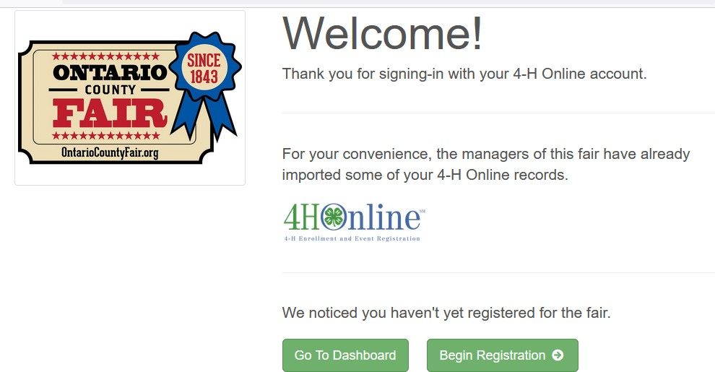
Step One – Entering Exhibitor Information
1. Once you select to register an Individual, you will have the option of registering one or more of all the members with an active and up to date registration of that 4H Online account.

6.8.22▪ 2

©RegistrationMax LLC
Step Two - Creating Entries for Exhibitors
Each exhibitor can have multiple entries. One entry must be made for each item, animal, class, etc. For example, if an exhibitor is bringing 2 photographs, two entries into the photography class must be created. If an exhibitor is showing one horse in 5 events, five class entries must be created. Once all entries have been created for the first exhibitor, you have the choice of creating another exhibitor in this exhibitor group (and entries) or proceeding to check-out (submitting the entries, whether or not fees are charged).
1. Click Add an Entry beside the correct exhibitor (if more than one has been created).
- Click Select beside the first department you wish to enter. Any departments that are not available for entry will be noted as “Not Available” with a short explanation.  - After you select a department, you will see a list of divisions to select from, and then a list of available classes. Also notice that there are blue “Change” links in case you mistakenly select an incorrect department, division, or class.  - After you have selected the class, click the green Choose button.  At this point, you will continue on with either the Multiple Entry process, or the Single Entry Process, depending on the option that your fair or show selected. The Multiple Entry process is described beginning on page 4, and single entries are described beginning on page 5. | 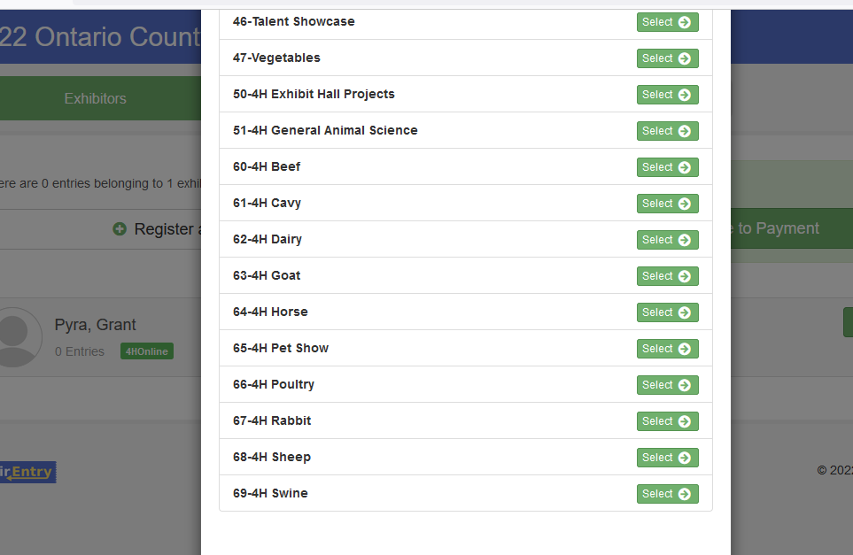
 |  | 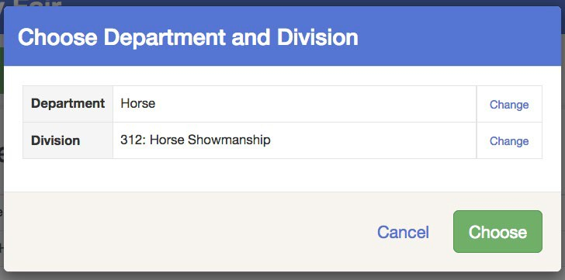

6.8.22▪ 3

©RegistrationMax LLC
Creating Class Entries Using the Multiple Entry Process
Our fair uses Multiple Entries option for Horse and Exhibit Hall Projects please follow the directions below. All other project areas, proceed to the single entry process directions on the next page.
- Click Change to select the Club to which these entries will be associated.  - If this is an Animal Entry, click Add Animal and enter the Animal’s details.  - Select which animals will be part of this entry (NOTE: these animals will be available for this exhibitor to use in other entries, if needed).  - Check the box next to each class this animal will enter. |  | 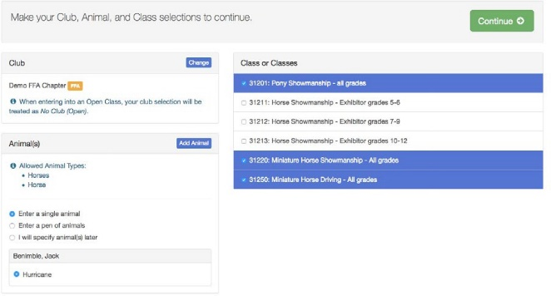
5. If this is not an animal entry or if animals will be added at check-in, simply select the classes and number of entries in each class that you would like to create for this exhibitor. Click  Continue. |  |  | 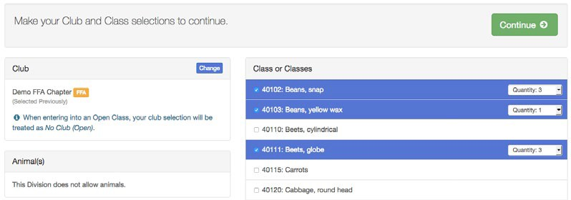
6. Review the entries. If you need to make any changes, click Cancel. If everything is correct, click Create Entries. |  |  | 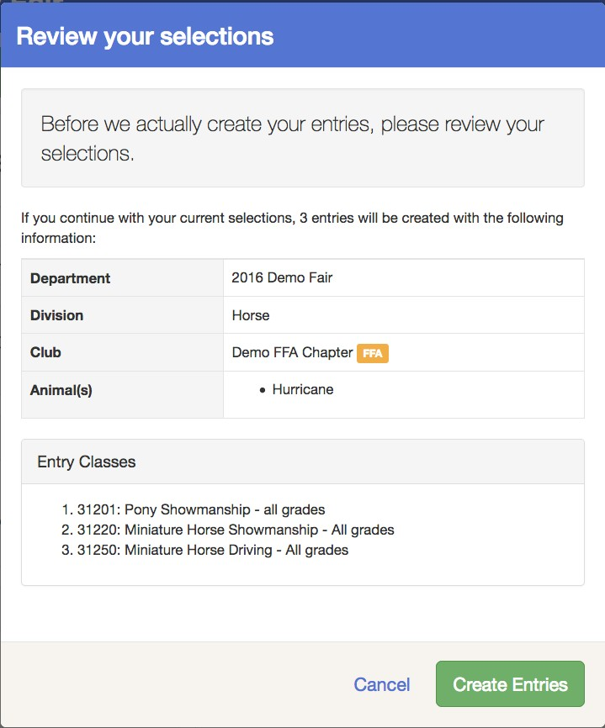

6.8.22▪ 4

- If you need to add another exhibitor, click on the Exhibitors button at the top left and repeat the steps to create a new exhibitor.
- If all entries are complete, click Continue to Payment.
- If you need to add more entries for an existing exhibitor, click Add an Entry.
Creating Entries Using the Single Entry Process
This is the process to use for all project areas, except for horse and exhibit hall projects.
- Select the appropriate class.  - Click Continue | 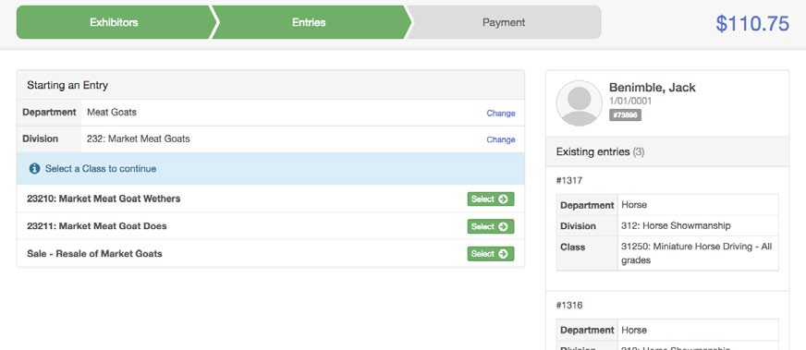
- Select a Club or Chapter for this entry. If this is an open class entry a Club or Chapter may not be required.  - If this is not an animal class entry, follow the instructions on-screen to enter any additional information such as Entry Description, Custom Questions or Custom Files associated with that entry. | 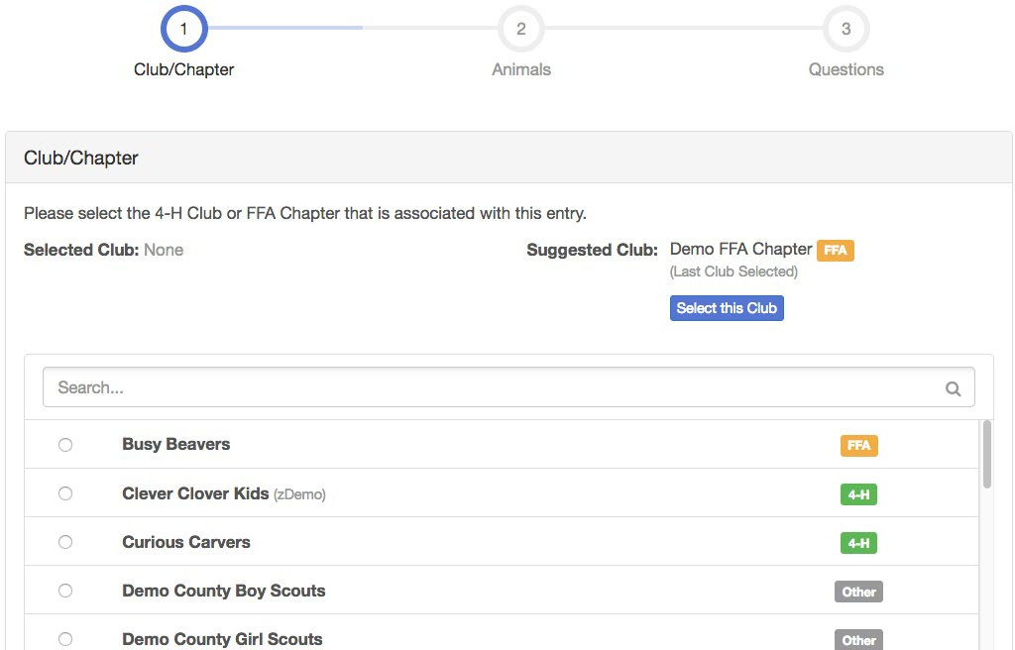

©RegistrationMax LLC

6.8.22▪ 5

- If this is an animal class entry, you will be  required to specify which animal will be exhibited in this class. You will see the option to “Add an animal”.  - You will choose “Enter a New Animal Record” to enter new animal information.  - Fill in all the fields with information about the animal you intend to exhibit. Click Create and Add Animal when finished. If the animal information was entered incorrectly, you have the option to either Remove From Entry (creating a new animal) or Edit Animal Details. When it’s correct, click Continue.  - Any questions or file uploads related to entry in this class will be next. Click Continue after answering those questions or uploading documents. |  | 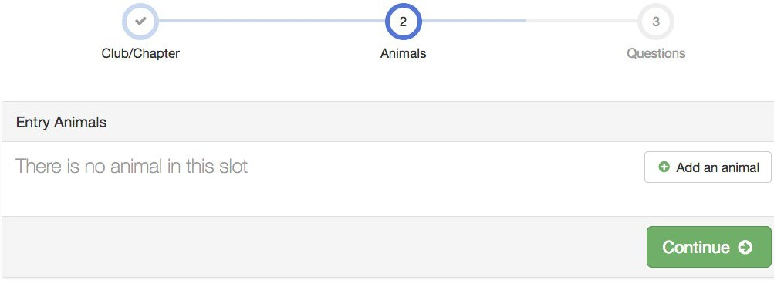
 | 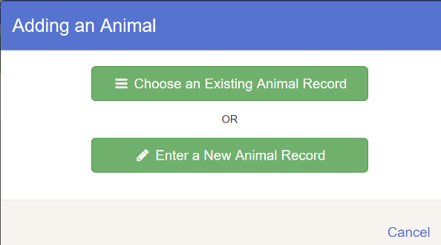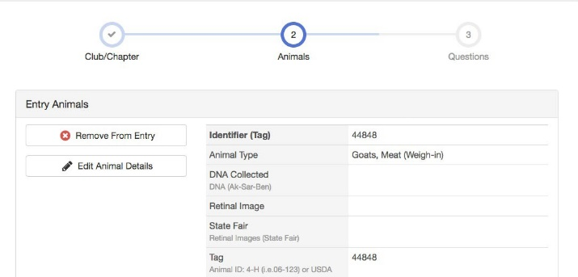
- When each class entry is complete, you have three choices for what to do next:
  - If all class entries have been completed for one exhibitor, you can Register another Exhibitor in this exhibitor group.
  - If this exhibitor has more class entries to make, you can Add another Entry for this Exhibitor. Do this until all entries for all exhibitors are complete, then Continue to Payment. *Please make sure you enter any open classes as well if you plan to take part in any open class opportunities. *
  - Don’t forget to purchase 1 parking
pass/car you will have on the fairgrounds.
 | 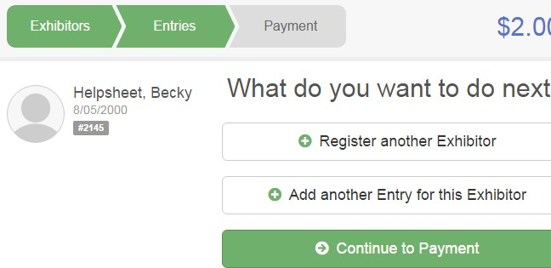

©RegistrationMax LLC

6.8.22▪ 6

©RegistrationMax LLC
Submitting Entries
When all entries for all exhibitors in the exhibitor group have been completed, Continue to Payment to finalize and submit your entries. You must submit your entries even if there are no fees, so no payment is required.
- Review your entries for completeness and accuracy. Notice the Summary and Detail buttons at the top of the list on the right. If there are errors, click on the green Entries section at the top of the page. Click Continue when all information is correct.  - Once all entries have been entered for exhibitors in your family, submit the invoice.  - You will receive an email message when the entries have been submitted. |  | 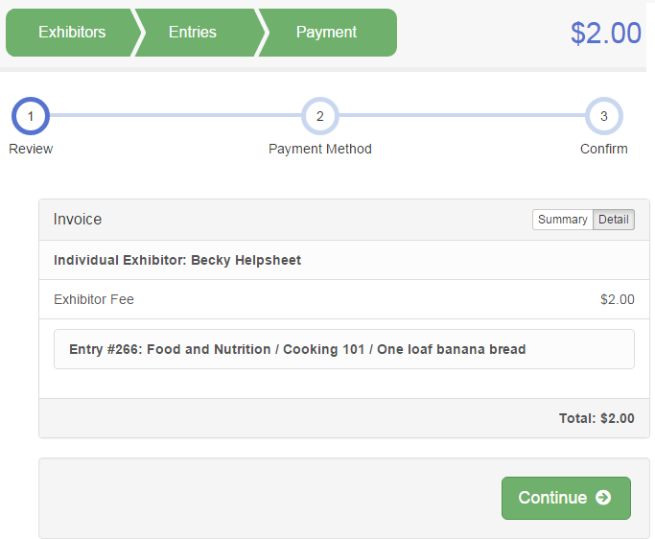

6.8.22▪ 7

4-H ANIMAL SCIENCE RULES AND REGULATIONS
2026
Deadlines: The following are due to the 4-H office no later than the date listed below.
June 1st of the current year - 4-H Horse Certificates
July 1st of the current year - 4-H Animal Entries and lease forms
July 1st: Rabies and Coggins Certificates for horses

Any form received after July 1st MUST have a written explanation as to why the entry is late. If the entry form and written explanation is submitted late, then the matter is reviewed by the 4- H staff as to whether or not the 4-H member is allowed to participate. If the form is late again the next year, there will be no review and the exhibitor will not be allowed to participate.

- 4-H members, in accordance with the Ontario County 4-H membership policy, must be enrolled with the Ontario County 4-H office by January 1 of the current year to be eligible to exhibit in the 4-H Division at the Ontario County Fair.
- 4-H ownership of all animals as follows: Horses –May 1, Beef/Market Animals –May 1, and all other animals by June 1.
- All animals must be on the grounds all week per instructions from the State Vet.
- Exhibitors must show their own animals on the show day unless they are showing another species of animal in a performance class, which occurs at the same time. Alternate exhibitors must also be 4-H members. Please inform the Superintendents of both species and inform the 4-H Staff members prior to the shows.
- All animal exhibitors are required to participate in the showmanship class for the species they are exhibiting.

HEALTH REQUIREMENTS: PLEASE READ THE NYS DEPARTMENT OF AGRICULTURE & MARKETS ANIMAL HEALTH REQUIREMENT BOOKLET FOR
THE CURRENT FAIR SEASON. (Changes are made every year to the requirements so, please
read this booklet every year! The regulations can be found at :
https://agriculture.ny.gov/animals/fair-health-requirements

- Youth on Fairground Rules
Reminder: ALL parents are responsible for chaperoning their children when they are
on the fairgrounds or must obtain an adult chaperone over the age of 21 for them
while not in attendance.

NO 4-H YOUTH WILL STAY OVERNIGHT IN ANY BARN
https://www.agriculture.ny.gov/
  - No exhibitor may remain on the fairgrounds overnight unless under direct adult supervision with written parental permission. This permission slip will include a medical release form.
  - We strongly recommend youth be accompanied by a parent at all times.

- All participants staying on the grounds in trailers or tents will be supervised by their parent or a guardian authorized by their parent.
  - No unauthorized person will be allowed in the barns after 11:00 PM.
  - There will be no community water tubs.
  - Smoking is not permitted in or around the barns. There will be no use of illegal drugs or alcohol by participants. Participants may be dismissed if they are found with these substances.

- Appropriate registration papers must accompany animals shown as registered breeding stock. Animals without registration papers will be shown as grades. Cattle will be shown in the same show at the same time.
- Any animal exhibited by a youth member may be subject to drug testing as deemed necessary by the Superintendent, Educational Coordinator, 4-H Extension Educator, or Departments of Agriculture and Markets. In the event that a positive result is obtained, the youth will be barred from showing animals at the Ontario County Fair, forfeit all premium money and awards and will be referred to the Ontario County 4-H Office.
- Each exhibitor must furnish enough feed and bedding for their own animals - also feed boxes and water buckets. Each exhibitor is responsible for their own animal or secures another exhibitor to care for it. If a superintendent or educator has to reprimand a participant about animal care, premiums may be withheld. Repeated offenses may result in the participant not being able to participate in future years at educator discretion.
- The county fair exhibition constitutes a public display. All exhibitors are encouraged to always keep their animals and the building clean and attractive. Exhibitors are urged to conduct themselves and their exhibits in a manner to reflect credit on 4-H and their industries. Upon removal of their animals from the exhibit, the exhibitors are required to leave the areas that have been occupied by their animals clean of straw and manure, and ready for occupancy. Straw and manure must be removed from the barn. Animal Superintendents will give direction for this to exhibitor.
- The use of showing and/or handling practices or devices such as striking animals to cause swelling, using electrical contrivance, or other similar practices are not acceptable and are prohibited. The use of drenching, mechanical pumping devices, or other abnormal methods to administer water or fluids to animals will not be permitted, except for veterinarian approved treatments for dehydration.
- Direct criticism or interference with the judge, fair or livestock show management, other exhibitors, breed representatives, or show officials before, during, or after the competitive event is prohibited. In the furtherance of their official duty, all judges, fair and livestock show management, or other show officials shall be treated with courtesy, cooperation, and respect and no person shall direct abusive or threatening conduct toward them.
- Weeklong fair passes can be obtained from the Ontario County Fair Office or via the new FairEntry system.
- In the event premium money is deleted or decreased from the New York State budget, premiums will be adjusted accordingly.
- 4-H animals must always be penned/stalled according to directions from the 4-H superintendent.
- For submissions guidelines for Section AA class 2, please refer to the Project Fairbook. An animal science item such as a rope halter, record book, animal first aid kit, etc. will be judged on exhibit judging day and exhibited in the youth building
- Note about 4-H Cloverbuds Showing Animals
    - Be sure to read the rules and regulations in the section of your animal.
    - There is a limit of one animal per species for Cloverbuds to enter at the fair.

RESPONSIBLITIES OF EACH 4-H ANIMAL EXHIBITOR
- Cleanliness of each animal and exhibitor
- Stall or pen area – manure removed, appropriate bedding
- Food and water supplied for the animal
- Cleanliness of the animal area including sweeping and raking
- Organization of tack in the appropriate storage area
- Identification of area
- Cooperation with animal superintendent and other exhibitors
- Cooperation and interaction with those attending the fair to share a positive image of 4-H to the public coming to the fair.

The Danish System is the primary system of judging the 4-H shows and exhibits. Each exhibit is evaluated by the judge on its own merit and is not compared to others in the same lot. Evaluation is based on the quality of the exhibit with consideration to the exhibitor’s age and experience in the project. There are certain areas where competitive judging may take place as well.

MOST IMPORTANT MESSAGE FROM VETERINARIANS:
When you are loading your livestock for the trip to the fair, take the time to examine them.
Make sure they are the same animals that are on the paperwork
If your animal is showing any sign of illness LEAVE THEM HOME.

4-H ANIMAL SCIENCE GENERAL ANIMAL SCIENCE PROJECTS
Department 51

Class:
- A completed 4-H project book: Due date July 9th (Fair cleanup). No late books will be accepted.
  - Beef
  - Rabbit
  - Cavy
  - Dairy
  - Goats
  - Horse
  - Pet
  - Poultry
  - Sheep
  - Swine
  - Dog

- Costume Class
(Large Animal) – Dairy and Beef cattle *will need to submit animal name and costume choice 24 hours before class*
(Small Animal) – Sheep, Goat, Poultry, Rabbit, Cavy *will need to submit animal name and costume choice 24 hours before class*

Educational Contests:
The contests below are open to any youth interested in the animal species regardless of if that youth is exhibiting that species in the county fair animal shows.

- Avian Bowl: This is structured after the state and national competition but will be in the form of a written test with questions about anything poultry related, whether it is breed characteristics, diseases, food preparation, poultry housing, etc. The questions will be created from several pages of the National 4-H Avian Bowl Manual and change from year to year. The selected pages will be announced/provided prior to the fair to allow for studying. If needed, the questions can be read to contestants.

- Poultry Science: This competition focuses on evaluating the quality of various poultry products, broken into 7 categories: interior egg quality (candling), interior egg quality (broken out), exterior egg quality, meat part ID, ready to cook broiler quality, breaded product quality, and past egg production (with oral reasons). The competition is structured after the state and national competition and is based on the National Poultry Judging Manual from Nebraska State University. 4-Hers are encouraged to participate even if they have minimal or no knowledge of judging, as it is meant to be a learning experience.

- Chicken BBQ: This competition is composed of three parts. First, participants will have two hours to cook four (4) bone-in, skin-on chicken thighs (provided at the beginning of the competition) on a charcoal grill. While cooking, contestants are evaluated on their BBQ and food safety skills. The meat is then evaluated by judges based on appearance and taste, which is the second part. The third part is a small, informal presentation about the commercial broiler industry, food safety, and nutrition of chicken. This is not meant to discourage competitors, and polished presentations are not expected. The main goal is for competitors to demonstrate a basic awareness of the poultry industry and of the meat that is being prepared. The presentation can be a PowerPoint, poster, or be given completely orally from note cards.

- Turkey BBQ: The same guidelines as for chicken, except participants will prepare turkey burgers from ground turkey provided at the beginning of the competition

- Rabbit Decathlon: This contest tests a participant’s knowledge of rabbit care and showing. Youth move around to different stations that test their knowledge of rabbit breeds, nutrition, health, standards for judging, etc.

4-H BEEF
Department 60
- All 4-H beef exhibitors are required to participate in Showmanship classes. Each contestant may show his/her own animal, but during the contest, may be asked to show some other animal.
- All non market animals will be shown by breed and judged on the Danish System.
- All steers will be placed in the appropriate weight class according to their weight at the fair. Exhibitors should sign up for the class they think their steers will be in.

4-H Beef Exhibitors are required to participate in Showmanship classes. Each contestant must show his own animal, but during the contest, may be asked by the judge to show another animal in the show ring. If you are showing in another age division, notice must be given to the superintendent before show day, and it needs to be noted on the animal entry form.
Beef Divisions 01-Black Angus
02 - Charolais
03 - Hereford
04 - Simmental 05 - Other Breeds 06 - Market Beef 07 - Showmanship

Class | Description | Age
01 | Junior Heifer Calf | Born after 1/1 of current year
02 | Senior Heifer Calf | Born previous year 9/1-12/31
03 | Summer Yearling Heifer | Born previous year 5/1-8/31
04 | Junior Yearling Heifer | Born 1/1 to 4/30 previous year
05 | Senior Yearling Heifer | Born 9/1 to 12/31 2nd previous year
06 | 2-year-old Heifer | Not Calved
07 | Cow/Calf Project | Cow, any age with natural calf born after Jan 1 of current year
08 | Junior Prospect Calf | Bull calves born Jan 1 – June 1 of current year, still nursing on cow
09 | Feeder Calf | To be weighed at the fair
10 | Market Steer | To be weighed at the fair
11 | Market Heifer Class | To be weighed at the fair
12 | 4-H Auction Market Steer | Animal specifically part of the 4-H Auction program. To be shown by weight.
13 | 4-H Auction Market Heifer | Animal specifically part of the 4-H Auction program. To be shown by weight.
14 | Registered Bred and Owned by 4-H Exhibitor Heifer | Reg papers will be checked.
15 | Registered Bred and Owned by 4-H Exhibitor Cow/Calf | Reg papers will be checked.
16 | Registered Bred and Owned by 4-H Exhibitor Steer | Proof of ownership will be checked.

Showmanship
CLASS | NAME OF CLASS | CLASS DESCRIPTION
1 | CLOVERBUDS | Age 5 - 7
2 | NOVICE | Showing for the first time-any age-does not include Cloverbud experience
3 | JUNIOR | 8 - 13 years of age as of January 1 of this year
4 | SENIOR | 14 - 19 years of age of a January 1 of this year

4-H Cavy
Department 61

- 4-H cavy exhibitors are required to be present for judging. The number of cavies will be limited to 4 per exhibitor. All cavies will be shown by breed, placed numerically, then grouped Excellent, Good, or Worthy. Cavy will be judged by the Standard of Perfection recognized by the American Rabbit Breeders Association.
- Cloverbuds are limited to one entry in the cavy section.
- All 4-H Cavy exhibitors are required to participate in Showmanship classes.
- Exhibitors must have rabbits fed, watered, and litter cleaned by 10:00 AM each morning. Aisles must be clear for fairgoers and supplies stored in the designated area.
- Cavies must have an identification tattoo in the left ear. See note in Pet Class section if exhibiting there. Those needing a tattoo added should contact their club leader. Tattoo clinics will be available prior to Fair.
- No Cavy under 3 months of age, nor doe and litter can be shown.

Showmanship for Cavy
The exhibitor will bring their animal from the cage, introduce themselves, present their rabbit to the judge including the following information: the breed of the animal and class, posing the cavy, checking the ears, teeth, feet, nails for condition, nose and eyes, sex and general health of the rabbit and other pertinent information regarding their animal. In addition, the presenter shall answer questions from the judge. Cloverbuds will participate in Showmanship but will not be judged with the standards of older 4-H Exhibitors.

CLASS | NAME OF CLASS | CLASS DESCRIPTION
1 | CLOVERBUDS | Age 5 - 7
2 | NOVICE | Showing for the first time-any age-does not include Cloverbud experience
3 | JUNIOR | 8 - 13 years of age as of January 1 of this year
4 | SENIOR | 14 - 19 years of age of a January 1 of this year

Class | Description | Birthdate
01 | Senior Boer | More than two pounds
02 | Senior Sow | More than two pounds
03 | Intermediate Boer | less than 6 mos, 1 lb 6 oz to 2 lbs
04 | Intermediate Sow | less than 6 mos, 1 lb 6 oz to 2 lbs
05 | Junior Boer | less than 4 mos, less than 1 lb 6 oz
06 | Junior Sow | less than 4 mos, less than 1 lb 6 oz

4-H DAIRY
Department 62
- 4-H animals must be housed in the 4-H section of the barn according to directions of the superintendent.
- Cows shown in dry cow classes may not be shown in milking classes.
- Milk cows may be brought in for show day. Exhibitors of milk cows must have young stock on exhibit during fair week.
- All animals will be shown by breed and judged using the Danish System.
4-H Dairy Exhibitors are required to participate in Showmanship classes. Each contestant must show his own animal but during the course of the contest, may be asked by the judge to show another animal in the show ring. If you are showing in another age division, notice must be given to the superintendent before show day, and it needs to be noted on the animal entry form.

Dairy Divisions
  - 01: Ayrshire
  - 02: Brown Swiss
  - 03: Guernsey
  - 04: Holstein/Red and White Holstein
  - 05: Jersey
  - 06: Other Recognized Breeds
Dairy Classes
Class | Description | Birthdate
01 | Spring Heifer Calf | Born after Feb. 28 current year
02 | Winter Heifer Calf | Born Dec 1st previous year to March 1st current year
03 | Fall Heifer Calf | Born Sept 1st to Nov. 30th previous year
04 | Summer Yearling | Born June 1st to Sept. 1st previous year
05 | Spring Yearling – not in milk | Born March 1st to May 31st previous year
06 | Winter Yearling – not in milk | Born Dec 1st to Feb 28th
07 | Fall Yearling – not in milk | Born Sept 1 – Nov 30th
08 | Fall Yearling – in milk | Born Sept 1 – Nov 30th
09 | Junior 2-year-old cow | Born March 1st – Aug 31st
10 | Senior 2-year-old | Born Sept 1st – Feb 28th
11 | Junior 3-year-old | Born March 1st – August 31st
12 | Senior 3-year-old | Born Sept 1st – Feb 28th
13 | 4-year-old cow | Born Sept 1st – August 31st
14 | 5-year-old cow | Born Sept 1st – August 31st
15 | Aged Cow | Six years or older2
16 | Dry Cow | Must have freshened at least once
17 | Registered Bred and Owned by 4-H Exhibitor | Trophy presented to owner. Must indicate on entry form eligibility for this class. Reg papers will be checked. And animal can only win this award once.

CLASS | NAME OF CLASS | CLASS DESCRIPTION
1 | CLOVERBUDS | Age 5 - 7
2 | NOVICE | Showing for the first time-any age-does not include Cloverbud experience
3 | JUNIOR | 8 - 13 years of age as of January 1 of this year
4 | SENIOR | 14 - 19 years of age of a January 1 of this year

4-H GOATS
Department 63
4-H Goat Exhibitors are required to participate in Showmanship classes. Each contestant must show his own animal but during the contest, may be asked by the judge to show another animal in the show ring. If you are showing in another age division, notice must be given to the superintendent before show day, and it needs to be noted on the animal entry form.

Goat Divisions

01: Alpine
02: Nigerian Dwarf
03: Nubian
04: Oberhasli
05: Pygmy
06: Togginburg
07: Saanen
08: Other Dairy Breeds 09: Meat Goat
10: Market Goat
11: Goat Showmanship
12: Pack Goat
13: Pet Goat

Class | Description | Age
01 | Junior Doe | Under 5 months (must be older than 3 months)
02 | Intermediate Doe Kid | 5 – 9 months
03 | Junior Yearling Doe Kid | 9 – 16 months
04 | Senior Yearling Doe Kid | 16-24 months
05 | In Milk | Under 2 years old
06 | In Milk | 2-3 years old
07 | In Milk | 3-5 years old
08 | In Milk | 5 years and over
09 | Dam & Daughter shown in individual classes
10 | Market Goat | Market Goat (class determined at weigh in)
11 | Junior Buckling Kid | Age 3-5 months
12 | Intermediate Buckling Kid | Age 6-9 months

Meat Goat
Class 1-4 as shown above & additional class & description in table below.
Class | Description | Age
05 | Dam & Daughter | shown in individual class
06 | Doe- kidded | Under 2 years old
07 | Doe – kidded | 2 and under 4 years old
08 | Doe – kidded | 4 and older

Showmanship
CLASS | NAME OF CLASS | CLASS DESCRIPTION
1 | CLOVERBUDS | Age 5 - 7
2 | NOVICE | Showing for the first time-any age-does not include Cloverbud experience
3 | JUNIOR | 8 - 13 years of age as of January 1 of this year
4 | SENIOR | 14 - 19 years of age of a January 1 of this year

Pack Goat Classes
Pack goats must be 6 months of age or older and may be withers, fertile or sterile does, or hermaphrodites.

Two pack goat classes are offered.

The first is Showmanship and Fitting class where you are asked to enter the ring with no pack on your goat. You will then need to tie your goat with a quick release knot to put the pack on while the judge observes for fit and willingness of the animal. The exhibitor should carry in their own pack or on their person the following emergency survival essentials: filled one liter water bottle, no-cook snacks, map, compass, sunscreen, insect repellent, first-aid kit, fire-starter kit in waterproof container, flashlight/headlamp with extra batteries, whistle, signaling mirror, strong twine or rope, and an emergency space blanket. Fire starter kit should not include real matches; instead, please use an empty match box or match book. Additional essentials/supplies may be carried in the goat’s pack.

The second class is a Trail Challenge class. These classes are intended specifically for pack goat projects. The youth must train their goats to pack and condition their goats by accompanying them on walk or hikes. Dairy and meat does that have been trained for packing may show in their appropriate dairy or meat goat shows as well as in the pack goat show. Meat and pack goats with horns are allowed, but aggressive horned goats may be required to be artificially tipped or required to leave the fairgrounds at the discretion of the superintendent.

We will offer Cloverbud, novice, junior and senior level classes. A “soft pack” must be used in our show.

Dress code: Pack goat club t-shirt, jeans, boots, or sneakers. No open toed shoes.

Pack Goat Classes

Class | Description | Subclasses
1-3 | Pack Goat Conformation (to take place during meat/dairy show) | Small, Medium, Large
4-6 | Pack Goat Showmanship | Cloverbud, Junior, Senior
7-9 | Pack Goat Trail Challenge
10 | Pack Goat Leadline Cart Class
11 | Pack Goat Driving Cart Class

4-H HORSE
Department 64
See website at www.cceontario.org under 4-H Events – County Fair for information There is a separate booklet for horse classes.
Tuesday – English Show
Wednesday – Cloverbuds, Minis, Mounted Games
Thursday – Western
Friday – Gymkhana

All Coggins and Rabies Certificates must be into the 4-H office BY Wednesday, JULY 1.

4-H Pet Show
Department 65

1. Pet Show – for youth any age with an indoor pet (advanced registration required). Pets will not stay overnight at fair. Limit 4 pets per species.

CLASS | NAME OF CLASS | CLASS DESCRIPTION
1 | CLOVERBUDS | Age 5 - 7
2 | NOVICE | Showing for the first time-any age-does not include Cloverbud experience
3 | JUNIOR | 8 - 13 years of age as of January 1 of this year
4 | SENIOR | 14 - 19 years of age of a January 1 of this year

4-H POULTRY
Department 66

Except for showmanship, all classes are judged in their cage, exhibitors do not need to be present. All entries will be judged according to the American Poultry Association’s Standard of Perfection

Cloverbuds:
- May only enter one bird, and for display only
- Will participate in showmanship
- Encouraged to participate in Cloverbud Mini Size Pet Show and the Animal Costume Class during fair week Note: these two events are separate from the poultry show, and are for multiple species

Showmanship:
- Mandatory for all exhibitors (including Cloverbuds)
- Dress code is black pants, a white shirt, and closed toe footwear.
- The top two Juniors and top two Seniors will be called back to compete for Master Showman. Novice may also be included at the discretion of the judge.

Barn Duty:
- All families that exhibit poultry must select a shift to supervise the poultry barn from 6-8pm or 8-10pm
- The 8-10pm shift will be responsible for closing the barn for the night
- If you do not select an evening that works best for you, one may be assigned

Rules and Guidelines:
- Birds will go through a check-in before entering the exhibit barn, any entries with lice, mites, or other problems will be asked to leave the fairgrounds.

- Cages will be assigned prior to exhibitor’s arrival at the fair and are not to be moved without approval by the superintendent.

- There is a limit of 15 birds per exhibitor (Cloverbuds limited to one). If the total number of entries is high, the superintendent may decrease the limit

- Feed and water cups are provided, but exhibitors are to provide their own feed

- Exhibitors must care for their bird(s) at least twice a day; in the morning and evening. If this is not possible, the exhibitor is responsible for making arrangements with someone to check their birds

- Exhibitors should consider the possibility of exhibits being lost, strayed, or stolen during fair week. Care will be taken to prevent losses, but superintendents and the Fair Association cannot assume responsibility.

- Nobody should open any cages of birds that do not belong to them unless permission is given by the owner

- All poultry except waterfowl and pigeons must come from US pullorum-typhiod clean or equivalent flocks, or have a negative pullorum test within 90 days of the fair. The pullorum certificate must be sent in with entries. (Photocopies are acceptable)

- Cages and feed/water dishes must be cleaned by the exhibitor upon removing the birds

- Failure to care for birds throughout the week, clean cages, or follow rules in general can result in no ribbon or premiums to the exhibitor.

**The following poultry competitions are open to any 4-Her aged 8-18 as of January 1st of the current year. All are welcome regardless of experience, including those who are not exhibiting birds. See the general animal science section for more information: Avian Bowl, Poultry Science, Chicken BBQ, Turkey BBQ.

Tentative Poultry Schedule:
Poultry Science Contest: 2:00-4:00pm Sunday
Poultry Arrival: Monday 3:00-7:00pm and Tuesday 8:00-9:00am
Chicken BBQ Contest: 10:00am-12pm Wednesday
Showmanship: 9:00am Friday
Avian Bowl: held during showmanship
Animal Release and Cleanup: 8:00pm Saturday, birds must be removed from cages by 8am Sunday
Rooster Crowing Contest: 12:15pm Wednesday-Saturday.

**Showmanship and Avian Bowl will run concurrently **

Poultry Classes

DIVISION | CLASS | NAME OF CLASS | DESCRIPTION
Market | 1 | Market Chicken | Auction program chicken
 | 2 | Market Turkey | Auction program turkey
Standard | 5 | Pullet | 4-12 months
 | 6 | Hen | Over 1 year
 | 7 | Cockerel | 4-12 months
 | 8 | Rooster | Over 1 year
Bantam | 9 | Pullet | 4-12 months
 | 10 | Hen | Over 1 year
 | 11 | Cockerel | 4-12 months
 | 12 | Rooster | Over 1 year
Pet** | 13 | Standard/Large Pet | Over 4 months
 | 14 | Bantam/Small Pet | Over 4 months
Waterfowl | 15 | Bantam Duck
 | 16 | Standard Duck
 | 17 | Goose
Other | 18 | Guinea Fowl
 | 19 | Partridge
 | 20 | Peafowl | Over 6 months
 | 21 | Pheasant
 | 22 | Pigeon
 | 23 | Quail
 | 24 | Turkey | Over 6 months
Pair  *both birds must be registered in their own class as well as the pair class* | 25 | Pair  (any species) | 1 male and 1 female, same breed and variety

**Pet class is ONLY for birds that are not in the Standard of Perfection. The two different pet classes (13 and 14) are only to help determine cage assignments and will not affect judging in any way.
Poultry Showmanship Classes

CLASS NAME | CLASS | CLASS DESCRIPTION
Cloverbud | 27 | Age 5-7
Novice | 28 | Showing for first time, any age- does not include cloverbud years
Junior | 29 | 8-13 years of age as of January 1 of this year
Senior | 30 | 14-19 years of age as of January 1 of this year
Market | 31 | Required for any exhibitor raising poultry in the Auction Program. This is in addition to normal showmanship.

Educational Poultry Contests (Register under General Animal Science in FairEntry)
- Avian Bowl: This is structured after the state and national competition but will be in the form of a written test with questions about anything poultry related, whether it is breed characteristics, diseases, food preparation, poultry housing, etc. The questions will be created from several pages of the National 4-H Avian Bowl Manual and change from year to year. The selected pages will be announced/provided prior to the fair to allow for studying. If needed, the questions can be read to contestants.

- Poultry Science: This competition focuses on evaluating the quality of various poultry products, broken into 7 categories: interior egg quality (candling), interior egg quality (broken out), exterior egg quality, meat part ID, ready to cook broiler quality, breaded product quality, and past egg production (with oral reasons). The competition is structured after the state and national competition and is based on the National Poultry Judging Manual from Nebraska State University. 4-Hers are encouraged to participate even if they have minimal or no knowledge of judging, as it is meant to be a learning experience.

- Chicken BBQ: This competition is composed of three parts. First, participants will have two hours to cook four (4) bone-in, skin-on chicken thighs (provided at the beginning of the competition) on a charcoal grill. While cooking, contestants are evaluated on their BBQ and food safety skills. The meat is then evaluated by judges based on appearance and taste, which is the second part. The third part is a small, informal presentation about the commercial broiler industry, food safety, and nutrition of chicken. This is not meant to discourage competitors, and polished presentations are not expected. The main goal is for competitors to demonstrate a basic awareness of the poultry industry and of the meat that is being prepared. The presentation can be a PowerPoint, poster, or be given completely orally from note cards.

- Turkey BBQ: The same guidelines as for chicken, except participants will prepare turkey burgers from ground turkey provided at the beginning of the competition

4-H RABBIT
Department 67
- 4-H rabbit exhibitors are required to be present for judging. The number of rabbits will be limited to 4 per exhibitor. All rabbits will be shown by breed, placed numerically, then grouped Excellent, Good, or Worthy. Rabbits will be judged by the Standard of Perfection recognized by the American Rabbit Breeders Association.

- Cloverbuds are limited to one entry in the rabbit section.

- All 4-H Rabbit exhibitors are required to participate in Showmanship classes.

- The breed and color of rabbit must be on each entry.

- Exhibitors must have rabbits fed, watered, and litter cleaned by 10:00 AM each morning. Aisles must be clear for fairgoers and supplies stored in the designated area.

- Rabbits must have an identification tattoo in the left ear. See note in Pet Class section if exhibiting there.
Those needing a tattoo added should contact their club leader. Tattoo clinics will be available prior to Fair.

- No rabbit under 3 months of age, nor doe and litter can be shown.

Rabbit Commercial Divisions
  - Commercial-American 13-Commercial-Crème D’Argant
  - Commercial-American Sable 14-Commercial-English Lop
  - Commercial-Argente Brun 15-Commercial-Flemish Giant
  - Commercial-Belgian Hare 16-Commercial-French Lop
- Commercial-Beveren 17-Commercial-Harlequin
- Commercial-Blanc de Hotot 18-Commercial-New Zealand
- Commercial-Californian 19-Commercial-Palomino
- Commercial-Champagne D’Argent 20-Commercial-Standard Rex
- Commercial-Checkered Giant 21-Commercial-Rhinelander
- Commercial-American Chinchilla 22-Commercial-Satin
- Commercial-Giant Chinchilla 23-Commercial-Silver Fox
- Commercial-Cinnamon 24-Coomercial-Silver Marten

CLASS | NAME OF CLASS | CLASS DESCRIPTION
1 | Senior Buck | Over 8 months
2 | Senior Doe | Over 8 months
3 | Intermediate Buck | 6 – 8 months
4 | Intermediate Doe | 6 – 8 months
5 | Junior Buck | 3 – 6 months
6 | Junior Doe | 3 – 6 months

Rabbit Fancy Divisions
- Fancy-Britannia Petite 35- Fancy-Mini Rex
- Fancy-Dutch 36- Fancy-Mini Satin
- Fancy-Dwarf Hotot 37- Fancy-Netherland Dwarf
- Fancy-English Spot 38- Fancy-Polish
- Fancy-Florida White 39- Fancy-Silver
- Fancy-Havana 40- Fancy-Standard Chinchilla
- Fancy-Himalayan 41- Fancy-Tan
- Fancy-Holland Lop 42- Fancy-Thrianta
- Fancy-Lilac 43- Fancy-Velveteen Lop
- Fancy-Mini Lop

CLASS | NAME OF CLASS | CLASS DESCRIPTION
1 | Senior Buck | Over 6 months
2 | Senior Doe | Over 6 months
5 | Junior Buck | 3 – 6 months
6 | Junior Doe | 3 – 6 months

Rabbit Meat Divisions
- Meat/Market

Meat Pen Class *2 Rabbits, same breed
- Meat Pen Class 3.5-9lbs
Single Entry Classes
- Fryer – Not over 10 wks 3.5-5.5lbs
- Roaster – Under 6 mos 5.5-9lbs
- Stewer – Over 6mos- over 8lbs
Market Auction Pair
- 4-H Livestock Auction Class

Rabbit Wool Divisions
- Wool-American Fuzzy Lop 48- Wool-Satin Angora
- Wool-English Angora 49- Wool-Jersey Wooly
- Wool-French Angora 50- Wool-Lionhead
- Wool-Giant Angora

CLASS | NAME OF CLASS | CLASS DESCRIPTION
1 | Senior Buck | Over 6 months
2 | Senior Doe | Over 6 months
5 | Junior Buck | 3 – 6 months
6 | Junior Doe | 3 – 6 months

Rabbit Pet Divisions
- Pet
Class: 01 – Pet Buck Class: 02 – Pet Doe

Rabbit Showmanship
CLASS | NAME OF CLASS | CLASS DESCRIPTION
1 | Cloverbuds | Age 5 – 7, as of January of this year
2 | Novice | Showing for the FIRST time – any age – does NOT include Cloverbud  experience
3 | Junior | 8 – 13 years, as of January 1 of this year
4 | Senior | 14 – 19 years, as of January 1 of this year
5 | Livestock Auction Showmanship | All youth participating in the Market Auction program

Showmanship for Rabbits
The exhibitor will bring their animal from the cage, introduce themselves, present their rabbit to the judge including the following information: the breed of the animal and class, posing the rabbit, checking the ears, teeth, feet, nails for condition, nose and eyes, sex and general health of the rabbit and other pertinent information regarding their animal. In addition, the presenter shall answer questions from the judge. Cloverbuds will participate in Showmanship but will not be judged with the standards of older 4-H Exhibitors.

4-H Rabbit Exhibitors (not Cloverbuds) are required to complete a Rabbit Project Book if entering rabbits at the Ontario County Fair. This is due at fair clean up. It can be found at: www.cceontario.org This can be entered on your voucher for a ribbon at the fair even though it is required to be entered by July 1.

4-H Rabbit Exhibitors are required to participate in Showmanship classes.
Each contestant must show one of their own animals in Showmanship. Cloverbuds are limited to one rabbit entry.

4-H Pet Care Project Rabbit-
- Only one entry can be made in this class per exhibitor.

- This class is for 4-H Project Rabbits that are of unknown or mixed breed origin.

- Rabbits in this class cannot be shown in any of the purebred classes.

- Rabbits that have one or more disqualifications per ARBA Standards can also be
entered in this Pet Care Class.

- These rabbits do not need to have permanent identification unless the exhibitor is planning to exhibit the animal at state fair.

4-H Meat Class Rabbit

- Meat Rabbits need to have permanent identification.
- Entries in these classes are limited to commercial rabbit breeds only.

- There will be NO Fancy rabbit breeds entered in this division.

4-H SHEEP
Department 68

- All 4H Sheep exhibitors are required to participate in Showmanship classes. Each contestant may show his/her own animal, but during the course of the contest may be asked to show a different animal.
- If an exhibitor chooses to show in a different age division, the exhibitor must enter in the desired Showmanship class and notify the 4H Sheep Superintendent 3+ days prior to the show to confirm that the entry was received and accepted.
- All animals will be shown by their division and breed.
- The judge will place the class numerically and award an Excellent, Good or Worthy award.
- Each entry should include the Division, Breed and Class for each animal.
- The 4H Sheep Show will consist of the following Divisions:
  - A – Showmanship will be grouped with the following Classes:
1. Cloverbuds: Ages 5 – 7 as of January 1st of this year
2. Novice: Showing for the first time (regardless of age) excluding Cloverbud experience
3. Junior: Ages 8 - 13 as of January 1st of this year
4. Senior: Ages 14 - 19 as of January 1st of this year
  - B – Breeding Sheep: Purebred Ewes and Rams of the following breeds:
    - Cheviot
    - Columbia
    - Corriedale
    - Horned Dorset
    - Polled Dorset
    - Hampshire
    - Oxford
    - Rambouillet
    - Romney – White
    - Romney – Natural Color
    - Southdown
    - Suffolk
    - Tunis
    - All other registered breeds
  - C – Commercial breeding Ewes and Rams
  - D – Market Lambs
- Divisions B, C & D: will have the following classes:
1. Yearling Ram: >1 year, under 2 years
2. Senior Ram: born September 1st – December 31st last year
3. Junior Ram: born January 1 – June 1st this year
4. Yearling Ewe: >1 year, under 2 years
5. Senior Ewe Lamb: born September 1st – December 31st last year
6. Junior Ewe Lamb: born January 1 – June 1st this year
7. Mature Ewe
8. Exhibitor Owned Flock: 1 Ram, 2 Ewes (any ages)
9. Market Lamb: shown by weight
10. 4H Auction Market Lamb: shown by weight; must be part of 4H Auction Program;

4-H SWINE
Department 69
- All 4-H swine exhibitors are required to participate in Showmanship classes. Each contestant may show his/her own animal, unless they have two entries in the same class.
- All non market gilts will be shown by breed, (you must have registration papers to show in the registered class, otherwise you will show under crossbred) placed numerically, then grouped Excellent, Good, Worthy.
- All Market Hogs will be placed in the appropriate weight class according to their weight at the fair.

Swine Divisions
  - Registered Berkshire Gilt
  - Registered Duroc Gilt
  - Registered Hampshire Gilt
  - Registered Yorkshire Gilt
  - Crossbred Gilt
  - Registered Other Breeds Gilt
  - Market Hogs
  - Swine Showmanship

Swine Classes

Class | Description | Age
01 | Senior Fall Gilt | Farrowed on or after July 1 of preceding year
02 | January Spring Gilt | Farrowed during January of current year
03 | February Spring Gilt | Farrowed during February of current year
04 | Junior Spring Gilt | Farrowed on or after March 1 of current year
05 | Market Hog | Will be shown by weight
06 | 4-H Auction Market Hog | Animals specifically part of the 4-H Auction Program

4-H Swine Exhibitors are required to participate in Showmanship classes. Each contestant must show his own animal but during the course of the contest, may be asked by the judge to show another animal in the show ring. If you are showing in another age division, notice must be given to the superintendent before show day, and it needs to be noted on the animal entry form.

CLASS | NAME OF CLASS | CLASS DESCRIPTION
1 | CLOVERBUDS | AGE 5 - 7
2 | NOVICE | Showing for the first time-any age-does not include Cloverbud experience
3 | JUNIOR | 8 - 13 years of age as of January 1 of this year
4 | SENIOR | 14 - 19 years of age as of January 1 of this year

4-H Dog
Department 70

General Rules:
- All youth must have graduated from 4-H dog obedience in order to show at county fair.
- All youth must participate in Grooming and Handling.
- Youth who have trained their dogs for obedience are eligible to participate.
- Dogs must be owned by the exhibitor or a member of the immediate family or filed a non-ownership certificate with the 4-H office.
- All dogs must conform to the rules and regulations of the Livestock Health requirements determined by the Department of Agriculture and Markets printed on our 4-H website or contact the 4-H office. Please check your Dates for Yates to determine when specific health forms are due to the 4-H Office.
- Individual dogs may not be entered in more than one level of obedience.
- Owners must show evidence of dog’s (1) initial rabies vaccination within the last year OR booster, within last 3 years, distemper, hepatitis, leptrospirosis, parvovirus booster, bordetella and parainfluenza virus vaccines are also recommended annually for show dogs.
- All exhibitors must have a SIGNED copy of their dog’s rabies certificate with their animal at all times.
- Dog leashes for on-leash exercises are to be 6 feet in length.
- Dogs must be on exhibit 1-hour prior to the start of the show. Cages may be placed in areas designated by Cornell Cooperative Extension 4-H staff.
- Females in season are not allowed.
- All dogs must be controlled on a leash while outside the ring. At no time may a dog be left unattended. Each exhibitor is responsible for his/her own dog and must clean up all accidents.
- All dogs must be at least 6 months of age
- Clothing must be neat, clean and properly fitting with no rips or tears. Skirts and dresses must be of an appropriate length. In addition: Agility – must wear sneakers or rubber soled shoes. Dress shorts may be worn in agility, but must be of appropriate length.
- The performance of the 4-H’er and their dogs will be scored according to standard score sheets. In general, AKC rules will be used for obedience class evaluation. Mixed breed parentage dogs are welcome.
- No food/bait is allowed in the ring during obedience, agility, or rally classes, whether in a pocket or exposed.
- The Danish system will be used for awards, with the highest scoring dog and handler in each class receiving a special award.
- Dogs receiving a red or white placing in a class may compete in that class a second year. Dogs that receive a blue placing must move up to the next level.
- Any dog that has been known to bite another dog/person must not be brought to the fair. As per AKC rules, any dog that attacks another dog or appears dangerous to other dogs in the ring (i.e., growling) must be excused.
- State fair qualification based on judge/educator discretion.

Grooming and Handling Class Rules/Guidelines:
- One entry per handler in Grooming and Handling. 4-H’er can not enter multiple Grooming & Handling Classes. Handler would be competing against themselves.
- The Appearance of the Animal (Grooming) will account for 45 points and the Showing (Handling) of the Animal will account for 45 points. Knowledge of handler (appropriate to class level) will account for 10 points. Maximum possible score will be 100 points. Ties are broken based upon handling skills and knowledge of handler.
- If a dog defecates or eliminates in the ring during Grooming and Handling, they will lose 15 points per occurrence.
- If a 4-H’er is also entered in one or more obedience classes, he/she should notify one of the stewards in the obedience class(es) that he/she is also entered in Grooming and Handling and note which ring. Where possible, 4-H’ers should participate in their Grooming and Handling class as scheduled. The individual exercises of the obedience classes require only one 4-H’er and their dog at a time so it is easier to pick up an obedience class later than it is to group 8 or more handlers together for a Grooming and Handling class. Discriminating use of bait (food, toy, etc.) will be allowed in Grooming and Handling classes but is not mandatory. Inappropriate baiting will be severely penalized.
- Dogs must be shown by the 4-H member who did the grooming. The same dog may not be shown twice.

Obedience Class Guidelines:
- Exhibitors should be neat, clean, and well-groomed in appearance. A more casual style is acceptable when competing in Obedience than Grooming & Handling. Youth with long hair should tie it back to keep it from interfering with handling or the judge’s view. They should wear clothing that is comfortable to handle in and appropriate for dog shows – not too tight or too revealing. Clothing should not distract, limit or hinder the judge’s view of the dog. Plain T-shirts and dark colored (black or brown) jeans are acceptable in the Obedience ring.
- Inappropriate clothing includes shirts, jackets or other apparel with slogans, 4-H club, FFA Chapter, or dog club names, logos, etc., halter tops, tank tops, blue jeans and shorts.
- Sleeveless shirts, including tank tops and halter tops, are not appropriate. Shirts, sweatshirts, jackets, etc. with slogans, logos, club names, etc. are not appropriate.
- Sandals, clogs, high-heeled shoes, open toed shoes and bare feet are not allowed for safety reasons.

Rally Class Rules:
- The Obedience Regulations & Rules applying to dog shows, where applicable, shall apply to all persons and dogs, except as otherwise provided.
- All dogs shall be shown in a flat buckle, snap collar or martingale.
- Food will NOT be permitted in the ring.
- A copy of the course will be posted at the announcers stand and maps will be in the show catalog or posted in advance.
- Competitors shall be provided with a 15-minute period to walk the course (without dogs) and ask the judge questions.
- There will be a maximum time of three (3) minutes per handler/dog team. Anyone with special needs should notify the Superintendent at time of entry.
- Dogs may be shown in only one level of Rally Obedience.
- If a dog defecates or eliminates in the ring during Rally, they will lose 15 points per occurrence.
- Times will be used only to break a tie for Grand or Reserve.
- Rally Jump Heights – Dog measured to the withers: under 10” – jump 4”; 10” and under 15” – jump 8”, 15” to less than 20” = jump 12” & 20” and above – jump 16”.
- Scoring generally follow AKC Guidelines.

Classes:

- Cloverbud Grooming and Handling - a non-competitive, educational class for youth ages 5-7, to showcase the bond with their dog. Participants will be asked to demonstrate basic handling skills and be knowledgeable about their breed of dog. All exhibitors will enter the ring one at a time in this class.
- Grooming and Handling A - Junior –For 4-H’ers ages 8-13 who are competing for the first time in grooming and handling. Dogs are scored on general condition and fitness, clipping, cleanliness, etc. Dogs should permit handling (including checking teeth) without resentment. Handlers to be judged on handling ability and their response to the judge’s directions. Appropriate attire is required. Judges look for neat and well-groomed handlers. Handlers who have previously received a red or white ribbon in this class, may compete in it a second year.
- Grooming and Handling A - Senior –For 4-H’ers ages 14-19 who are competing for the first time in grooming and handling. Dogs are scored on general condition and fitness, clipping, cleanliness, etc. Dogs should permit handling (including checking teeth) without resentment. Handlers to be judged on handling ability and their response to the judge’s directions. Appropriate attire is required. Judges look for neat and well-groomed handlers. Handlers who have previously received a red or white ribbon in this class, may compete in it a second year.
- Grooming and Handling B –For 4-H’ers who have previously competed in grooming and handling.
- Grooming and Handling C - For 4-H’ers who have previously completed in Grooming and Handling at the state level.
- Cloverbud Obedience – Cloverbud Obedience class is for youth 5-7 years old to demonstrate communication and partnership with their dog. For this non-competitive class, youth will be asked to have the dog perform basic obedience skills, such as sit, down, walking on leash, and be able to talk with the judge about how the work with and take care of their dog.
- Obedience Beginner A- For 4-H’ers who have not previously trained a dog. The dogs in this class must not have graduated beyond Beginner level. All exercises will be performed with the dog on lead. The maximum possible score is 200 points. Dogs receiving a blue in this class MUST move to Beginner B.
- Obedience Beginner B - For 4-H’ers who have previously trained a dog. The dogs in this class must not have graduated beyond the Beginner level. All exercises (Heel on Leash, Figure 8; Sit for Exam; Sit Stay (30 sec. – 1 min.), Recall) will be performed with the dog on lead. The maximum possible score is 200 points. Dogs receiving a blue in this class must move to Beginner C. Dogs entered in this class cannot also participate in Agility, Brace or 4-Person Team or higher.
- Obedience Graduate Beginner A – For 4-H’ers who have not previously trained a dog in Graduate Beginner Level. Dogs must not have graduated beyond Graduate Beginner Level. Exercises and maximum possible points are the same as in Beginner a and B classes EXCEPT that of the Stand for Examination, Recall, Long Sit and Long Down exercises are done with leash attached to collar and placed next to dog. Dogs receiving a blue ribbon in this class MUST move up to Novice.
- Obedience Novice A – For 4-H’ers and dogs who have completed a Novice course of instruction but have not graduated beyond this level. Dogs must not have completed their AKC Companion Dog title or equivalent, unless it was earned within 60 days of the show. Other than Heel On Leash and Figure 8, all other exercises will be performed off lead.
- Rally Novice A- Course shall consist of 10-15 stations plus a START and FINISH sign. This course is open to all dogs at all levels of obedience. Rally Novice will be performed on a leash. Dogs receiving blue ribbons must move up to the next level. Dogs who have received a Rally Novice (RN) Title (or the equivalent R1, etc.) unless within 60 days of the show must move to Rally Advanced.
- Rally Novice B - For dogs that are not yet ready for Rally Advanced but received a blue ribbon in the previous year. Class description is the same as Rally Novice A. This class is available only once. If the dog received a blue, the dog must move to Rally Advanced in the next year.
- Rally Intermediate - Will be Rally Advanced course performed on leash. No jump. No dogs previously shown in Rally Advanced eligible.
- Rally Advanced – Course shall consist of 12-17 exercise stations. Rally Advanced Course shall be performed with dog off leash. All dogs must be working at the Graduate Beginner level to be in this class. Dogs not entered in an obedience class may be asked to perform an off leash exercise to show that they belong in Rally Advanced. Beginner A and B Obedience Dogs are not eligible.
- Fun Trick Class - Purpose of class is for fun to see cool tricks your dog can do! Ribbon only.
- Costume Class- Entry to consist of one or more dogs and prepared to carry out a theme. Will be judged on originality, beauty, humor and/or novelty. No acts or skits permitted. A 3”x5” card indicating the name of the handler and the dog along with the theme of the costume should be handed to the announcer upon entering the ring.

General Ontario County Fair information not related to 4-H can be found at (schedules, grandstand events, rides)
www.ontariocountyfair.org

