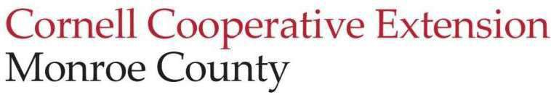
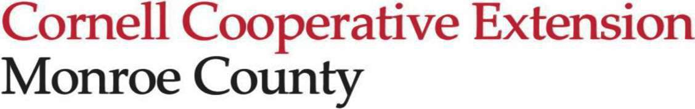
Education Center
2449 Saint Paul Blvd
Rochester, NY 14617
t. (585) 753-550
f. (585) 753-560
e. monroe@cornell.edu http://cce.cornell.edu/monroe

Executive Committee Meeting Minutes
01/26/2026 4:30 pm
CCE Monroe Conference Room| Zoom

Attendance:
Melissa Brown, Henry Huang (video), Andrea Lista, Ann Marie Purdy, Sandhya Sarlashkar (video), Marita Smith

Call to Order and Opening Remarks
Melissa welcomed everyone back and called the meeting to order at 4:34 pm.

Old Business:
The executive committee did not meet in December. Henry motioned to approve the November minutes. Sandhya seconded the motion, which passed unanimously.

New Business:
- Executive Director Update
  - Today’s meeting will focus on organization. Andrea went over the agenda for this evening’s full board meeting.
  - Our new legislative representative is Dave Long. He’s an Irondequoit resident and very supportive of CCEM.
  - Diligent work has been put into the budget to make sure it reflects the work everyone is doing.
  - Andrea will attend the SBN meeting tomorrow in Wyoming County.
  - Albany next week to discuss funding with our representatives.
  - Melissa and the Funding Contingency Committee met yesterday. The Bridge the Gap (BTG) goal was exceeded. It was decided that the fundraising momentum will continue.

- President/Board/Committee Updates
  - There was discussion about potential committee assignments, which Melissa will discuss with the new members before making them official.
  - There will be a future conversation about a program advisory committee.
  - The budget does not include BTG funds at this time.
  - Sandhya gave updates from today’s Governance meeting, including Board member attendance at meetings, a roles and responsibilities matrix, and an events/professional development calendar suggested by Sam.

Adjournment:
- Sandhya motioned to adjourn at 5:15 pm; Marita seconded.

Meeting minutes respectfully submitted by Marita Smith, Board Secretary.
.

