News Release
For Immediate Release CONTACT: Andrew Graham
January 23, 2026 845-344-1234 /acg239@cornell.edu

Community Members Gather in Port Jervis to Learn About Flood Preparedness and Launch the Sunflower City Project

Middletown, NY — More than 35 community members gathered on January 16 at RH Smith Mercantile in Port Jervis for an interactive showcase highlighting local efforts to better understand and prepare for flooding. The event marked the culmination of months of work by a small community climate action group and increased public awareness about flood risk, preparedness, and nature-based solutions.

During the evening, attendees explored floodplain and risk maps provided by the Open Space Institute, which helped guide this initiative and helped them gain a clearer understanding of how flooding affects different areas of Port Jervis and why proactive planning is critical. Many participants shared that seeing the maps helped them better visualize their own vulnerability and the importance of community-wide preparation.

The event featured several hands-on demonstrations designed to make flood science accessible to people of all ages and backgrounds. One demonstration showed how water pools and moves through clay-type soil, a common soil type in the region, helping explain why certain areas are more prone to standing water and flooding. Another demonstration highlighted how sensors can be used to detect rising water levels and provide early warning during flood events.
In addition to the technical learning, the evening centered community voices and their lived experiences through recordings of personal memories of past flooding events in Port Jervis. These stories will help preserve local knowledge while informing future resilience and preparedness efforts.

The showcase also introduced the Sunflower City Project, an innovative and community-driven initiative launched by the climate action group to reduce flooding through creative, nature-based approaches. The project demonstrates how residents, regardless of age or prior expertise, can play a role in addressing local climate challenges by planting sunflowers. Plants with deep, strong root systems, like sunflowers, help break up soil and improve water absorption.
Held in an open, welcoming setting with food and conversation, the free event emphasized connection, learning, and collective action. Organizers hope the showcase inspires continued engagement and empowers more residents to take part in shaping a flood-resilient future for Port Jervis.

This work is funded by Orange and Rockland Utilities to support Cornell Cooperative Extension in building community resilience in Orange County. For more information about the Sunflower City Project, visit www.sunflowercity.org. To learn about upcoming community resilience activities, please contact Dr. Julika von Stackelberg at jv426@cornell.edu

Cornell Cooperative Extension and its partnerships provide programs for Orange County residents on youth and family development; nutrition, health, and food safety; community and economic vitality; and agricultural sustainability through Cornell based research. Committed to Orange County, we design programs to meet local needs to enable people to improve their lives and communities. For more information call Cornell Cooperative Extension Orange County at 845-344-1234 or visit our website at www.cceorangecounty.org.
Cornell Cooperative Extension Orange County provides equal employment and program opportunities.
###
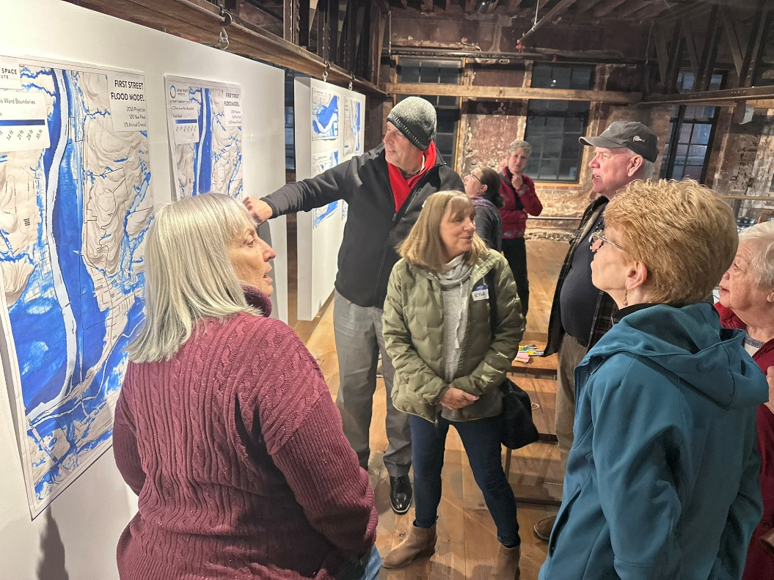
Port Jervis residents looking at flood maps
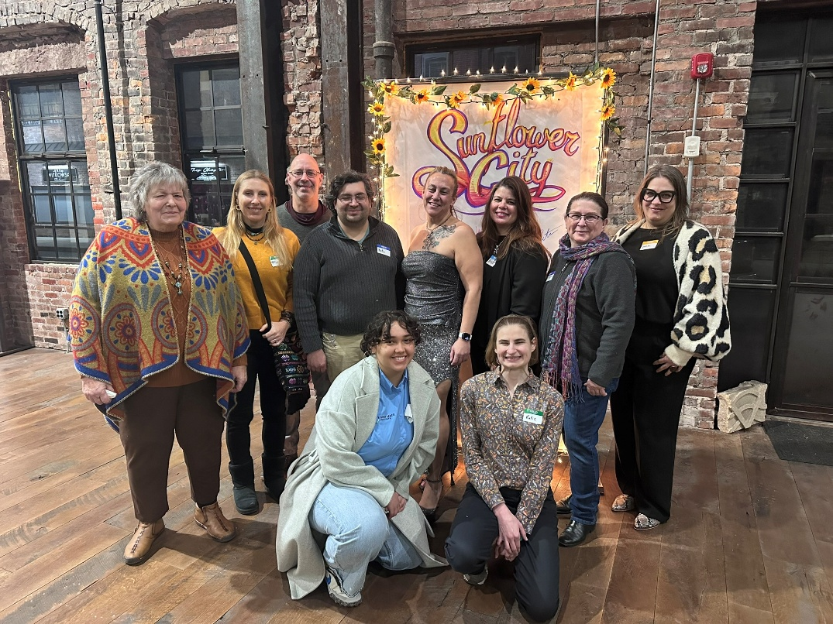
The Port Jervis Climate Action Group

