News Release
For Immediate Release CONTACT: Andrew Graham
December 8, 2025 845-344-1234 /acg239@cornell.edu

Cornell Cooperative Extension Orange County Holds 110th Annual Meeting & Awards Celebration, New Board of Directors Members Installed

Middletown, NY – Cornell Cooperative Extension Orange County celebrated their 110th Annual Meeting and Awards Celebration honoring volunteers, staff, and electing new members of the community to the Board of Directors at The Country Club at Otterkill in Campbell Hall, NY. Showcasing our achievements from 2025 were Executive Director Lucy Joyce and Board President Gordon Dean.

During the business meeting portion of the evening, Orange County residents were elected to the Board of Directors. Elected to serve on the Board of Directors for 2026: Amy Minutolo, Edwin Estrada, Jill Marie, David Goggins, Mingjia “Jacky” Guan, Tiffany Chapman, and Diane Aboushi Saleh. Each new Board of Directors electee will serve three-year terms with the organization.

During the awards portion of the evening, Richard Mayfield, a former Board Member and Volunteer was given the “Distinguished Service” Award for his years of service to CCE Orange County. The “Friend of Extension” Award was given to Dave & Kim LeBlanc for all their contributions to our organization during this year and beyond. Exceptional Volunteers were also celebrated for hard work and dedication to CCEOC. Thank you to Cecille Jones, Gary Johnson, Bob Nywening, Megan Wieboldt, Doug Carter, and Wendy Nocar. Each of our volunteer honorees were nominated by their peers and CCE Orange County Staff.

“The Annual Meeting and Awards Presentation is a great occasion to share the positive impact of CCE Orange County’s programs,” said Lucy Joyce, CCE Orange County Executive Director. “It also gives us an opportunity to acknowledge our community members and celebrate the individuals who help carry our mission forward—thank you for your continued support.”

Cornell Cooperative Extension and its partnerships provide programs for Orange County residents on youth and family development; nutrition, health, and food safety; community and economic vitality; and agricultural sustainability through Cornell based research. Committed to Orange County, we design programs to meet local needs to enable people to improve their lives and communities. For more information call Cornell Cooperative Extension Orange County at 845-344-1234 or visit our website at www.cceorangecounty.org.
Cornell Cooperative Extension Orange County provides equal employment and program opportunities.
###

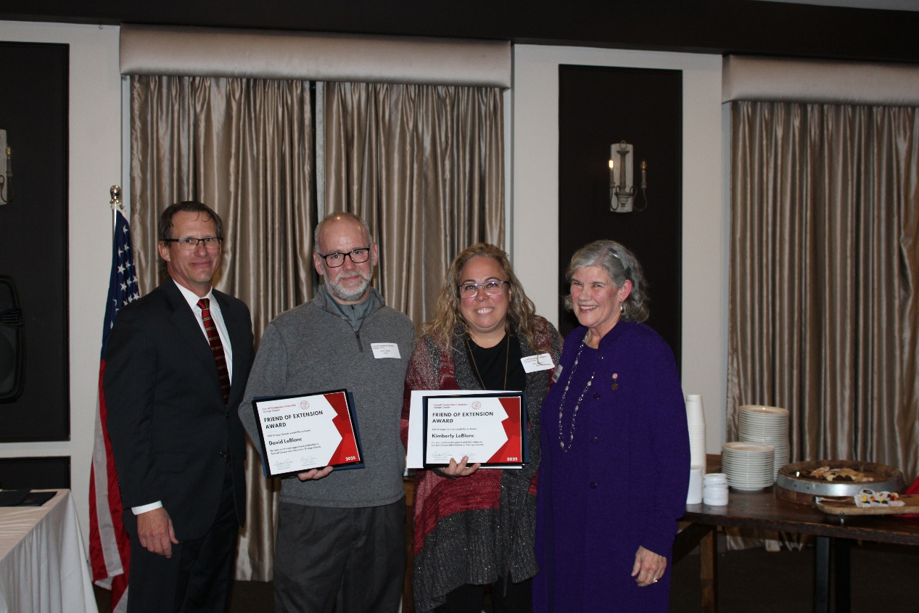
Photo Caption: (From Left to Right: Gordon Dean, Dave LeBlanc, Kim LeBlanc, and Lucy Joyce)

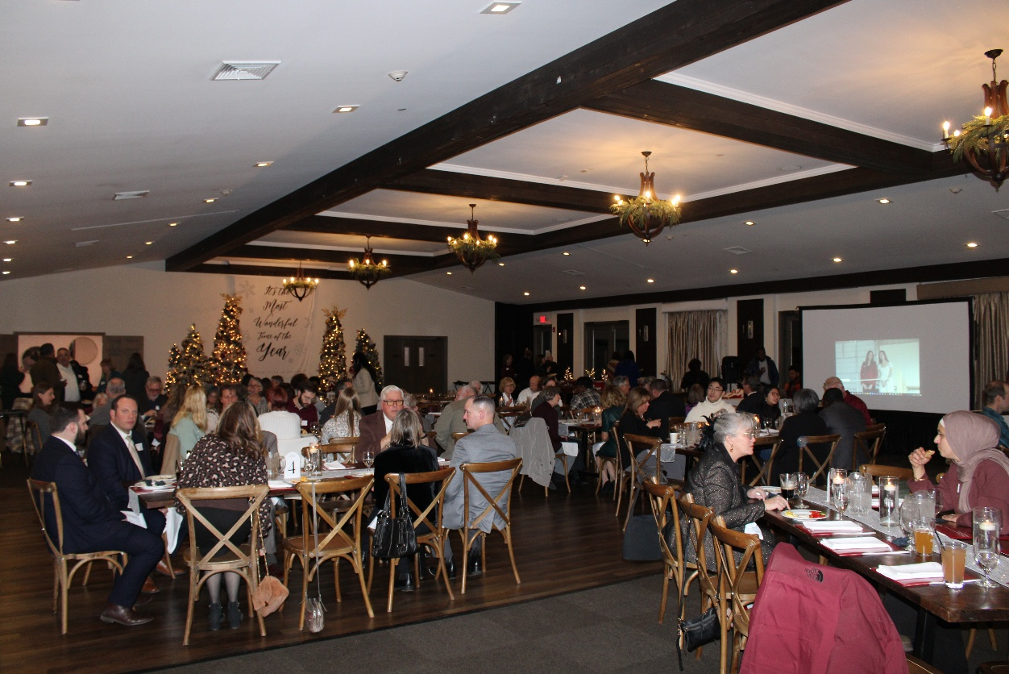
Photo Caption: CCE Orange County Annual Meeting & Awards Celebration at The Country Club at Otterkill

