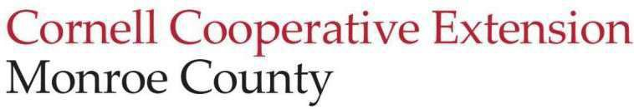
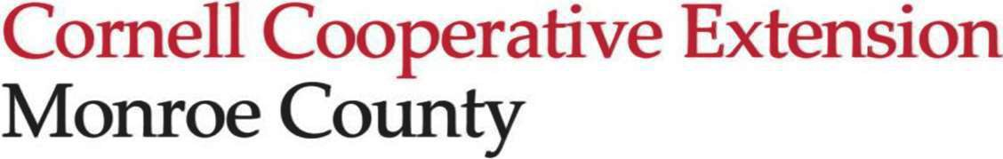
Education Center
2449 Saint Paul Blvd
Rochester, NY 14617
t. (585) 753-550
f. (585) 753-560
e. monroe@cornell.edu http://cce.cornell.edu/monroe

Board Meeting Minutes
12/11/2025 5:30 - 7:00 pm
CCE Monroe Conference Room| Zoom

Attendance: Steve Brew, Melissa Brown, Theresa Cimino, Henry Huang, Barbara James, Josh Knoblock (video), Gabbie Krawiec, Andrea Lista, Wiley Little (video), Patrick Meredith (video), Chris Murray (video), Ann Marie Purdy, Branden Raczkowski(video), Aron Reina (video), Marita Smith

Absent: Sam Beck-Andersen, Sandhya Sarlashkar, Renee Smith Mooneyhan

Call to Order & Introductory Remarks:
Melissa called the meeting to order at 5:33 pm. A quorum was present.

Old Business

Marita moved to approve the November meeting minutes; Theresa seconded. There was no discussion. Aron, Wiley, and Gabbie abstained. The motion carried.

New Business
- Executive Director Report
  - Roc the Day yielded $750.
  - The state informed Wayne County $90,000 in unspent money earmarked for our region can be used to continue SNAP through the end of April. This is great news but staff continues to develop contacts and create new contracts because they will be needed on May 1, 2026.
  - Theresa moved to approve the 2026 Board meeting schedule as presented. Marita seconded the motion. The motion carried unanimously.

- Board Committee Reports
  - Executive
    - The committee did not meet today. will focus on program advisory committees in 2026.
    - The Board reviewed the proposed 2026 holiday schedule. Barb moved to approve the schedule; Henry seconded. There was discussion concerning holiday changes due to mandates however, employers make their own decisions about schedules. The motion carried unanimously.

    - Theresa moved to approve the 2026 Board meeting schedule as presented. Marita seconded the motion. The motion carried unanimously.

  - Finance (Henry)
    - Our current cash balance is lower than last year but we are actively collecting several large receivables, including the Monroe County appropriation and the Food Insecurity Project funds.
    - Deferred revenue, currently at $118,346, should be at about $150,000. The balance reflects two months of the county appropriation and a deposit from the Avangrid project.
    - Our current ratio is 2.05, which is lower than last month but last month was extremely high. The Bridge the Gap campaign has brought in $275,000 so far so that will skyrocket our current ratio for November. All those funds will come directly to CCE Monroe.
    - Our net income for October will show a loss of $3,000-4,000, which is typical for this time of year because programs are slowing down.
    - The Finance Committee recommends that the Board approve interim spending from now through, when the full budget receives approval. Aron moved; Barb seconded. The January 2025 financials were shared to show that it’s typically a slow month with spending because new grants are starting and others don’t end in January. Steve asked what percentage of the budget comes from grant funding. Andrea explained that 35% of the budget comes from county, state, and federal government, at least 50%, possibly 60%, is from grants, and the balance is from donor developments and fee-for-service. The motion carried unanimously.
    - Henry asked for a motion to approve the 2026 staff salary increases. Marita moved and Barb seconded. Andrea explained that CCE, as a state system, uses a broadband chart to classify positions and determine comparable pay rates across similar organizations. Cornell asks the extensions to target a range for 25% - 40%. Anyrate below 25% is considered noncompetitive. The CCE Monroe minimum is 35% but more than that, especially for staff who has been in the position more than 2 years. Melissa and Andrea met and presented an amount to the Finance Committee. The motion carried unanimously.
    - The committee needs another member, so contact Henry.

  - Governance (Melissa)
    - Board member introductions at meetings will begin in 2026.
    - The committee is working on board member requirements for in-person attendance at meetings, including the annual meeting.
    - Everyone will receive the BoardSource credentials.
    - There is a need for new committee members.

  - Strategic Planning (Theresa)
    - There is a need for additional people on this committee because they currently only have two.

  - Nominating (Branden)
    - They did not have an official meeting but they have a 2026 project in the works.

  - Legislative Update (Steve)
    - The 2026 County budget passed. It contains many good elements.
    - Kudos to Pat and his team for the marvelous job they did in remodeling the Church Lodge at Churchville Park and having it ready in time for the Wreaths Across America project that lays 600 wreaths on veterans’ graves.
    - As he leaves his position, Steve shared he will miss the administration and the people he served with, and gave final thoughts on his impact on the legislature.

  - Monroe County (Patrick)
    - The County plans to build an ADA accessible sidewalk at the Church Lodge next year. This will make it easier for patrons to reach the lodge from the parking lot and the detached restrooms.
    - The holiday display at the Conservatory will be open until mid-January.

- Board Recognition
  - On behalf of the Board, Andrea and Melissa thanked Aron, Barb, and Steve and expressed appreciation for their commitment. We will miss their contributions and wish them well.

Reminders/Upcoming Dates:
- Next meeting Thursday, January 22, 2026
- Board Orientation, January 10, 2026
- See h ttps://monroe.cce.cornell.edu/events for more upcoming events

Adjournment:
- Barb motioned for adjournment; Aron seconded. The motion carried unanimously. The meeting adjourned at 6:52 pm.

Minutes respectfully submitted by Marita Smith, Board Secretary.
.

