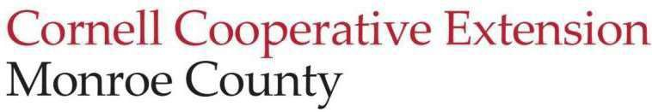
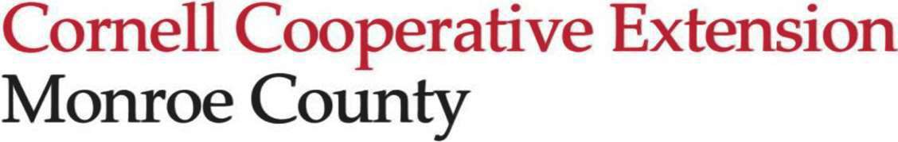
Education Center
2449 Saint Paul Blvd Rochester, NY 14617
t. (585) 753-550
f. (585) 753-560
monroe@cornell.edu http://cce.cornell.edu/monroe

Cornell Cooperative Extension of Monroe County
Executive Committee Meeting – 11/20/2025
2249 St. Paul Blvd & Zoom | 4:30pm - 5:30pm

Attendance
Melissa Brown, Henry Huang (video), Andrea Lista, Ann Marie Purdy, Sandhya Sarlashkar, Marita Smith (absent)

Call to Order and Opening Remarks
Melissa called the meeting to order at 4:49 pm.

Old Business
- The September Board Meeting Minutes were reviewed. Henry moved for approval of the September minutes; Melissa seconded the motion. There was no discussion. The motion carried. The Executive Committee did not meet in October due to the annual meeting.

New Business
- President Updates (Melissa)
  - The Executive Director's Conferral of Title is today. Melissa explained the process and how it will work in this evening’s meeting. The CCE accreditation process occurs every four years and includes an accreditation checklist and a 360 survey. Andrea will introduce some exciting plans during her presentation.
  - Some big contingency funding donations have come in, including a large gift from the Krall Family Foundation. Other major gifts have come in from the community in direct response to board members' outreach efforts. It is anticipated that year-end donations, including Roc the Day, will increase funds coming in. We will have a better idea of Bridge the Gap giving in January.
  - Board Orientation will be in January. In-person attendance is preferred,
  - Henry informed us that he will request approval to move the full budget meeting, usually held in December, to the January organizational meeting. This will allow more time for the review of the budget before presenting it to the board.

Adjournment
Henry moved to adjourn the meeting at 5:20 pm; Sandhya made the second. The motion carried.

Minutes respectfully submitted by Marita Smith, Board Secretary

