News Release
For Immediate Release CONTACT: Andrew Graham
October 30, 2025 845-344-1234 /acg239@cornell.edu

5th Annual Sunflower Growing Competition Winners

Middletown, NY – Cornell Cooperative Extension Orange County held its 5th Annual Sunflower Growing Competition this year. Sunflower seeds along with instructions on how to plant their seeds and care for their plants were distributed to over 750 youth ages 5-19 in May and June. Participants submitted photos and measurements of their sunflowers and were judged on the height of the plant and the diameter of the bloom.
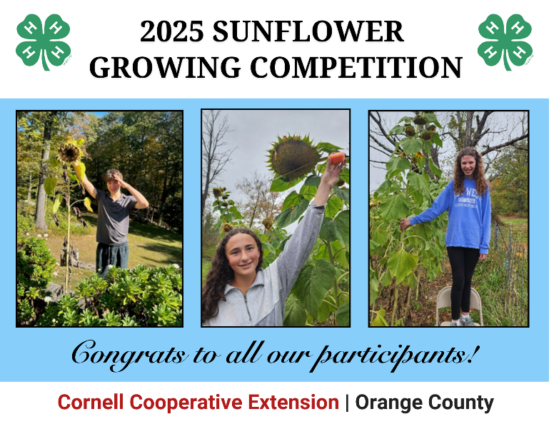
This year’s winner are:

Tallest Sunflower – 8 feet 5 inches
- Samantha C.

Largest Bloom – 13 inch diameter
- Lucy R.
This year’s winners will receive a Window Gardening Herb Kit so they can continue growing things this winter!
Registration for our 6th Annual Sunflower Growing Competition will be in May 2026 and is open to all Orange County youth ages 5-19.
To learn more about upcoming 4-H Programs please check us out on Facebook (https://www.facebook.com/youthprograms.4H.cceorangecounty) or visit our website at https://cceorangecounty.org/4-h-youth

Cornell Cooperative Extension and its partnerships provide programs for Orange County residents on youth and family development; nutrition, health, and food safety; community and economic vitality; and agricultural sustainability through Cornell based research. Committed to Orange County, we design programs to meet local needs to enable people to improve their lives and communities. For more information call Cornell Cooperative Extension Orange County at 845-344-1234 or visit our website at www.cceorangecounty.org.
Cornell Cooperative Extension Orange County provides equal employment and program opportunities.
###

