News Release
For Immediate Release CONTACT: Andrew Graham
October 3, 2025 845-344-1234 /acg239@cornell.edu

Appreciating the Extraordinary Master Gardener Volunteers of
Cornell Cooperative Extension Orange County for their 2024 Service

Middletown, NY – On September 20, 2025 Cornell Cooperative Extension (CCE) Orange County celebrated our dedicated Master Gardener Volunteers for all their work in 2024. Our 89 Master Gardener Volunteers contributed a total of 7780 hours of service. We also had 16 Master Gardener Volunteer Trainees complete over 100 hours of training. In 2024, a volunteer hour in New York state was valued at $38.48 meaning that together they contributed over three-hundred and sixty thousand dollars ($360,943) worth of time to Cornell Cooperative Extension Orange County.

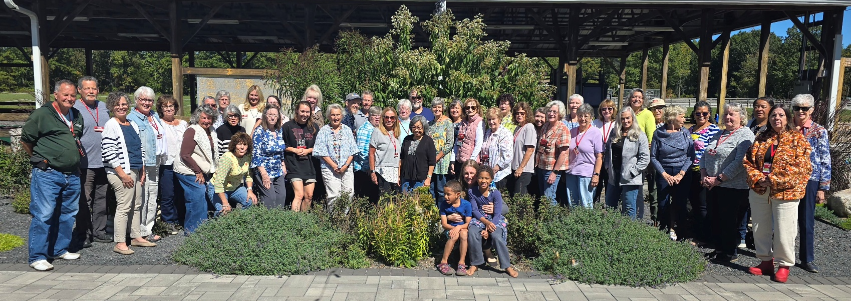
Community Horticulture Educator Susan Ndiaye, who leads the Master Gardener Volunteer Program and Program Coordinator Katy Boula, her assistant, presented all the awards during the event at our Education Center and 4H Park in Otisville, NY. “Working with the Master Gardener Volunteers is a joy! They are extraordinary individuals who dedicate so much time giving back to their community. It’s truly amazing!” said Ms. Ndiaye
To learn more about the Master Gardener Volunteer Program and our upcoming events, please visit our website at: http://cceorangecounty.org/gardening.

Stand-Out Master Gardener Volunteers | Award
Karen Heil | All-In Award
Donna Beyer, Renee Stover | Big Hearted Award
Lynn Cheney, Patti Martellaro | Cross Pollinator Award
Edie Sherman | Energizing and Inspiring
Cecelia Lillard, Mary Pobedisnky | Mentorship Award
Judy Boyd-Persen | Silen Superstar Award

Master Gardener Volunteers | Award Level Achieved | Cumulative Service Hours
Mary Harnick, Cecelia Lillard, Lorie Lotito, Doug Milne | Senior | 1250
Janis Cortright | Shovel | 4500
Gerda Krogslund, Brooke Moore | Magnolia | 4000
Lisa Rittweger, Edie Sherman | Acorn | 3500
Jarna Maniguet | Oak Leaf | 2500
Claudine Sullivan | Purple | 1500
Cecille Jones, Kathleen Welshoff | White | 750
Dennis Fanton, Linda Gayton, Arnold Kornbluth | Blue | 500
Lynn Cheney, Bettye Hill, Deanna Neiger, Mary Pobedinsky, Gigi Sobiech Swales, Bonnie Walker | Red | 250
Doug Carter, Nina Fraas, Laura Gordon, Kathy Kenny, Michele Lawrenson, Cee Major, Angelina Rivera, Dianne Wilder | Green | 100
Michele Lawrenson, Cecille Jones, Mary Pobedisnky | Gold Star | New Advisory Committee Members

Cornell Cooperative Extension and its partnerships provide programs for Orange County residents on youth and family development; nutrition, health, and food safety; community and economic vitality; and agricultural sustainability through Cornell based research. Committed to Orange County, we design programs to meet local needs to enable people to improve their lives and communities. For more information call Cornell Cooperative Extension Orange County at 845-344-1234 or visit our website at www.cceorangecounty.org.
Cornell Cooperative Extension Orange County provides equal employment and program opportunities.
###

