News Release

For Immediate Release CONTACT: Andrew Graham

September 16, 2025 845-344-1234 /acg239@cornell.edu

**CCE Orange County’s 10th Annual Bountiful Harvest Celebration Fundraiser Celebrates Old and New**

**Middletown, NY** – On Friday, September 12, Cornell Cooperative Extension (CCE) Orange County held their 10th Annual *Bountiful Harvest Celebration* fundraiser out at the Education Center & 4-H Park in Otisville, NY. This year’s celebration honored the growth of the Education Center & 4-H Park and past *Bountiful Harvest Celebrations*.

The evening of celebrations began with a social hour in which guests could converse and chat with each other or take a ride on a horse drawn carriage. After that, guests were then brought over to one of the main events of the evening, the “Celebrity” Cow Milking Contest. There our 4 celebrities, representing on behalf of local marketing businesses, went head-to-head with each other to see who would win the famous Blue Ribbon prize for most milk milked. This year’s Cow Milkers included Lagwana Tyler from *Mediacom*, Josh Sommers from *Focus Media*, Kayla Lloyd from *BBG&G Integrated Marketing*, and Paul Harrington from *WALL Radio*. Kayla Lloyd from *BBG&G Integrated Marketing* took home the title with 16 oz. of milk in her bucket, while Josh Sommers from *Focus Media* earned top fundraiser honors, collecting nearly **$5,000** in his virtual milk bucket. Altogether, the contestants raised an incredible $8,000 to support CCE Orange County.

“We are deeply grateful to our incredible cow milkers for bringing so much energy and heart to this fun tradition—and to Chris Van Aken of Van Aken Dairy, whose generosity in providing the cows makes this community favorite possible year after year. Their support embodies the true spirit of agriculture, community, and giving back.” Said Lucy Joyce, CCE Orange County Executive Director.

Following the cow-milking contest, guests gathered to watch a short video—produced by EC Media Group, LLC—highlighting the rich history of Bountiful Harvest and the vital role the event plays in supporting the ongoing growth of the Education Center & 4-H Park.

Adding to the evening’s excitement, NYS Senator James Skoufis joined us in person to present $800,000 in funding from the Dormitory Authority of New York State for continued infrastructure improvements at the 4-H Park. We are honored and deeply grateful for Senator Skoufis’ steadfast support and investment in the future of our Education Center & 4-H Park, which will directly benefit local youth, families, and the agricultural community for years to come.

Guests then enjoyed a farm-to-table dinner prepared by Country Courtesy Catering, featuring a menu brimming with locally sourced favorites—many proudly grown by farmers right here in Orange County. The evening concluded with a thrilling live auction, led by Walden Savings Bank’s Derrick Wynkoop, where spirited bidders competed for an array of exceptional auction items.

CCE Orange County’s own Master Gardener Volunteers helped create a festive atmosphere for all attendees by designing and installing cheerful décor throughout the outdoor barns and walkways. Guests even had the opportunity to purchase some of the decorations at the end of the evening.

A heartfelt thank you goes out to the generous sponsors of this year’s *Bountiful Harvest Celebration*. For 10 years, their support makes events like this possible, allowing us to bring the community together for an evening filled with joy, connection, and festive charm. A special thank you to Walden Savings Bank, First Federal Savings of Middletown, Orange Bank & Trust, Mid-Hudson Valley Federal Credit Union, and Crist Bros. Orchard for their generous sponsorships. To see a full list of all those who sponsored this event, visit <http://bit.ly/4n0G12x>

The Education Center & 4-H Park is located at 300 Finchville Turnpike in Otisville. The Park has Three open pole barns, an enclosed pole barn, bathroom facility, and large outdoor horse arena are already completed. To learn more, schedule a tour, or pledge financial support for the new Center, contact Jill Van Aken at 845-344-1234 or email at [jd863@cornell.edu](mailto:jd863@cornell.edu). Visit our website at [www.cceorangecounty.org](http://www.cceorangecounty.org) for more fundraising updates and to donate.

*Cornell Cooperative Extension and its partnerships provide programs for Orange County residents on youth and family development; nutrition, health, and food safety; community and economic vitality; and agricultural sustainability through Cornell based research. Committed to Orange County, we design programs to meet local needs to enable people to improve their lives and communities. For more information call Cornell Cooperative Extension Orange County at 845-344-1234 or visit our website at* [*www.cceorangecounty.org*](http://www.cceorangecounty.org)*.*

*Cornell Cooperative Extension Orange County provides equal employment and program opportunities.*

###

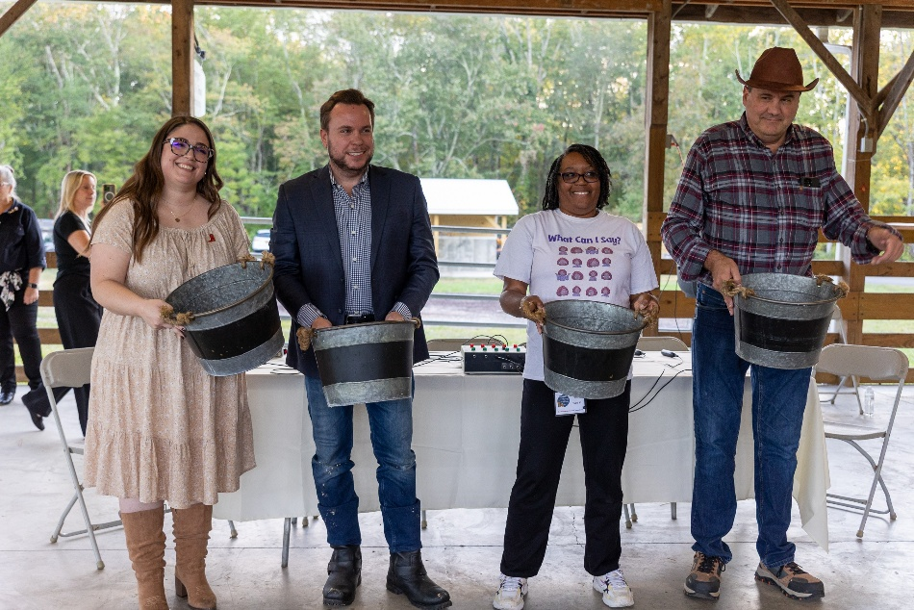

*Photo Caption: This year’s Celebrity Cow Milkers! (From Left to Right: Kayla Lloyd, Josh Sommers, Lagwana Tyler, Paul Harrington)*

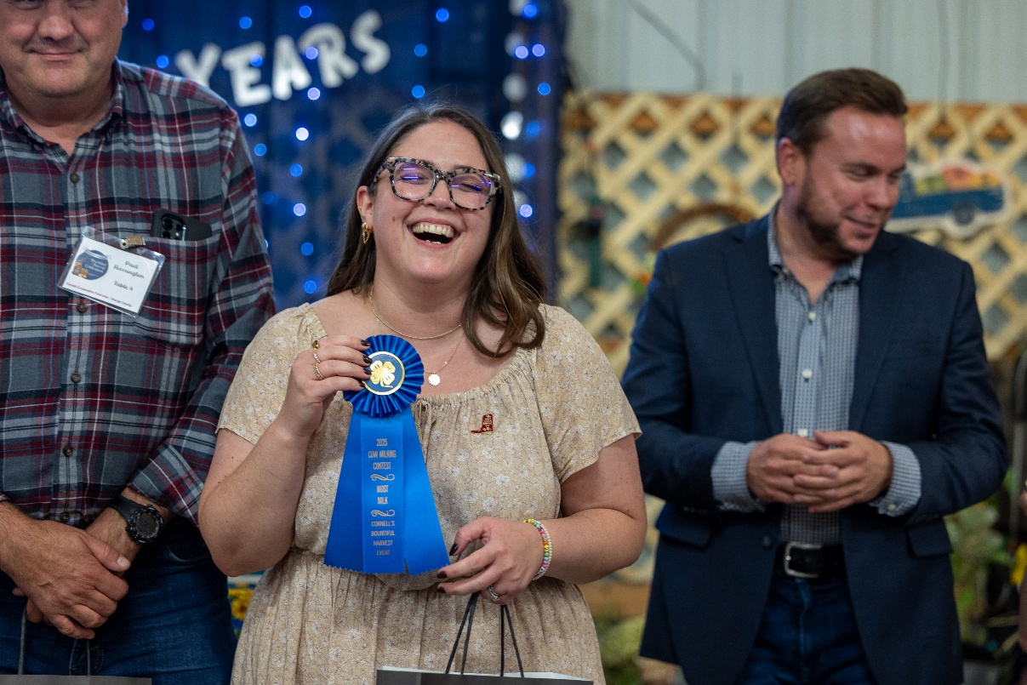

*Photo Caption: This year’s Celebrity Cow Milker Blue Ribbon Winner, Kayla Lloyd from BBG&G Integrated Marketing*