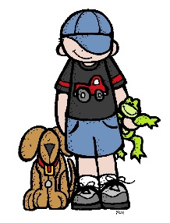Chenango County 4-H

Cloverbud Pet Care Project Record

My project is:

You must complete 1 project record for each pet in this project area.

Name ___________________________ Age _____Project Year________

Address_________________________________________________

Club____________________________________________________

Club Leader______________________________________________

Member Signature ________________________________________

Leader or Parent Signature__________________________________

Project Picture

Attach 1 or 2 pictures of your animal(s). You may attach another sheet of pictures if you want.

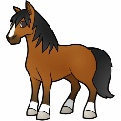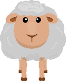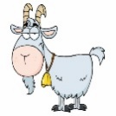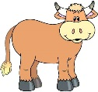

 Page 2

My pet is a __________________.Its name is __________.

It is _____ years old. I have had my pet since __________.

**I feed my pet:**

Write or draw a picture of what you feed your pet ________.

**Work with your animals**

Put an ‘x’ next to the things you did with your pet. In empty space you can add something not on list.

|  |  |  |  |
| --- | --- | --- | --- |
| Taught to lead |  | Brushed my animal |  |
| Fed my animal daily |  | Bathed my animal |  |
| Washed food dish |  | Watered my pet |  |
| Taught my animal tricks |  | Cleaned up after my pet |  |
| Played with my pet |  | Gave my pet treats |  |
| Milked my animal |  | Showed my animal |  |
| Went to vet with my animal |  | Helped clip my animal |  |

Page 3

Did you have fun working with your pet? Yes / No

What was fun about working with your pet? ______________________ __________________________________________________________

What was hard to do with your pet? ____________________________

__________________________________________________________

Learn all you can about your animal.

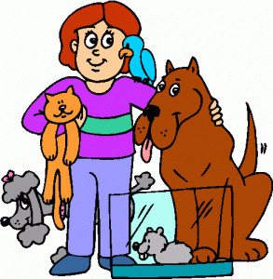Don’t forget to take good care of your pets!



If you’d like you can write a little story about your pet or draw a picture of you and your pet on the back of this page.