**For Immediate Release**

Contact: Lynn Bliven

Cornell Cooperative Extension, Allegany County

Phone: (585) 268-7644 ext. 18

Email: [lao3@cornell.edu](mailto:lao3@cornell.edu)  
July 16, 2025

ANGELICA, NEW YORK – **2025 Allegany County Fair Youth Dairy Show Results**Lynn Bliven, Agriculture & Natural Resources Issue Leader

On Wednesday, July 16th the Allegany County Fair held the Youth Dairy Show. This year’s show opened with meet and greet with the judge, Casey Arlig from Houghton, NY.

Beginning the show with Senior Showmanship division first place blue to Morgan Holcomb from Friendship, NY followed by Natalie Burrows from Cuba, NY; Abigail Morton Caneadea, NY; Jim Eshelman Scio, NY; Shaelynn Eddy Cuba, NY; and Riley Blarr of Belmont.

In our Junior Showmanship division, Bentley Foster Friendship NY received a blue ribbon followed by Cooper Hunt from Bolivar, NY and Lily Morton of Scio, NY. For the Novice division receiving blue ribbons Tinsley Foster Friendship, NY, and Damilynn Morton of Scio, NY.

Winners in Each of the showmanship divisions received a halter sponsored by Zane Covert. The top 2 from each division competed for Master Showmanship. This year’s winner Morgan Holcomb received a director’s chair sponsored by The York Agency, Lester York. Reserve Master Showman, Natilie Burrows, received a bucket of grooming supplies sponsored by Zane Covert.

Following the showmanship breed classes were held. Highlights for these classes:

Award Sponsor Recipient

Grade Junior Champion Chet & Donna Greene Cooper Hunt

Grade Reserve Junior Champion Hillcrest Homestead Damilynn Morton

Ayrshire Junior Champion Dave’s Printing Morgan Holcomb

Ayrshire Reserve Junior Champion Zane Covert Natalie Burrows

Guernsey Junior Champion Zane Covert Jim Eshelman

Holstein Junior Champion Kim Shaklee & Janice Brown Cooper Hunt

Holstein Reserve Junior Champion Hillcrest Homestead, LLC Bentley Foster

Jersey Junior Champion Kim Shaklee & Janice Brown Shaelynn Eddy

Jersey Reserve Junior Champion Dave’s Printing Abigail Morton

Brown Swiss Junior Champion Kim Shaklee & Janice Brown Morgan Holcomb

Brown Swiss Res Junior Champion Allegany County Farm Bureau Shaelynn Eddy

Lineback Junior Champion Country Crossroads Feed & Seed Riley Blarr  
Lineback Grand Champion Dave’s Printing Riley Blarr

Ayrshire Senior Champion Country Crossroads Feed & Seed Natalie Burrows

Guernsey Senior Champion Allegany County Pomona Grange Jim Eshelman

Guernsey Res. Senior Champion Zane Covert Jim Eshelman

Jersey Senior Championship Center Vu Farm Morgan Holcomb

Jersey Reserve Senior Champions Kim Shaklee & Janice Brown Shaelynn Eddy

Holstein Senior Champion Hillcrest Homestead LLC Abigail Morton

Holstein Reserve Senior Champion Chet & Donna Green Riley Blarr

Brown Swiss Senior Champion Kim Shaklee & Janice Brown Abigail Morton

Brown Swiss Res. Senior Champion Zane Covert Abigail Morton

Grade Grand Champion Allegany County Farm Bureau Cooper Hunt

Grade Reserve Grand Champion Willcara Farm Damilynn Morton

Ayrshire Grand Champion Dave’s Printing Morgan Holcomb

Ayrshire Reserve Grand Champion Country Crossroads Feed & Seed Natalie Burrows

Guernsey Grand Champion Country Crossroads Feed & Seed Jim Eshelman

Guernsey Reserve Grand Champion Kim Shaklee & Janice Brown Jim Eshelman

Holstein Grand Champion Hillcrest Homestead, LLC Abigail Morton

Holstein Reserve Grand Champion Allegany County Farm Bureau Riley Blarr

Jersey Grand Champion Willcara Farm Shaelynn Eddy

Jersey Reserve Grand Champion Allegany County Farm Bureau Morgan Holcomb

Brown Swiss Grand Champion Willcara Farm Abigail Morton

Brown Swiss Res Grand Champion Allegany County Pomona Grange Abigail Morton

Supreme Champion – Browm Swiss The York Agency, Lester York Abilgail Morton

Best Breed and Owned Cheyenne Wolfer Memorial Riley Blarr’s Holstien

Dairy Herd – 1st place Friendship Everlasting 4-H Club   
Club Herd – 1st place Friendship Everlasting 4-H Club

We want to thank our judge, Casey Arlig. She owns and operates Lakeview Genetics where she focuses on Ayrshire, Jersey, and Guernsey genetics but believes a good cow can come in any color. Casey has shown cattle for 25years and has judged in 8 countries with 4-H and college level teams. She also is an animal science teacher at C.G. May BOCES center. Casey says 4-H will take you places and to cherish every memory you make!

Youth shows at the fair are one of many programs offered by Cornell Cooperative Extension of Allegany County (CCE-Allegany). The association is part of the national cooperative extension system, an educational partnership between County, State, and Federal governments. As New York’s land grant university Cornell administers the system in this state. For more information, call 585-268-7644 or visit our website at www.cce.cornell.edu/allegany. Cornell Cooperative Extension provides equal program and employment opportunities.

Photo Credit; Lynn Bliven

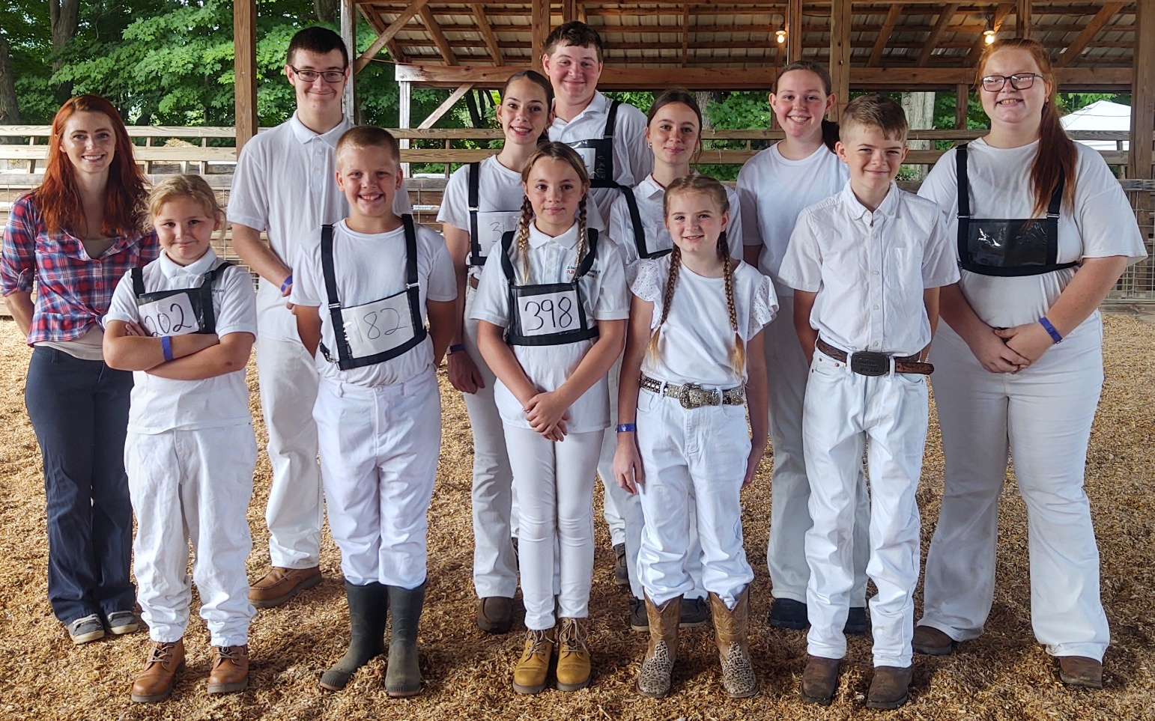

Photo caption: Youth dairy exhibitors with judge Casey Arlig (Front row: Damilynn Morton, Cooper Hunt, Lily Morton, Tinsley Foster, Bentley Foster. Back: Casey Arlig, Riley Blarr, Abigail Morton, Jim Eshelman, Morgan Holcomb, Shaelynn Eddy, Natalie Burrows)

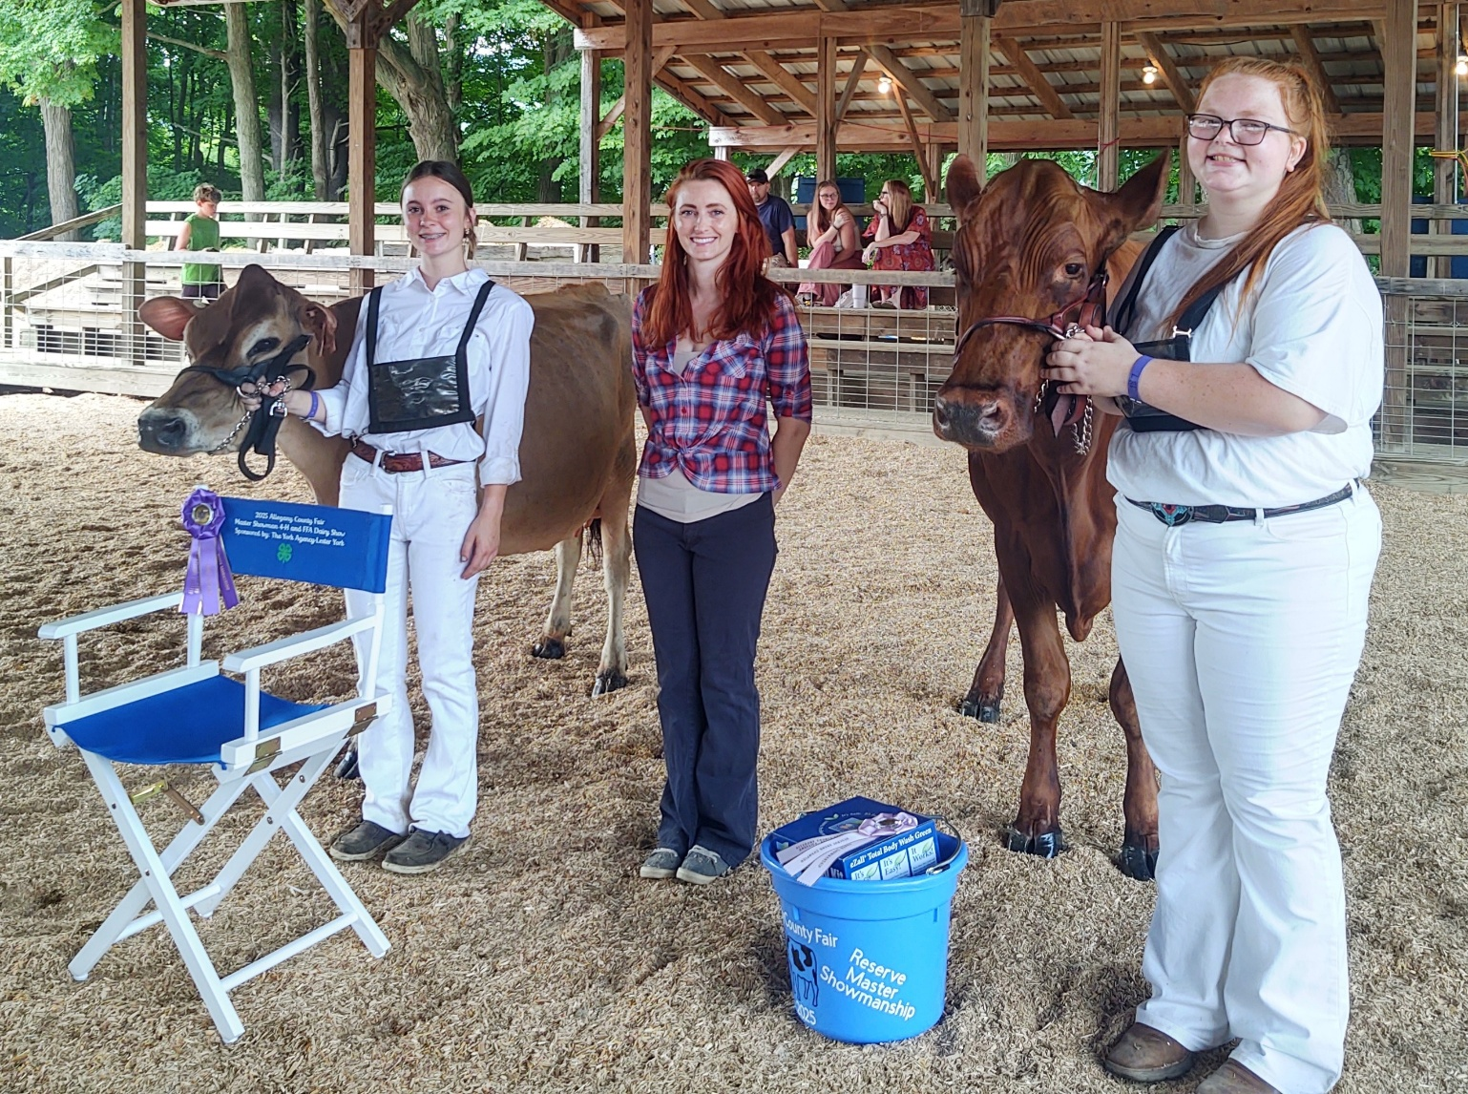

Master Showmanship Winners (Left to Right) Master Showman Morgan Holcomb, Judge Casey Arlig, Reserve Master Showman Natalie Burrows.

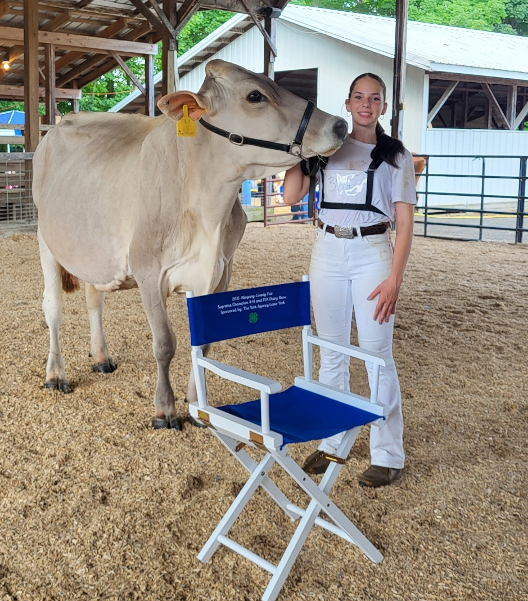

Supreme Champion of the 2025 Show, Brown Swiss exhibited by Abigail Morton.