**2025 Allegany County Fair Youth Sheep Show Results**Lynn Bliven, Agriculture & Natural Resources Issue Leader

Tuesday, July 15th youth exhibitors showed off their sheep projects at the Allegany County Fair. The contest is an opportunity to be rewarded for the months of hard work caring for and training their animals.

In the Senior Showmanship division, Sarah Wilson Dansville, NY received a blue ribbon along with a banner sponsored by Bob & Donna Wilson, Canaseraga, NY. Second blue to Collin Wilson Dansville, NY followed by Jim Eshelman Scio, NY; Shane Ploetz Cuba, NY: and Ben Eshelman Scio, NY.

For Junior Showmanship Brenden Wilson topped the class followed by Faith Wilson, and Garret Ploetz; all receiving blue ribbons. Brenden received a banner sponsored by Bob & Donna Wilson, Canaseraga, NY.

Novice Beverly Ploetz received a blue ribbon along with a banner sponsored by Bob & Donna Wilson and harness sponsored by the Cuba Hometown Fitness.

The top from each division competed for Grand Champion Showman. This year’s grand winner Sarah Wilson and Reserve Grand Champion Showman, Brendon Wilson. Both received a banner sponsored by Bob & Donna Wilson, Canaseraga.

Two market lamb divisions in the show, with all lambs receiving blue ribbons. In the medium weight first to Sarah Wilson, followed by Brenden Wilson, Shane Ploetz, Sarah Wilson, Collin Wilson, and Faith Wilson. For the heavyweight division first place blue to Garrett Ploetz followed by Beverly Ploetz, Brenden Wilson, and Collin Wilson. Grand Champion Market Lamb sponsored by the Alco Federal Credit Union exhibited by Sarah Wilson. The Reserve Grand Champion Market Lamb sponsored by LC Whitford Company was awarded to Brenden Wilson.

Best Bred & Owned by exhibitor in the market lamb class first to Sarah Wilson and second to Brenden Wilson. Each received a cash award.

In the breeding sheep division, an excellent group of blue-ribbon stock exhibited by Ben Eshleman, Jim Eshleman, Garrett Ploetz, Brendon Wilson, Collin Wilson, and Faith Wilson, and Sarah Wilson. Grand Champion Ewe exhibited by Sarah Wilson. Grand Champion Ram exhibited by Sarah Wilson. Grand Champion Flock exhibited by Brenden Wilson Each of these championship classes received a banner sponsored by Bob & Donna Wilson, Canaseraga, NY.

This year’s judge for the show was Kirby Palmer from Cowlesville, NY. Along with her family, she raises and sells competitive show sheep across the country.

Youth shows at the fair are one of many programs offered by the 4-H Program through Cornell Cooperative Extension of Allegany County (CCE-Allegany). The association is part of the national cooperative extension system, an educational partnership between County, State, and Federal governments. As New York’s land grant university Cornell administers the system in this state. For more information, call 585-268-7644 or visit our website at www.cce.cornell.edu/allegany. Cornell Cooperative Extension provides equal program and employment opportunities.

Photo Credit: Lynn Bliven

Photo Caption: (left to right) Judge Kirby Palmer, Grand Champion Showman Sarah Wilson, Reserve Grand Champion Showman Brenden Wilson.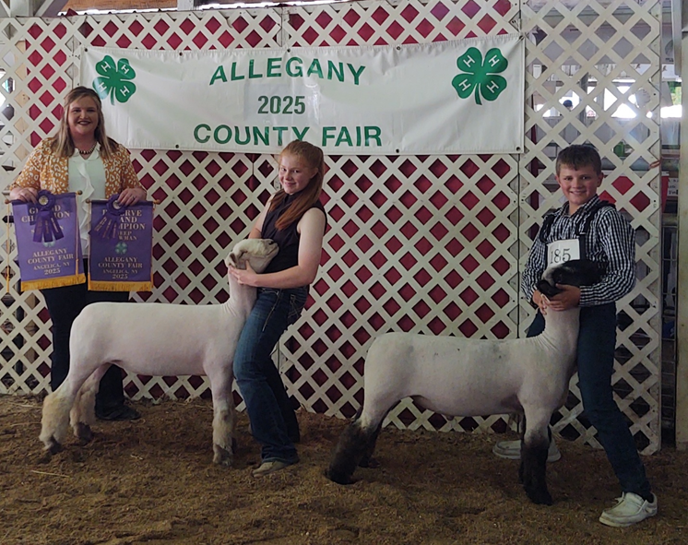

Photo Caption: (Left to right) Judge Kirby Palmer, Champion Market Lamb exhibitor Sarah Wilson, Reserve Grand Champion Market Lamb exhibitor Brenden Wilson. These lambs will be sold at the Annual Youth Market Animals Sale at 6 PM on Wednesday, July 16th.

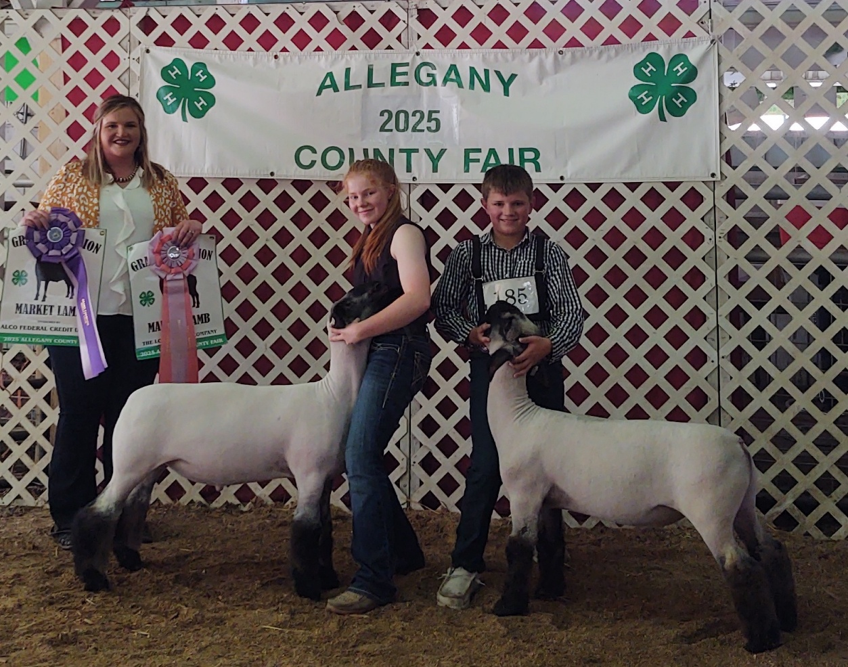

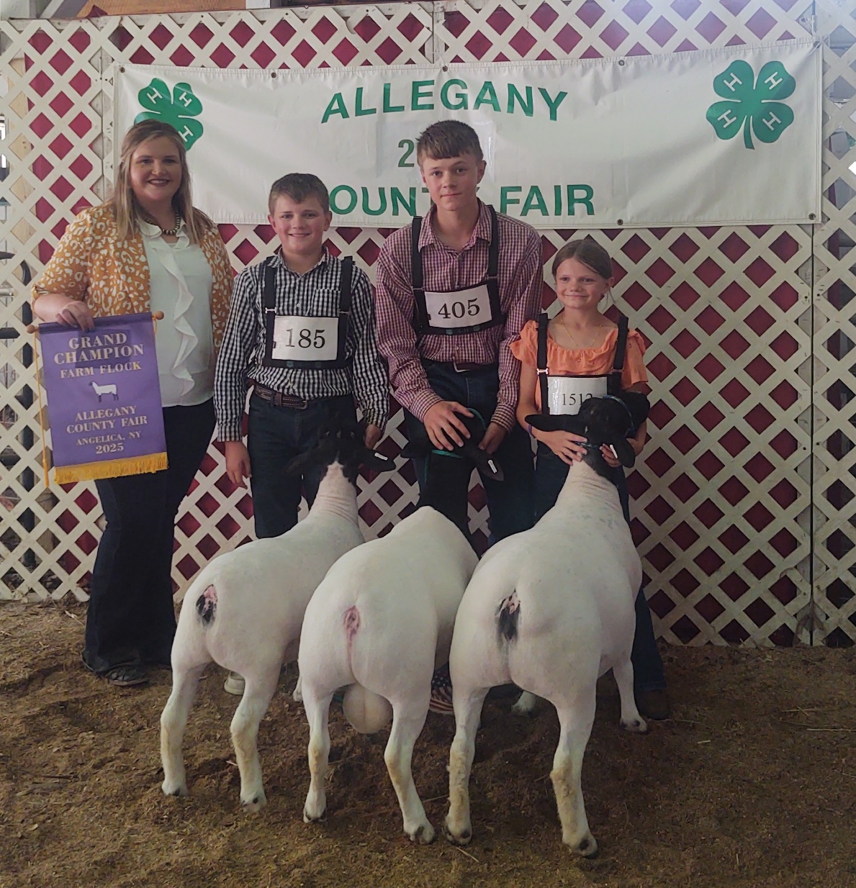Photo Caption: Grand Champion Farm Flock exhibited by Brenden Wilson. (Left to right) Judge Kirby Palmer, Brendon Wilson, Collin Wilson, Faith Wilson.