FOR IMMEDIATE RELEASE

Contact: Lynn Bliven  
Cornell University Cooperative Extension  
Phone: 585.268.7644 ext. 18  
E-mail: lao3@cornell.edu

ANGELICA, NEW YORK (July 15, 2025)

**2025 Allegany County Fair Youth Beef Show Results**Lynn Bliven, Agriculture & Natural Resources Issue Leader

Tuesday, July 15th youth exhibitors showed off their beef projects at the Allegany County Fair. The contest is a culmination of a year plus of hard work caring for and training their animals.

In the Senior Showmanship division, Mason Findlay Fillmore, NY with a first-place finish received a blue ribbon along with a shoulder bag sponsored Mark & Lorraine Stone followed by Conner Armison Farmersville Station, NY both receiving blue ribbons. Shane Ploetz Cuba, NY first red ribbon followed by Wyatt Tyler.

For the Junior Showmanship Caidence Armison Farmersville Station, NY topped the class followed by Garret Ploetz Cuba, NY both receiving blue ribbons. Caidence received a shoulder bag sponsored by Bugman & Son’s.

Beverly Ploetz Cuba, NY received a blue ribbon and show harness awarded by Wellsville Elks Lodge #1495 for the Novice Division.

The top from each division competed for Grand Champion Showman. This year’s winner Mason Findlay received a shoulder bag sponsored Big D’s Farm – Bill “Dozer” Slocum. Reserve Grand Champion Showman, Conner Armison received a shoulder bag sponsored by Sky View Farm.

Following showmanship, the market classes were held starting with the Lightweight Division with 2 entries. First blue ribbon awarded to steer shown by Shane Ploetz followed by second blue exhibited by Wyatt Tyler.

In the Medium Weight Division receiving blue ribbons Caidence Armison first followed by Mason Findley; first red to Garrett Ploetz with second red exhibited by Shane Ploetz. The heavyweight Division with 2 blue ribbons winners exhibited by Conner Armison and Mason Findlay.

Grand Champion Market Beef was awarded to the heavy weight steer exhibited by Conner Armison. He received a banner sponsored by Nicholson Pharmacy. The Reserve Grand Champion Market beef was exhibited by Mason Findlay, awarded to his heavy weight steer. He received an award banner sponsored by the First Citizens Bank. One blue ribbon entry in the Dairy Beef Steer division exhibited by Shane Ploetz, He received a banner sponsored by Almond Rod & Gun Club.

In the breeding beef division, an excellent group of blue-ribbon stock exhibited by Conner Armison, Mason Findlay, Beverley Ploetz, Garrett Ploetz, and Shane Ploetz. Grand Champion Female awarded to Simmental Senior Calf exhibited by Mason Findlay, sponsored by Marshall Insurance Services. Reserve Grand Champion Female, sponsored Cattaraugus County Trappers, shoulder bag awarded to Mason Findlay’s Simmental Junior Yearling. Grand Champion Bull and Reserve Grand Champion Bull exhibited by Shane Ploetz. Both bulls were awarded shoulder bags; grand sponsored In Memory of Sara Bieler and reserve by LC Whitford Company.

This year’s judge for the show John Kriese, he has been judging for nearly 40 years. John has traveled to almost every county in New York, as well as judging youth shows at Cooperstown and the NYS Fair. John brings not only expertise but also heartfelt advice for the Allegany County Youth: to be a great showperson, you must form a strong bond with your animal. That bond takes practice, perseverance, and patience!

Youth shows at the fair are one of many programs offered by Cornell Cooperative Extension of Allegany County (CCE-Allegany). The association is part of the national cooperative extension system, an educational partnership between County, State, and Federal governments. As New York’s land grant university Cornell administers the system in this state. For more information, call 585-268-7644 or visit our website at www.cce.cornell.edu/allegany. Cornell Cooperative Extension provides equal program and employment opportunities.

Photo Credit; Lynn Bliven

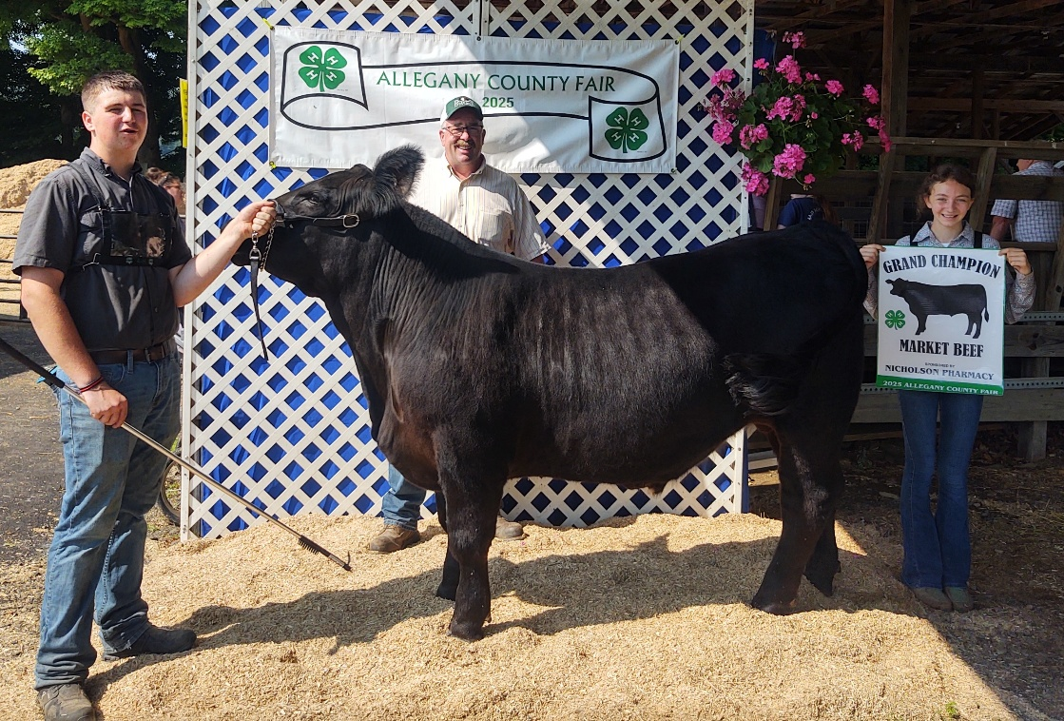

Photo Caption: Grand Champion Market Steer exhibited by Conner Armison with Judge John Kriese. This steer will be sold at the Annual Youth Market Animals Sale at 6 PM on Wednesday, July 16th.

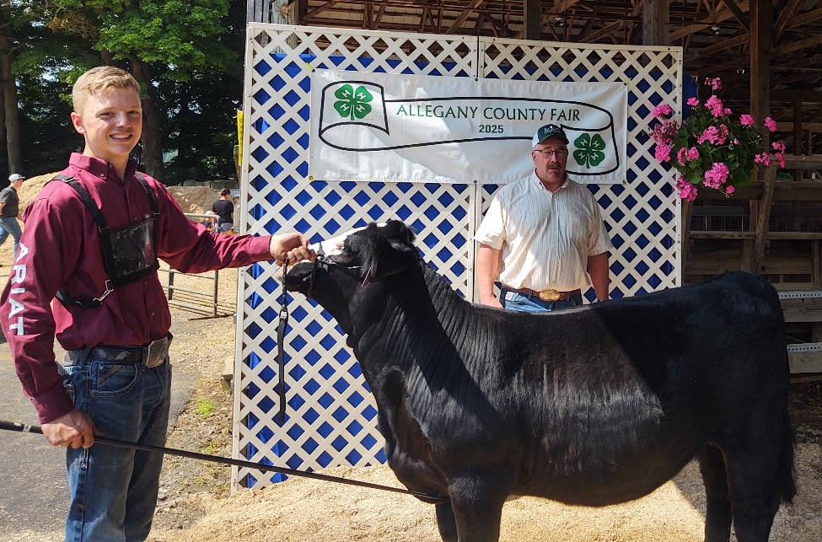 Photo Caption: Grand Champion Female exhibited by Mason Findlay with Judge John Kriese.