FOR IMMEDIATE RELEASE
Contact: Lynn Bliven
Cornell Cooperative Extension
Phone: 585.268.7644 ext. 18
E-mail: lao3@cornell.edu
ANGELICA, NEW YORK (July 14, 2025)
2025 Allegany County Fair Youth Swine Show
Lynn Bliven, Agriculture & Natural Resources Issue Leader
Monday, July 14th youth exhibitors showed off their swine projects at the Allegany County Fair. The contest is an opportunity to be rewarded for the months of hard work caring for and training their animals.
In the Senior Showmanship division, Lindsey Reynolds of Cuba, NY with a first-place finish received a blue ribbon along with a shoulder bag sponsored by Mark & Larraine Stone. Second place finish to Mason Findlay of Fillmore, NY; followed by Morgan Holcomb of Friendship, NY; Conner Armison of Farmersville Station, NY; Collin Wilson Dansville, NY; Shane Ploetz Cuba, NY; Natalie Burrows Cuba, NY; Wylee Ringelberg Black Creek, NY; all awarded a blue ribbon.
For the junior division with 9 participants, Lincoln Reynolds Cuba, NY topped the class followed by Faith Wilson Dansville, NY; Brendon Wilson from Dansville, NY; and Grant Bell Bolivar, NY receiving blue ribbons; 1st red ribbon to Grady Bell Bolivar, NY followed by Garrett Ploetz Cuba, NY; Grace Bell Bolivar, NY; Bentley Foster Friendship, NY and Caidence Armison of Farmersville Station, NY. Lincoln received a shoulder bag sponsored by the Ken Miller Family.
In the novice class, first blue awarded to Beverly Ploetz followed by Grayson Bell, and Tinsley Foster. Beverly received a showman harness sponsored by the Nicholson Pharmacy.
The top 2 from each division competed for Grand Champion Showman. This year’s winner Lindsey Reynolds received a belt buckle sponsored by the Gene & Linda Hatch. Reserve Grand Champion Showman Mason Findley received shoulder bag sponsored by Bugman & Son’s.
One future showman participated in the Cloverbub division open to youth between 5-7 years old. The judge complemented Gabriel Bell for an excellent job participating in the show.
Four classes in the market swine division starting with light weight. The class of 5 receiving blues: Conner Armison, Grace Bell, Grady Bell, Tinsley Foster, and Caidence Armison.
The medium weight swine, all received blue ribbons. First place exhibited by Lindsey Reynolds, followed by Lincoln Reynolds in second, third Collin Wilson, fourth Grant Bell, fifth Beverly Ploetz, sixth Conner Armison, and seventh blue to Natalie Burrows.
Mason Findley placed first blue in the intermediate weight class followed Faith Wilson, Mason Findley, Brenden Wilson, Collin Wilson, Natalie Burrows, Morgan Holcomb, Shane Ploetz, and Grady Bell. Another group of blue-ribbon winners.
Blue ribbon heavy weight hogs exhibited by Morgan Holcomb followed by Grant Bell, Grace Bell, Garrett Ploetz, Grayson Bell, Bentley Foster, Tinsley Foster, Grayson Bell, Bentley Foster.
Grand Champion Market Swine receiving a banner sponsored by Wellsville Elks Lodge #1495 along with a wall plague from the NYS Pork Producers Association was awarded to the top heavy hog exhibited by Morgan Holcomb. The Reserve Grand Champion Market Swine banner was sponsored In Memory of Sara Beiler and awarded to Mason Findlay’s intermediate weight hog. All these market hogs will be sold at the Annual Youth Market Animals Sale beginning at 6 PM on Wednesday, July 16th.
In the breeding division first place and Grand Champion Gilt, was exhibited by Shane Ploetz, he received a shoulder bag sponsored by First Citizens Bank. Additional blue ribbons awarded to Morgan Holcomb, Beverly Ploetz, Lindsey Reynolds, Bentley Foster, and Mason Findlay.
This year’s judge for the swine show was Bruce Beery from Ohio. He has judged swine shows since 2009 and loves working with youth and their livestock. Bruce believes that 4-H shows are a great learning experience and encourages youth to listen closely to judges feedback it’s a valuable tool to grow your skills in both showmanship and the market ring.
The youth swine show was followed by the Livestock Judging Contest. First place senior, Collin Wilson, received a clip board sponsored by Nicholson Pharmacy. First place junior, Brendon Wilson, clip board was sponsored by First Citizens Bank. Thank you to our official Judge, Lenny Ando from Houghton, NY.
Youth shows at the fair are one of many programs offered by the 4-H Program through Cornell Cooperative Extension of Allegany County (CCE-Allegany). The association is part of the national cooperative extension system, an educational partnership between County, State, and Federal governments. As New York’s land grant university Cornell administers the system in this state. For more information, call 585-268-7644 or visit our website at www.cce.cornell.edu/allegany. Cornell Cooperative Extension provides equal program and employment opportunities.
Photo Credit: Lynn Bliven
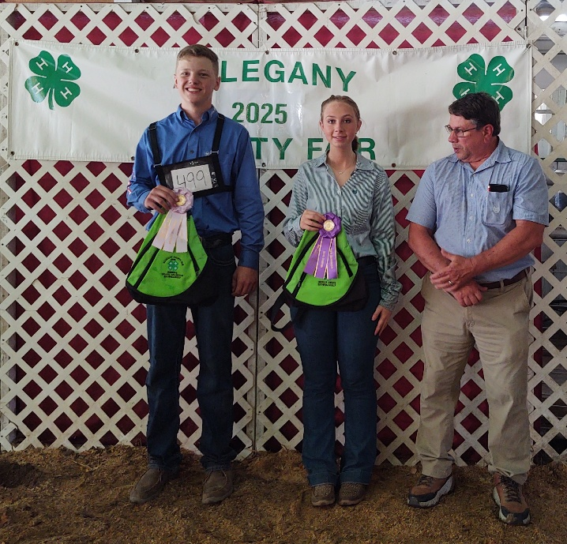
Photo Caption: (left to right) Mason Findley Reserve Master Showman; Lindsey Reynolds Master Showman, judge Bruce Beery.

Photo caption: Grand Champion Marget Hog Drive. These animals will be sold at the Annual Youth Market Animals Sale at 6 PM on Wednesday, July 16th. (left to Right) Mason Findley, Conner Armison, Lindsey Reynolds, Judge Bruce Beery, Morgan Holcomb.
