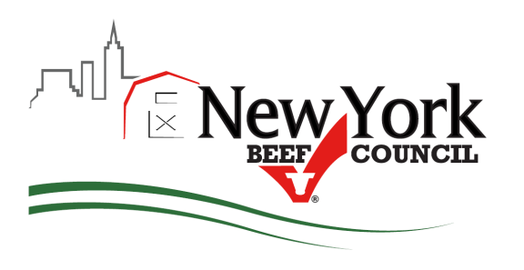 PO Box 250, Westmoreland, NY 13490-0250
Phone: 315-339-6922; Fax: 315-339-6931
www.nybeef.org

FOR IMMEDIATE RELEASE
Contact:
Jean O’Toole, Executive Director
New York Beef Council
315-339-6922
jotoole@nybeef.org
GOT BEEF? Cuts, Sides or Quarters?

Westmoreland, NY (November 2017) – The New York Beef Council wants to congratulate producers on their local efforts to sell beef direct to consumers via Farmer’s Markets or Direct Marketing halves and quarters this year! NYBC at the same time wishes to remind beef producers to remit their Checkoff dollars, $1.00 for each cow slaughtered and sold to their customers via Private Treaty by the end of the year.

A Private Treaty Form can be downloaded from the NYBC’s website at: http://www.nybeef.org/checkoffinformationforms.aspx or you can call NYBC to have Private Treaty’s mailed to you (private treaty’s come in triplicate for your records) at 315-339-6922.

“Producers often believe their dollar is taken and remitted at the slaughter facility, however this isn’t the case, the slaughter facility never owns the animal.” explains Jean O’Toole, NYBC’s Executive Director and Compliance Officer. “When sending cattle to auction, the auction house remits, however if producer’s directly sell cuts at Farmer’s Markets or sides and quarters through direct marketing, they (the seller) needs to remit the dollar via the Private Treaty.” O’Toole goes on to explain, “There is a return on their investment, producers are able to order cut charts and recipe pamphlets FREE from the beef council to help their customers understand how to cook the beef they purchased, the order form is also on the website.”

The Beef Checkoff Program was established as part of the 1985 Farm Bill. The checkoff assesses $1 per head on the sale of live domestic and imported cattle, in addition to a comparable assessment on imported beef and beef products. States retain up to 50 cents on the dollar and forward the other 50 cents per head to the Cattlemen's Beef Promotion and Research Board, which administers the national checkoff program, subject to USDA approval. Consumer-focused and producer-directed, the National Cattlemen’s Beef Association and its state beef council partners are the marketing organization for the largest segment of the food and fiber industry.

For those interested in learning more about how their Checkoff dollars are being invested and the beef promotion efforts here in New York State sign up for our monthly newsletter: http://www.nybeef.org/newsletter.aspx

###
The Beef Checkoff Program was established as part of the 1985 Farm Bill. The checkoff assesses $1 per head on the sale of live domestic and imported cattle, in addition to a comparable assessment on imported beef and beef products. States retain up to 50 cents on the dollar and forward the other 50 cents per head to the Cattlemen's Beef Promotion and Research Board, which administers the national checkoff program, subject to USDA approval. Consumer-focused and producer-directed, the National Cattlemen’s Beef Association and its state beef council partners are the marketing organization for the largest segment of the food and fiber industry.

