TUBI ACQUIRES DESTRY ALLYN SPIELBERG’S FEATURE DIRECTORIAL DEBUT HORROR THRILLER “PLEASE DON’T FEED THE CHILDREN”

The Tubi Original Starring Michelle Dockery and Giancarlo Esposito
Premieres Friday, June 27

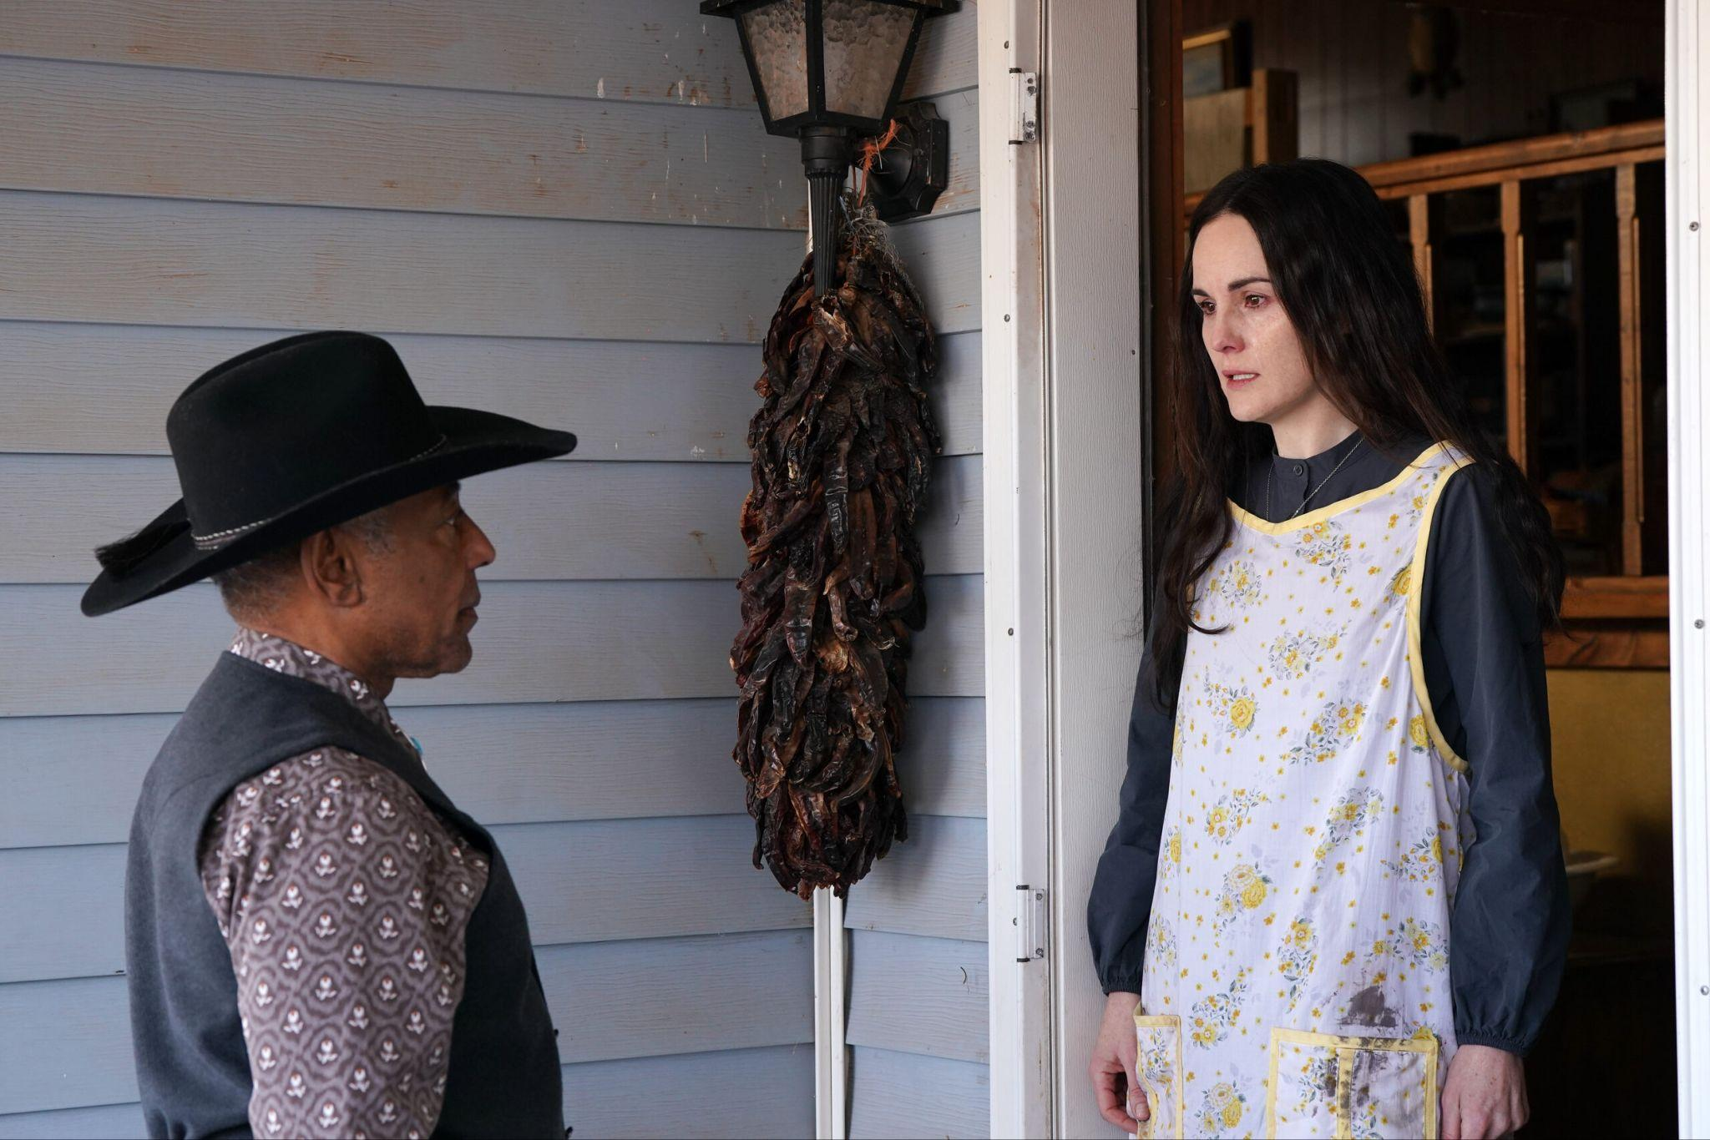

SAN FRANCISCO, (June 3, 2025) – Tubi (www.tubi.tv), Fox Corporation’s (NASDAQ: FOXA, FOX) ad-supported video-on-demand service, today announced it has acquired as a Tubi Original Film the horror thriller “PLEASE DON’T FEED THE CHILDREN” which will premiere exclusively on the service Friday, June 27th. Directed by Destry Allyn Spielberg, the film stars Michelle Dockery (Downton Abbey, The Gentlemen), Giancarlo Esposito (Better Call Saul, “Megalopolis”), Zoe Colletti (Only Murders In The Building, Boo Bitch), Andrew Liner (Ransom Canyon), Dean Scott Vazquez (“Transformers: Rise of the Beasts”, “You Are So Not Invited To My Bat Mitzvah”) Regan Aliyah (Ironheart, XO, Kitty), Emma Meisel (Doogie Kameāloha, M.D.), Josh Melnick (Saint X, “Tesla”) and Vernon Davis (“Chariot”, “A Day To Die”).

“PLEASE DON’T FEED THE CHILDREN” takes place in a not-so-distant future where society contends with a pervasive virus that afflicts the entire adult population. After the deadly viral outbreak, a group of orphans flee in search of a new life, only to be taken hostage by a woman hiding a sinister secret. The horror thriller is written by Paul Bertino and marks the directorial debut of Destry Allyn Spielberg.

"I am incredibly grateful to be doing what I love with a hard working cast and crew. It has been a wild ride getting here, and I can’t wait to share this film with everyone,” said director Destry Allyn Spielberg.

“We cannot wait to premiere PLEASE DON'T FEED THE CHILDREN on Tubi and introduce viewers to Destry's incredible work as a first-time filmmaker," said Tubi SVP, Content Acquisitions & Partnerships Samuel Harowitz. "Featuring a captivating young cast, relentless suspense and Michelle Dockery as a sinister antagonist, horror-thriller fans are in for a chilling experience. We're grateful that Destry and Paul chose Tubi as the best home to showcase this unique film, and we are excited to bring their vision to Tubi audiences.”

“PLEASE DON’T FEED THE CHILDREN” is produced by Perry Street Films presented in association with Head Gear Films and Metro Technology & Fieldhouse Pictures in association with Altitude Film Entertainment & Sugar23 a BK Studios production. The film is produced by Jason Dubin, Josh Kesselman, Michael Hagerty, Daniel Ryniker, Bill Kenwright. Executive Producers include Phil Hunt Compton, Ross Daniel Negret, Will Clarke, Andy Mayson, Mike Runagall, David Gilbery, Naomi George, Ben Kaye, Steven Schneider, Joe Health, Owen King, Kimberly Atwood, Atty Cleworth and Dockery. The deal was brokered by Abraham Bengio and Maddie Neil, WME and Sarah Corrigan of Tubi.

“PLEASE DON’T FEED THE CHILDREN” premieres on Friday, June 27 for free exclusively on Tubi.

PHOTOS: HERE
Courtesy: Shane Sigler

About Tubi
Tubi is a global entertainment company dedicated to providing all people access to all the world’s stories. Tubi offers the largest collection of premium on-demand content, including over 275,000 movies and TV episodes and more than 300 exclusive originals. With a passionate fanbase and over 97 million monthly active users, the company is committed to putting viewers first with free, accessible entertainment. Tubi is part of Tubi Media Group, a division of Fox Corporation that oversees the company’s digital businesses.

About Perry Street Films
Perry Street Films’ mission is to be the unapologetic pulse of cinema, fueling fearless filmmakers who break boundaries and rewrite the rules. We champion raw, unconventional stories that defy expectations, driven by authenticity and unshakable integrity. Our vision is to create a space where bold voices thrive, shaking up the industry and igniting a new era of storytelling that hits hard and leaves a mark.

About Fieldhouse Pictures
Fieldhouse Pictures leads with the mission of creating entertainment with impact and a safe haven for filmmakers. Fieldhouse works with their partners to bring authentic narratives to the forefront of storytelling, focussing on production, collaboration, media relations, marketing partnerships and community engagement to deliver commercially viable products that stay true to their artistic integrity and core values.

