

BRENDAN FRASER, SARAH MICHELLE GELLAR, ANNIE MURPHY ELIZABETH HURLEY AND JOSH GAD JOIN TUBI’S ADULT ANIMATED COMEDY “BREAKING BEAR”

Wildly Original Series to be Executive Produced by
blink-182 Frontman Tom DeLonge and Evoke Entertainment
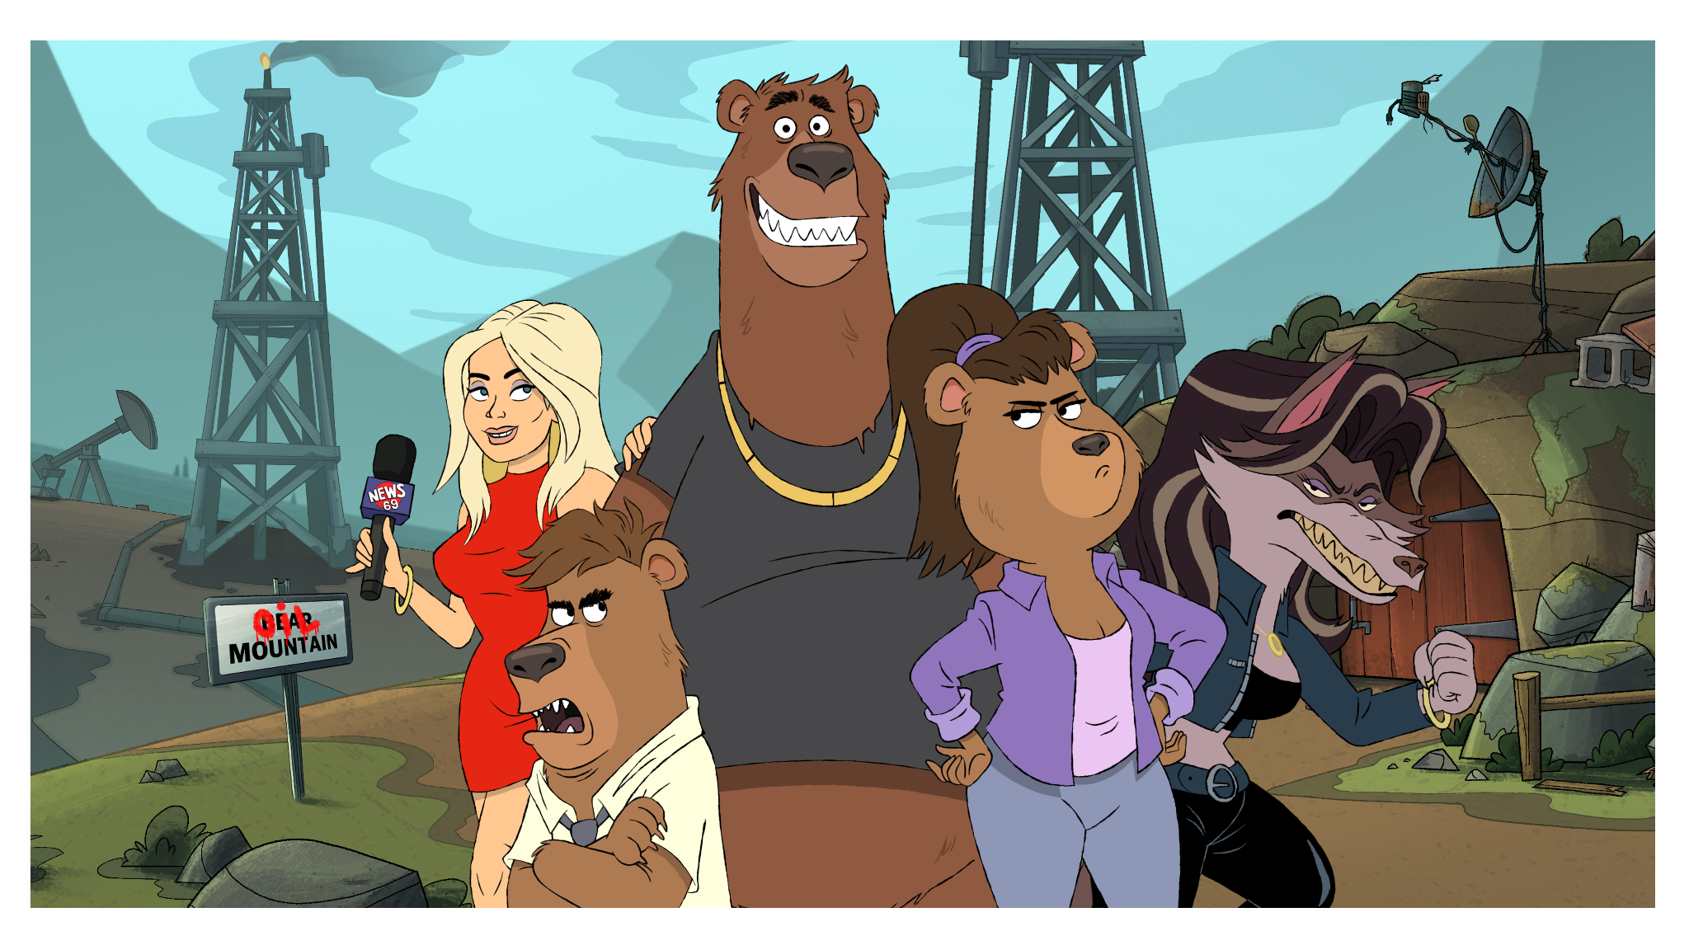
SAN FRANCISCO, May 8, 2025 – Tubi (www.tubitv.com), Fox Corporation’s (NASDAQ: FOXA, FOX) ad-supported streaming service, today announced it has foraged and found its series regulars - OscarⓇ Winner Brendan Fraser (The Whale), EMMYⓇ Winner Sarah Michelle Gellar (Buffy the
Vampire Slayer), EMMYⓇ Winner Annie Murphy (Schitt’s Creek) with Elizabeth Hurley (The Royals) and TonyⓇ Nominee Josh Gad (Frozen) who will lend their voices to the adult animated series, BREAKING BEAR.

Created by Julien Nitzberg (The Wild and Wonderful Whites of West Virginia) and produced by Evoke Entertainment (Creepshow, Twelve Forever, and Day of the Dead) and Tom DeLonge’s To The Stars Media (Monsters of California, Unidentified), BREAKING BEAR parodies the tropes of mobster dramas, comically combining elements of characters like Yogi Bear with series like The Sopranos.

BREAKING BEAR is a fur-flying, law-breaking, forest-saving rampage following a dysfunctional family of bears who go full criminal to stop frackers, mobsters, and a psychotic wolf pack from destroying their home. As they spiral deeper into the criminal abyss, they face off against biker gangs, an egomaniacal news anchor, and their own spectacular talent for self-sabotage.

- Fraser plays “Jer” – The oldest of the bear siblings, Jer fancies himself the brains of the operation. Unfortunately, he's not only wrong - he’s lazy, clueless and usually the one getting everyone into hot water. If there is a wrong move to make, Jer has already made it.

- Gellar plays “Blair” – The middle sister and actual brains of the family. Constantly overlooked, Blair’s the one who ends up cleaning up her brothers’ messes and keeping the family alive - whether they notice or not.

- Murphy plays “Tawny” – A human, she’s a gorgeous local news anchor whose number one goal is getting ahead in her field to become the next big national newscaster.

- Hurley plays “Wolf Queen” - the fierce and unyielding guardian of the forest. She is locked in a bitter rivalry with the Bears, whose growing presence and destructive ways threaten the land she is sworn to protect, by any means necessary.

- Gad plays “Alistair” – The baby brother of the family, Alistar swings wildly from adorably anxious to full-on unhinged with zero warning. Push him the wrong way, and this teddy bear turns terrifying.

“With Brendan, Sarah, Annie, Elizabeth and Josh, we have an incredible cast of series regulars,” said Adam Lewinson, Chief Content Officer at Tubi. “BREAKING BEAR is our wild, no-holds-barred send-up of classic mob sagas—from Scarface to Goodfellas—as a dysfunctional crew of bears crash headfirst into the world of crime, all in a desperate bid to save their forest. It’s bold, it’s chaotic, and we’re here for every outrageous second.”

BREAKING BEAR is executive produced by Tom DeLonge (“Poet Anderson: The Dream Walker”), Stan Spry (Creepshow, Day of the Dead), Jeff Holland (Creepshow, Day of the Dead), and Bradford Bricken (Twelve Forever). Brendan Frasher, Sarah Michelle Gellar, Josh Gad are also executive producers with Julien Nitzberg, who also serves as showrunner.

About Tubi
Tubi is a global entertainment company dedicated to providing all people access to all the world’s stories. Tubi offers the largest collection of premium on-demand content, including over 275,000 movies and TV episodes and more than 300 exclusive originals. With a passionate fanbase and over 97 million monthly active viewers, the company is committed to putting viewers first with free, accessible entertainment. Tubi is part of Tubi Media Group, a division of Fox Corporation that oversees the company’s digital businesses.

About Evoke Entertainment
Evoke Entertainment, formerly known as Cartel Entertainment, was founded in 2011 and is a full-service management, production, and finance company with offices in Los Angeles, Canada, London, and Las Vegas. The company represents top-tier showrunners, show creators, writers, directors, producers, animators, and production companies in film, TV, and new media. Evoke Entertainment has produced and financed several series since its inception, including the hit series Creepshow for Shudder/AMC, the animated family series Twelve Forever for Netflix and the Universal/Syfy series Day of the Dead. Evoke Entertainment also produced the series Ties That Bind for Up TV, and A Place in the Sun for Discovery.

About To The Stars Media
About To The Stars Media, Inc. To The Stars Media (TTSM) is a wholly owned subsidiary of To The Stars Inc. (TTS), a public benefit corporation based in San Diego, California. TTS was founded in 2017 by Tom DeLonge from blink-182, former senior CIA officer Jim Semivan and physicist Dr Hal Puthoff. The company strives to be a revolutionary collaboration between academia, industry and pop culture to advance society’s imagination, curiosity and understanding of scientific phenomena and other mysteries of the universe. To The Stars Media creates award-winning content across music, tv, film, books and merchandise that is informed by the vast knowledge and experience of its own scientific advisory board that come from prestigious government agencies and academic institutions. The company became internationally recognized when it obtained the first official US Government military evidence of unidentified aerial phenomenon that it released in a front page expose with the New York Times in connection with the research for its book series, Sekret Machines. Other original To The Stars Media franchises include “Poet Anderson: The Dream Walker,” winner of IPBA’s ‘Best Teen Fiction’ and ‘Best Animated Short’ at Toronto International Short Film Festival, “The Lonely Astronaut on Christmas Eve,” “Cathedrals of Glass'' and “Monsters of California.” www.ToTheStars.Media

