Friday, Sept. 24, 2021
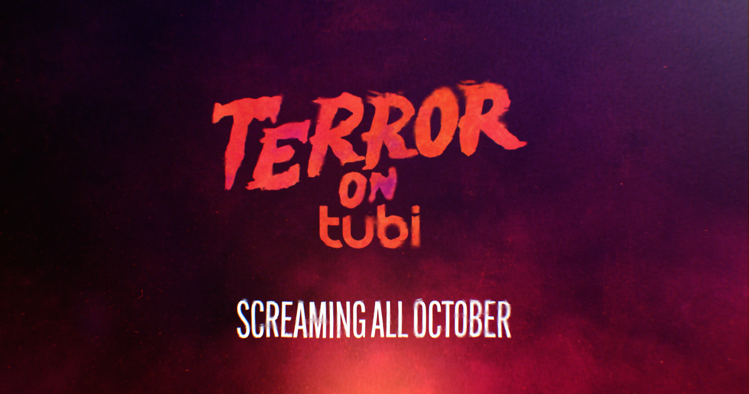
SCARY GOOD STREAMING THIS OCTOBER ON TUBI!

TUBI CELEBRATES HALLOWEEN WITH “TERROR ON TUBI,”
A MONTH-LONG CELEBRATION FEATURING
MORE THAN 5,000 TITLES, INCLUDING NEW AND CLASSIC HORROR AND PARANORMAL TITLES, PLUS FOUR ALL-NEW ORIGINALS
-- ALL FREE--

Four Tubi Halloween Originals, Including MEET, MARRY, MURDER; HARLAND MANOR;
FAMOUSLY HAUNTED: AMITYVILLE and CELEBRITY EXORCISM,
to Debut this October

Marks the First FOX Alternative Entertainment Originals to Appear on Platform

Tubi, FOX Entertainment’s free streaming service, announced today “Terror on Tubi,” it's scary good streaming Halloween celebration, which kicks off this October. All month long, Tubi will offer thousands of hours of scares from streaming's biggest free Halloween movie collection, with more than 5,000 horror and paranormal titles from which to choose. As part of “Terror on Tubi,” the streaming service is premiering four Tubi Originals: MEET, MARRY, MURDER; HARLAND MANOR; and two projects brought by FOX Alternative Entertainment to Tubi, including FAMOUSLY HAUNTED: AMITYVILLE and CELEBRITY EXORCISM; as well as a plethora of haunting and heart-pounding films for horror and paranormal enthusiasts.

As previously announced, Tubi is kicking off its original programming this fall and will debut 140+ hours of all-new content, including original programming from FOX Alternative Entertainment (FAE). Throughout October, Tubi will feature an array of frightening content, ranging from paranormal series to horror films and true crime series, including MEET, MARRY, MURDER, hosted by Michelle Trachtenberg (October 6), FAMOUSLY HAUNTED: AMITYVILLE (October 15), CELEBRITY EXORCISM (October 22) and horror film HARLAND MANOR (October 29). All of the “Terror on Tubi” offerings are available for free on the platform.
“TERROR ON TUBI” - Page 2

“Tubi viewers devour horror titles all year long so we've made 'Terror on Tubi' extra enticing,” said Adam Lewinson, Chief Content Officer, Tubi. “With more than 5,000 horror and paranormal titles and four bone-chilling originals, Tubi ramps up its position as a formidable force in horror."

“We’re thrilled to be premiering our first FAE Tubi original titles on the platform with the inaugural ‘Terror on Tubi’ celebration,” said Rob Wade, FOX Entertainment’s President of Alternative Entertainment and Specials. “We look forward to continuing to bring original content that not only draws in new audiences with the bold programming that has long been synonymous with FOX, but that also reflects the genres and entertainment Tubi’s streaming audiences love most.”

ORIGINAL “TERROR ON TUBI” PROGRAMMING:
- MEET, MARRY, MURDER (October 6), a 13-part true crime series hosted and executive-produced by actress Michelle Trachtenberg (“Gossip Girl”), explores the true stories of people who were murdered by their partners, and features interviews with witnesses to discuss the tragic unions. The series is from FilmRise and FirstLookTV and is executive-produced by Will Hanrahan, Gillian Carter, Danny Fisher and Max Einhorn.
- FAMOUSLY HAUNTED: AMITYVILLE (October 15) - When infamous Amityville killer Ronnie Defeo died behind bars this year, social media blew up with a new wave of armchair detectives and paranormal experts obsessed with the real-life horror story that shattered this sleepy Long Island village nearly 50 years ago. Now, just in time for Halloween, from FOX Alternative Entertainment comes FAMOUSLY HAUNTED: AMITYVILLE, a fresh look at how six shocking murders spawned one of the most terrifying ghost stories in American history.
- CELEBRITY EXORCISM (October 22) - From FOX Alternative Entertainment, CELEBRITY EXORCISM stars Jodie Sweetin (“Full House”), Shar Jackson (“Moesha”) and Metta World Peace (NBA Champion and All-Star), as they come together for a good old-fashioned fright fest! With the help of an acclaimed exorcist, this team of brave celebrities enrolls in a paranormal boot camp like we've never seen before - journeying to exorcise an iconic haunted location... Do you dare to join them?
- HARLAND MANOR (October 29) - Directed by Steven R. Monroe (“The Exorcism of Molly Hartley,” “I Spit on Your Grave”) and co-written by Steven R. Monroe and John Thaddeus (“Sea of Love”), HARLAND MANOR stars Camille Sullivan (“Intelligence”), Summer H. Howell (“Cult of Chucky”), Dion Johnstone (“Sweet Magnolias”) and Josh Strait (“The Ice Road”) as a team of paranormal investigators who document the haunted Harland Manor, only to find themselves hunted by the malevolent ghosts that still dwell there. HARLAND MANOR is produced by Stan Spry (“Creepshow,” “Day of the Dead,” “Jeepers Creepers 3”) and Eric Scott Woods (“Creepshow,” “Toys of Terror”) from Cartel.

“TERROR ON TUBI” - Page 3

In addition to the Originals, Terror on Tubi will offer more than 5,000 horror and paranormal titles to celebrate Halloween, including “Life After Beth,” “Sweeney Todd: The Demon Barber of Fleet Street,” “Astral,” “Bones,” “Captivity,” “The Reaping,” “Virus,” “The Awakening,” “Wer,” “P2,” “Rest Stop,” “Rest Stop: Don’t Look Back,” “Curve,” “I Spit On Your Grave,” “I Spit On Your Grave 2,” “Rosemary’s Baby (2014),” “Buffy the Vampire Slayer (film),” “The Hills Have Eyes 2,” “Predators,” “Paranormal Prison,” “Flight 7500,” “The Fog (1980),” “The Vatican Tapes,” “Dracula (1931),” “The Mummy (1932),” “Waking the Dead,” “Virus (1999),” “Snow White: A Tale of Terror,” “Rosewood Lane” and more.

FOX Entertainment’s free streaming service previously announced it will debut this fall 140+ hours of all-new content, including Tubi Original Documentaries from FOX Alternative Entertainment; animated titles from FOX Entertainment’s Emmy Award-winning animation studio, Bento Box Entertainment; and premium independent-minded titles across the Black Cinema, thriller, horror, sci-fi, romance and Western genres.

Tubi has more than 35,000 movies and television series from more than 250 content partners, including every major studio, in addition to the largest live local and national news channels. The platform gives fans of entertainment, news and sports an easy way to discover new content that is available completely free.

Tubi is available on Android and iOS mobile devices, Amazon Echo Show, Google Nest Hub Max, Comcast Xfinity X1, Cox Contour, and on OTT devices such as Amazon Fire TV, Vizio TVs, Sony TVs, Samsung TVs, Roku, Apple TV, Chromecast, Android TV, PlayStation 5, Xbox Series X | S, and soon on Hisense TVs globally. Consumers can also watch Tubi content on the web at www.tubi.tv.

About Tubi
Headquartered in San Francisco, Tubi (www.tubi.tv), a division of FOX Entertainment, is an ad-supported video on demand (AVOD) service with movies and television shows from nearly every major Hollywood studio. Tubi gives fans of films and television programs an easy way to discover new content that is available completely free. The service is currently available in the U.S., Canada, Australia and Mexico.

###

Contacts:
Morgan Albrecht Alex Gillespie
Tubi FOX
malbrecht@tubi.tv Alexandra.Gillespie@fox.com

