FOR IMMEDIATE RELEASE
Tuesday, February 8, 2022

FOX WELCOMES GUMBY

FOX Celebrates Acquisition of Beloved IP,
Welcoming Gumby, Pokey and All Their Friends to the FOX Studios Lot

FOX Entertainment Studios, Bento Box, Tubi, Blockchain Creative Labs and
the entire FOX Creative Team ‘Reimagining’ Gumby for New Generations

New Animated Series, Live-Action Original Content, NFTs,
Consumer Products, Licensing, Publishing and More to Follow

Iconic Claymation Characters Making FOX Studios Their New Home,
Bring L.A. Traffic to a Standstill (see below)

FOX Entertainment has acquired the iconic animated character Gumby, and all his friends, from the estate of Joseph Clokey, son of creator Art Clokey, it was announced today by FOX Entertainment CEO Charlie Collier. The acquisition expands on FOX Entertainment’s long-term strategy of building a select, curated and culturally compelling library of owned content and intellectual property to showcase across its linear, AVOD, blockchain-based and other platforms.

FOX Entertainment has obtained all rights to the popular franchise, including film, television and streaming, consumer products, licensing, publishing and all other categories. In addition, FOX has acquired the full library of Gumby animated series, specials, movies and content, which will expand Tubi’s current offerings of the franchise. This classic and well-known IP complements other recent FOX Entertainment acquisitions and FOX partnerships, including Tubi, Bento Box Entertainment, Studio Ramsay Global, TMZ, MarVista Entertainment and start-up company Blockchain Creative Labs, as well as FOX Alternative Entertainment and the newly formed FOX Entertainment Studios.

“Picking a new home was important to me, and I’ve found great partners in FOX Entertainment,” explained Gumby in a very green statement. “They have a vision for my modern, multi-platform reemergence, which is thrilling. Throughout our conversations, Pokey and I reiterated that we are talent they can mold. Literally.”

“Competition for globally recognized intellectual property is fierce. Uncovering this gem, with its built-in awareness and affinity, and bringing it to FOX, adds meaningful value and creative possibilities to the IP itself and to multiple divisions of our company,” said Collier. “FOX is proud to be home to these iconic characters. Welcome one and all.”

Internal teams are already hard at work both showcasing the classic Gumby series on Tubi and reimagining this beloved franchise for broadcast, streaming and beyond.

Upon Gumby and Pokey’s arrival at the iconic FOX Studios Lot in Century City, traffic on Pico Blvd. came to a standstill.

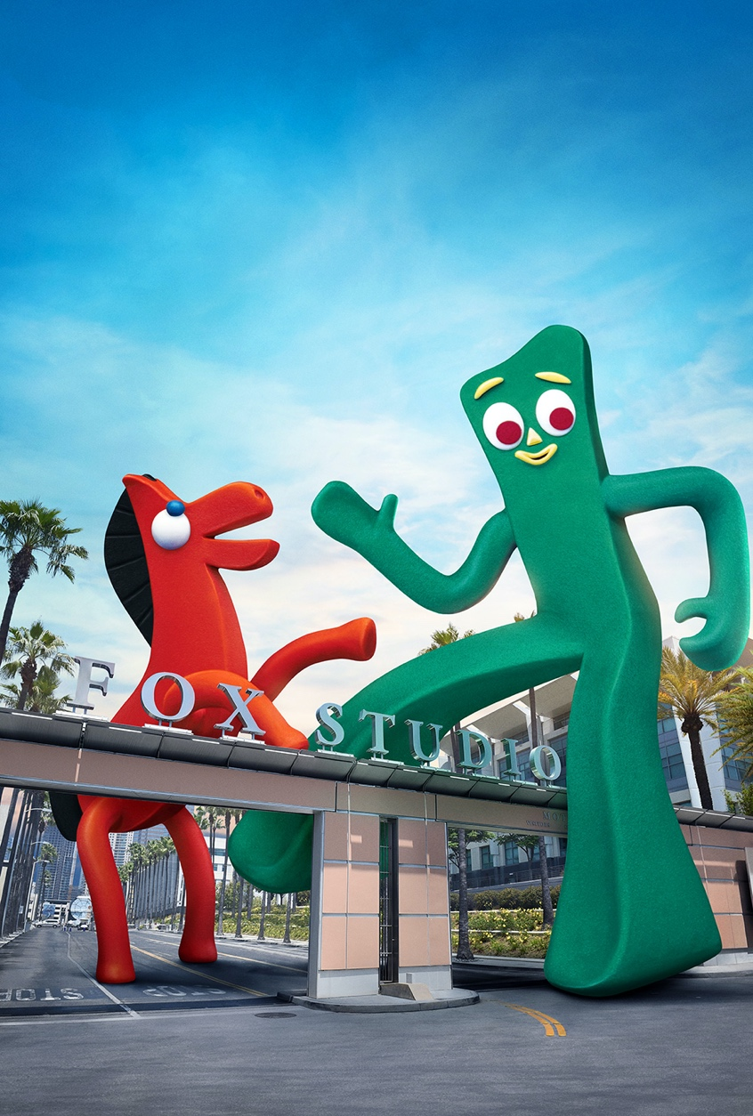

About FOX Entertainment
FOX Entertainment’s 35-year legacy of innovative, hit programming includes 9-1-1, 9-1-1: Lone Star, The Masked Singer, Lego Masters, The Simpsons, Empire, 24, The X-Files and American Idol. Delivering high-quality scripted, non-scripted, animated and live content and major sports, FOX won the 2021 fall broadcast season, marking the third consecutive year it ranked #1. In addition to its broadcast network, FOX Entertainment oversees the operations of FOX Alternative Entertainment, its in-house unscripted studio that produces The Masked Singer, I Can See Your Voice and Name That Tune, among other series; the award-winning animation studio Bento Box Entertainment, which produces animated content for FOX, including the Emmy Award-winning hit Bob’s Burgers, Duncanville, The Great North and HouseBroken, as well as programming for other broadcast, streaming and cable platforms; and Blockchain Creative Labs, a new business and creative unit formed in 2021 by FOX Entertainment and Bento Box, to build, launch, manage and sell Non-Fungible Tokens (NFTs) and related content and experiences, and fungible tokens, as well as digital goods and assets. FOX Entertainment also recently formed the production venture Studio Ramsay Global, in partnership with award-winning chef, restaurateur and presenter Gordon Ramsay, to develop, produce and distribute culinary and lifestyle programming for FOX, its fast-growing ad-supported video-on-demand (AVOD) service, Tubi and platforms worldwide. Tubi features more than 35,000 movies and television series, and news content available in the U.S., Canada, Mexico, and Australia. FOX Entertainment recently acquired the entertainment platform TMZ and all its media properties, including its hit syndicated magazine programs TMZ and TMZ LIVE and its flagship digital platform, TMZ.com. Most recently, FOX Entertainment acquired MarVista Entertainment, a global leader in made-for-platform original content. Ranking among the world’s leading independent studios, MarVista will focus on developing and producing content for FOX’s digital platforms, including Tubi, as well as for third-party platforms worldwide.

-FOX-

Contact:
Jean Guerin
310-369-2843
Jean.Guerin@fox.com

