FOR IMMEDIATE RELEASE Contacts: Aly Sands
Tuesday, February 22, 2022 212-556-2567
Aly.Sands@fox.com
Kelley Kirkpatrick
310-369-5820
Kelley.Kirkpatrick@fox.com

“MASTERCHEF JUNIOR” SEASON EIGHT IS BACK WITH
16 YOUNG HOME COOKS

Top 16 Face Their First Challenge on Season Premiere,
Thursday, March 17, on FOX

MASTERCHEF JUNIOR returns for a highly-anticipated eighth season, giving talented kids the chance to showcase their culinary abilities and passion for food through a series of mouth-watering challenges. The Top 16 junior chefs, between the ages of 8 and 13, receive a coveted white apron and must prove that they deserve to stay in the game by completing their first mystery challenge of the season. Judges and mentors in Season Eight include world renowned chef Gordon Ramsay, acclaimed chef Aarón Sánchez and wellness advocate, author and new judge Daphne Oz. The three culinary heavyweights will determine which pint-sized home cook will be named America’s next MASTERCHEF JUNIOR, taking home a trophy and $100,000 in prize money.

One of the toughest seasons yet, Season Eight will feature even more unique and messy challenges for the judges and chef-testants, including cooking a meal for diners at a historical renaissance fair, participating in a WWE-themed episode, competing to see how they size up to monster trucks at a motocross track, and welcoming Gordon’s daughter, Tilly Ramsay, into the kitchen for a donut challenge.

In the premiere episode, “Punch And Munch,” airing Thursday, March 17 (8:00-9:00 PM ET/PT) on FOX, the pint-sized contestants must punch a hole through a wall of mystery ingredients, and make a dish featuring the item in their respective squares.

Meet the MASTERCHEF JUNIOR Top 16 and find out their signature dishes:

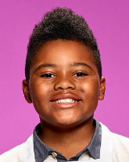 | A’Dan  Hometown: Atlanta, GA  Signature Dish: Grilled Salmon with Steamed Broccoli & Mashed Potatoes  Culinary Dream: Open a vegan restaurant

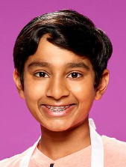 | Abir  Hometown: San Ramon, CA  Signature Dish: Penne Pasta with Sun-Dried Tomato Pesto & Meatballs  Culinary Dream: Write a cookbook that teaches people how to add a punch of flavor

-more-
“MASTERCHEF JUNIOR” SEASON EIGHT TOP 16 FINALISTS – Page 2

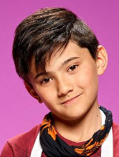 | Andrew  Hometown: Superior Township, MI  Signature Dish: Pan-seared Filet Mignon with Baked Potato & S’More Brownies  Culinary Dream: Open a hockey-themed establishment in Michigan, where he will serve all kinds of sweets

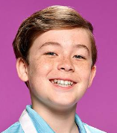 | Blake  Hometown: Darien, IL  Signature Dish: Teriyaki Salmon with Steamed Asparagus  Culinary Dream: Go to a famous culinary school in Italy or France & become a famous chef

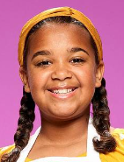 | Ciara  Hometown: Bakersfield, CA  Signature Dish: Roasted Chicken with Balsamic Sauce & Cheesy Potatoes with Zucchini  Culinary Dream: Own a bakery that offers classes to kids with disabilities

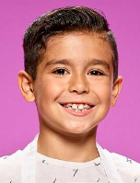 | Cruz  Hometown: Porter Ranch, CA  Signature Dish: Papa La Huancaina, a Spicy Sauce Made from Peruvian Chili & Cheese over Boiled Potatoes  Culinary Dream: Open a restaurant; become a famous food critic

 | Eva  Hometown: Sag Harbor, NY  Signature Dish: Roasted Shrimp Salad with Roasted Yellow & Red Peppers  Culinary Dream: Own a 3-Star Michelin Restaurant

-more-

“MASTERCHEF JUNIOR” SEASON EIGHT TOP 16 FINALISTS – Page 3
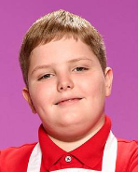 | Freddy  Hometown: Philadelphia, PA  Signature Dish: Fried Chicken Sandwich with Pepper Jack Cheese & Spicy Coleslaw  Culinary Dream: Own a restaurant franchise in Philadelphia

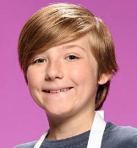 | Grayson  Hometown: Austin, TX  Signature Dish: Pan-seared Duck Breast with Duck Fat Potatoes, Asian Pears and Blackberry Gastrique  Culinary Dream: Open a technique-driven, ingredient-focused restaurant in Los Angeles, serving Japanese French fusion cuisine

 | Ivy  Hometown: Darien, CT  Signature Dish: Grilled Chicken with Creamy Mashed Potatoes & Roasted Vegetables  Culinary Dream: Write her own cookbook with recipes inspired by fashion icons

 | Jillian  Hometown: Yonkers, NY  Signature Dish: Grilled Shrimp with Lemongrass Tomato Sauce over Pasta  Culinary Dream: Write a kids cookbook teaching healthy and tasty recipes

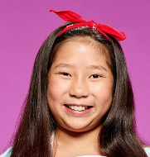 | Liya  Hometown: Scarsdale, NY  Signature Dish: Pork Dumpling with Spicy Garlic Sauce  Culinary Dream: Open a restaurant that serves hibachi & sushi

-more-

“MASTERCHEF JUNIOR” SEASON EIGHT TOP 16 FINALISTS – Page 4

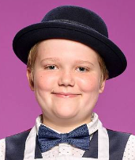 | Maclain  Hometown: South Salem, NY  Signature Dish: Linguini Carbonara in a Light Cream & Egg Sauce with Bacon  Culinary Dream: Open a patisserie in the Northeast

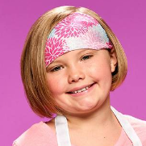 | Molly  Hometown: Springfield, MO  Signature Dish: The Molly Burger: Wagyu Beef topped with Cheese, Bacon & a Worcestershire-based Sauce with a side of Hand-Cut French Fries  Culinary Dream: Open a restaurant in Springfield called “Molly Moos,” that serves southern comfort and Italian dishes

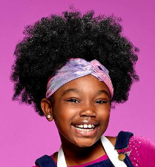 | Starla  Hometown: Bay Minette, AL  Signature Dish: Doritos-crusted Chicken Breast with a side Caesar Salad  Culinary Dream: Open a food truck serving mini pancakes and waffles with  southern fried meats

 | Tegan  Hometown: Billings, MT  Signature Dish: Pan-seared Chicken Breast with Sautéed Veggies & Rice  Culinary Dream: Open a restaurant

MASTERCHEF JUNIOR is produced by Endemol Shine North America and One Potato Two Potato, and is based on a format created by Franc Roddam and Endemol Shine. Elisabeth Murdoch, Natalka Znak, Danny Schrader, Gordon Ramsay, Pat Llewellyn, Ben Adler, Sharon Levy, DJ Nurre and Georgie Hurford-Jones serve as executive producers. “Like” MASTERCHEF JUNIOR on Facebook at facebook.com/MasterChefJuniorFOX. Follow the series on Twitter @MasterChefJrFOX and join the discussion at #MasterChefJunior. Check out photos and videos on Instagram @masterchefjunior/.

-more-

“MASTERCHEF JUNIOR” SEASON EIGHT TOP 16 FINALISTS – Page 5

ABOUT ENDEMOL SHINE NORTH AMERICA
Endemol Shine North America delivers world-class content and compelling storytelling to multiple platforms in the U.S. and across the globe.
A division of Banijay, the world’s largest international content producer and distributor, subsidiary production companies in the U.S. include Authentic Entertainment, Truly Original, 51 Minds Entertainment, Bunim/Murray Productions and Stephen David Entertainment. Its Endemol Shine Latino division oversees all original Spanish and Portuguese-language operations across Latin America, including Endemol Shine Brasil, Mexico City-based Endemol Shine Boomdog and Banijay Mexico and U.S. Hispanic.
Endemol Shine North America is behind such hit series as “Big Brother” (CBS), MASTERCHEF (FOX), “MASTERCHEF JUNIOR” (FOX), “Wipeout” (TBS), “LEGO MASTERS” (FOX), "Foodtastic" (Disney+), “The Real Housewives of Atlanta” (Bravo), “The Real Housewives of Potomac” (Bravo), “Below Deck” (Bravo), “Below Deck Mediterranean” (Bravo), “Below Deck Sailing Yacht” (Bravo), “Swamp People” (History), “The Challenge” (MTV), "Married to Real Estate" (HGTV) and the upcoming launches of "The Surreal Life" (VH1), "The Courtship" (NBC) "The Real Housewives of Dubai" (Bravo) and “Ripley” (Showtime).

ABOUT GORDON RAMSAY
Scottish by birth, Gordon Ramsay was brought up in Stratford-upon-Avon, England, and trained with some of the world’s leading chefs, such as Albert Roux and Marco Pierre White in London, and Guy Savoy and Joël Robuchon in France.

In 1993, Ramsay became chef of Aubergine in London, which, within three years, was awarded two Michelin stars. In 1998, at the age of 31, Ramsay set up his first wholly owned and namesake restaurant, Restaurant Gordon Ramsay, which quickly received the most prestigious accolade in the culinary world – three Michelin stars. Today, Restaurant Gordon Ramsay is London’s longest-running restaurant to hold this award, and Ramsay is one of only four chefs in the U.K. to maintain three stars.

Ramsay inked a deal in 2019 with private equity firm Lion Capital to expand his restaurant concepts across the U.S., where the company currently has 13 restaurants across Las Vegas, Chicago, Boston, Orlando, Atlantic City, Baltimore, Lake Tahoe and Kansas City, several of which are in partnership with Caesars Entertainment. Gordon Ramsay North America is scaling dining concepts including outdoor and take-out, as the company taps into several of Gordon Ramsay’s successful U.S. and international key brands including Gordon Ramsay Fish & Chips, Gordon Ramsay Burger, Gordon Ramsay Street Pizza, Gordon Ramsay Steak and Hell’s Kitchen. In addition to the Gordon Ramsay North America restaurants, there are 40 international restaurants in the Gordon Ramsay Restaurants portfolio worldwide, where Gordon Ramsay holds a total of 7 Michelin stars.

Renowned for highly successful and award-winning original programming, Emmy-nominated and BAFTA-winning Ramsay produces TV shows on both sides of the Atlantic, seen by audiences worldwide in more than 200 territories, and he is the only talent on air in the U.S. with four prime-time national network shows. He hosts and executive-produces NEXT LEVEL CHEF, HELL’S KITCHEN, MASTERCHEF, MASTERCHEF JUNIOR and GORDON RAMSAY’S 24 HOURS TO HELL AND BACK, in addition to specials, including 2021’s “Gordon Ramsay’s American Road Trip.”

-more-

“MASTERCHEF JUNIOR” SEASON EIGHT TOP 16 FINALISTS – Page 6

Ramsay and FOX Entertainment recently announced their leading new worldwide production venture Studio Ramsay Global to develop, produce and distribute culinary and lifestyle programming for FOX, Tubi and global markets. His earlier multimedia production company Studio Ramsay was launched in the U.K. in 2016 to create and develop unscripted, digital and scripted programming, focusing on new formats and innovative programming, as well as fostering new talent. Its shows include GORDON RAMSAY’S 24 HOURS TO HELL AND BACK, which was the highest-rated food show of 2019; “The F-Word Live With Gordon Ramsay”; “Gordon Ramsay: Uncharted,” on National Geographic Channel, which airs in 172 countries and 43 languages worldwide; the ratings hit and BAFTA-nominated “Gordon, Gino and Fred’s Road Trip,” for ITV; “Gordon Ramsay’s Bank Balance,” on BBC1; the daytime cooking series “Culinary Genius,” which premiered on ITV in the U.K., and was syndicated on FOX stations in the U.S.; the ITV series “The Savoy” and “Gordon on Cocaine”; and the highly popular children’s series “Matilda and the Ramsay Bunch,” starring Tilly Ramsay for U.K. children’s channel CBBC.

Studio Ramsay Global Digital Division is behind all of Ramsay’s original content on his highly successful YouTube Channel, which has made Ramsay the most subscribed chef on the platform. The 18-34 dominated channel launched the trending interview series “Scrambled,” and is also behind the highly successful “Ramsay in 10,” which went live during the global COVID-19 pandemic. Studio Ramsay Global Digital oversees and creates content for all behind-the-scenes moments from Studio Ramsay linear programming, has produced content for National Geographic and Masterclass, and produces recipe content across Gordon’s 80 million plus Social Media reach, including his breakout TikTok account.

For his work on "MasterChef Junior," Ramsay received a 2017 Emmy Award nomination for Outstanding Host for a Reality or Reality/Competition Program.

In 2014, Ramsay and his wife, Tana, set up the Gordon and Tana Ramsay Foundation to make a meaningful difference to charities that are important to them. The Foundation is currently partnered with Great Ormond Street Hospital, one of London’s most respected Children’s Hospitals.

Ramsay received an OBE (Order of the British Empire awarded by Queen Elizabeth II) in 2006 for services to the industry.

He lives with his wife and five children, along with their two dogs, two cats and a tortoise. He divides his time between Los Angeles and London.

[EDITOR’S NOTE: For information on MASTERCHEF JUNIOR, please visit www.foxflash.com.]

-FOX-

