FOR IMMEDIATE RELEASE
Monday, July 31, 2023

THE FIRST SEASON WAS HELL … AND NOW HELL HAS FROZEN OVER

FOX ENLISTS A NEW GROUP OF ALL-STAR CELEBRITY RECRUITS
FOR THE SECOND SEASON OF
SPECIAL FORCES: WORLD’S TOUGHEST TEST,
PREMIERING MONDAY, SEPTEMBER 25 ON FOX

The 14 Celebrity Recruits Are
Dez Bryant, Tyler Cameron, Savannah Chrisley, Blac Chyna, Brian Austin Green, Robert Horry,
Erin Jackson, Bode Miller, Jack Osbourne, Tara Reid, Kelly Rizzo,
Tom Sandoval, JoJo Siwa and Nick Viall

Watch/Share First Look at Season 2
HERE

FOX’s ultimate celebrity social experiment, Special Forces: World’s Toughest Test, returns for a second season, enlisting a troop of household names to endure some of the harshest, most grueling challenges from the playbook of the actual Special Forces selection process. This time around, the recruits will be faced with the harsh reality of winter warfare training on the mountains of New Zealand where the terrain and freezing temperatures are brutal and the tasks will feel like torture. They will face the ice breaker drill where they will be submerged in a frozen lake to find their body temperature plummeting to near hypothermic levels. They will attempt a treacherous ravine crossing atop a 4700 ft snowcapped mountain peak as well as an emergency escape out of a helicopter submerged deep in icy waters. There are no votes, and no eliminations – just survival. These celebrities, who are so used to being in the spotlight, will quickly learn the meaning of “no guts, no glory” – and no glam.

Selection for the Special Forces is a test unlike any other. Fourteen celebrities from all genres and walks of life, will take on, and try to survive, demanding training exercises led by Directing Staff (DS) agents Rudy Reyes, Mark “Billy” Billingham, Jason “Foxy” Fox and new agent, Jovon “Q” Quarles, an elite team of ex-special forces operatives. In this unique series, the only way for these recruits to leave is to give up on their own accord, through failure or potential injury, or by force from the DS. Special Forces: World’s Toughest Test is the ultimate test of physical, mental and emotional resilience – revealing these celebrities’ deepest and truest character. Who will quit, who will survive? Special Forces: World’s Toughest Test is produced by Minnow Films. Sophie Leonard, Liam Humphreys, and Becky Clarke serve as Executive Producers.

Meet the 14 celebrity recruits joining the Special Forces:

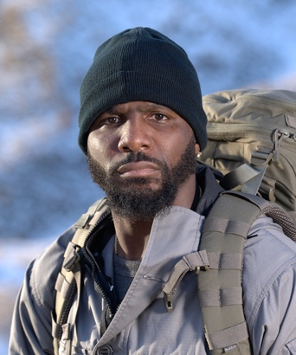  Former All-American and NFL Star  Dez Bryant | 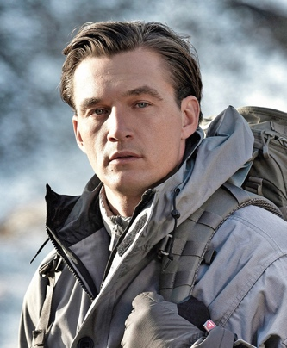  Television Personality and Contractor  Tyler Cameron
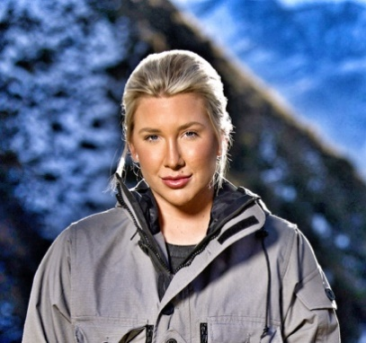  Reality TV Star and Entrepreneur  Savannah Chrisley | 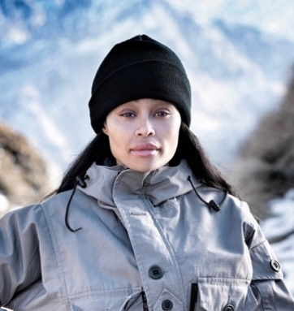  Actress, Model, Influencer and Entrepreneur  Blac Chyna
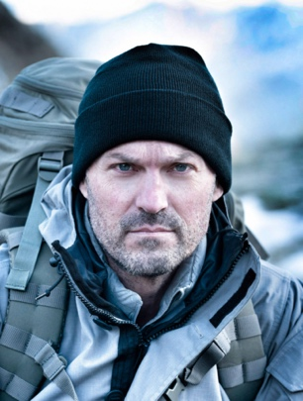  Actor and 90’s Icon  Brian Austin Green | 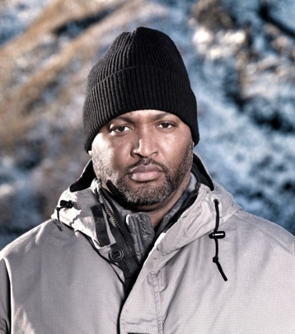  Seven Time NBA Champion  Robert Horry
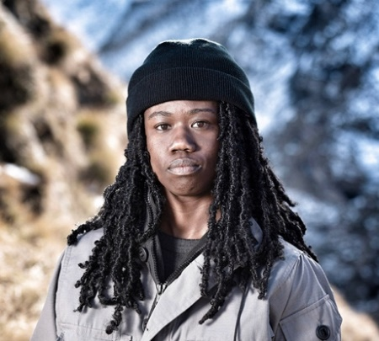  Olympic Gold Medalist Speed Skater  Erin Jackson | 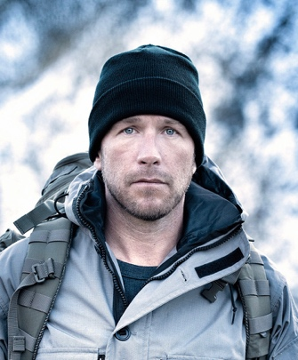  Olympic and World Championship Gold Medalist Alpine Skier Bode Miller
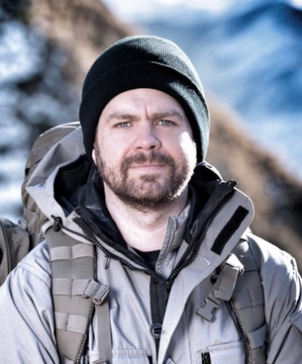  Television Personality and Host  Jack Osbourne | 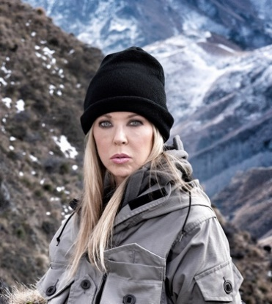  Actress and Pop Culture Phenomenon  Tara Reid
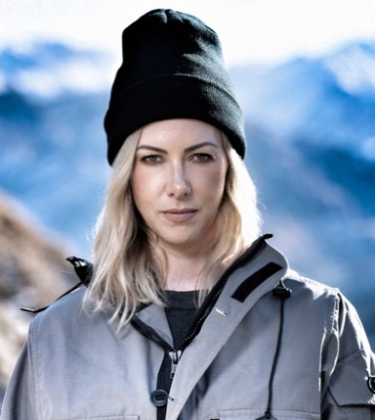  Lifestyle Television Host, Influencer and Producer Kelly Rizzo | 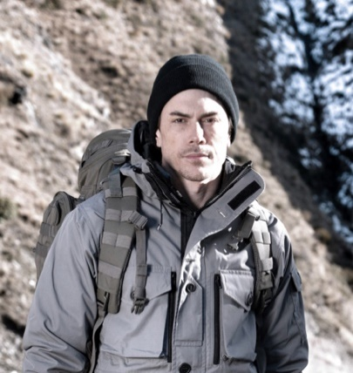  Reality TV Star, Restaurateur and Musician  Tom Sandoval
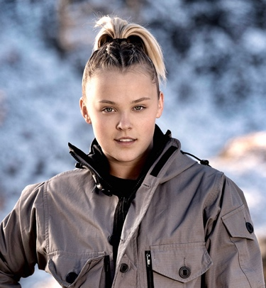  Recording Artist and Global Superstar  JoJo Siwa | 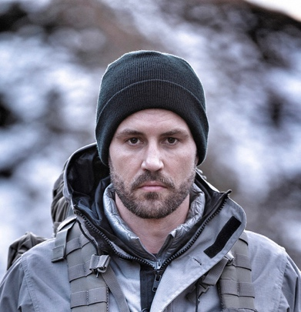  Award-Winning Podcast Host, Author and Television Personality Nick Viall

For photos and more information on Special Forces: World’s Toughest Test, please visit https://www.foxflash.com/shows/special-forces-worlds-toughest-test

About FOX Entertainment
With a legacy spanning more than 35 years, FOX Entertainment is one of the world’s most recognizable media brands and a prolific content producer across its iconic broadcast network and both owned and third-party streaming platforms. Known for its independent, innovative spirit and provocative, groundbreaking storytelling, the company was reinvented in 2019 with the formation of FOX Entertainment. While maintaining its leadership in broadcast television (9-1-1, The Simpsons, The Cleaning Lady, Hell’s Kitchen, LEGO Masters), the company is actively building a portfolio of businesses and library of owned original content. To date, FOX Entertainment’s long-term growth strategy has included the acquisitions of award-winning animation studio Bento Box Entertainment (Bob’s Burgers, The Great North, Krapopolis, Grimsburg), entertainment platform TMZ, and global production studio MarVista Entertainment (The Way Home), as well as the formation of the culinary and lifestyle content venture Studio Ramsay Global (Next Level Chef, Gordon Ramsay’s Food Stars) in partnership with Gordon Ramsay. The company also established its in-house unscripted studio FOX Alternative Entertainment (The Masked Singer, I Can See Your Voice, Name That Tune) and FOX Entertainment Studios (Animal Control) to develop scripted content, worldwide content sales unit FOX Entertainment Global.

-FOX-

Contacts:

Todd Adair Alison Daulerio Jacob Pickar
Todd.Adair@fox.com Alison.Daulerio@fox.com Jacob.Pickar@fox.com

