FOR IMMEDIATE RELEASE
Thursday, December 14, 2023

NEW FARMERS. MORE ROMANCE.

MEET THE FOUR FARMERS IN SEARCH OF TRUE LOVE IN AMERICA’S HEARTLAND
ON THE UPCOMING UNSCRIPTED DATING SERIES
FARMER WANTS A WIFE
SET TO MAKE ITS SEASON TWO DEBUT THURSDAY, FEBRUARY 1 ON FOX

Superstar Entertainer and Grammy Award Winner Jennifer Nettles Returns as Host

Season Two of Farmer Wants a Wife, the most successful dating show in the world, airing in 32 countries and resulting in 201 marriages and 514 children…and counting, returns Thursday, Feb. 1 (9:00-10:00 PM ET/PT) on FOX. In a trend that continues to sweep America, there’s been a migration from city-centers to suburban and rural locales, and with that, love follows. Hosted by superstar entertainer and Grammy Award winner Jennifer Nettles, the anticipated season follows four farmers in search of real, lasting love.

Season Two’s new crop of farmers—Ty Ferrell, Mitchell Kolinsky, Brandon Rogers and Nathan Smothers—host a group of single women who leave behind the comfort and convenience of city life for the charms and challenges of country living, as they embark on an adventure that could change the course of their lives forever.

With diverse backgrounds in cattle ranching, citrus, potato and barley farming, horse training and more, the upcoming season promises an even more in-depth look at the pursuit of genuine love as each farmer and their group of hopeful singles meet and mutually select one another before the women are invited to experience life on their respective farm. From there, the farmers show each group what it is really like on an actual working farm, from tending to the land, harvesting crops and feeding cattle, to the behind-the-scenes business operations.

As the ladies immerse themselves in the realities of farm life, some will blossom while some will head out to pasture, and ALL will quickly learn a manicure only lasts so long in the great outdoors. With this comes even more fish-out-of-water moments, and only time will tell if the ladies have the patience, spirit and adaptability required to be a farmer’s wife. Together, with the hope of finding their ever-after, they endeavor to discover the beauty, humor, trials and romance that come with finding the one.

Click here for a sneak peek at Season Two of Farmer Wants a Wife.

Meet the Farmers:

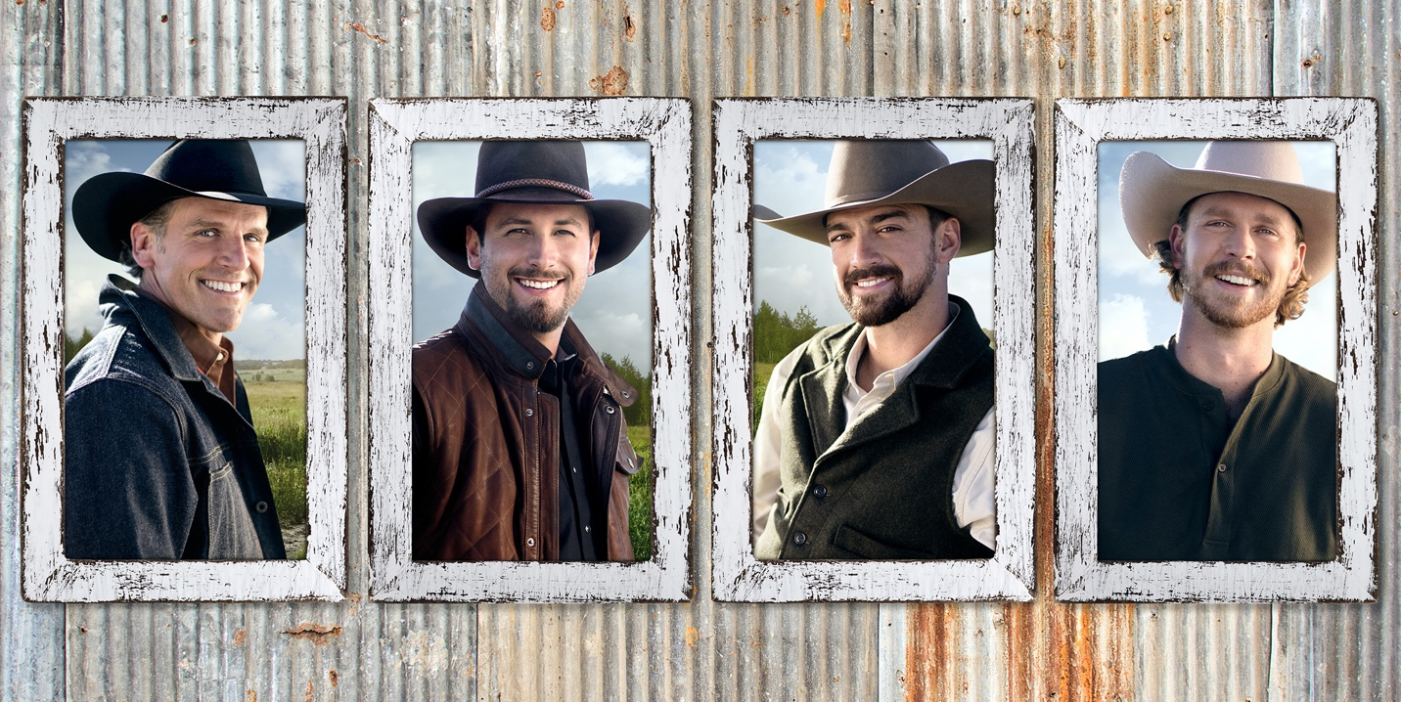

TY FERRELL  Age: 42  Hometown: Sikeston, MO  Current Location: Sikeston, MO  Occupation:  Team Roper  Type of Farm: 50-acre farm with horses and roping cattle  Meet Ty:  Ty is a 42-year-old divorced Dad of a 12-year-old daughter. He’s had rope in his hand since he was a kid, and he hasn’t been without it since. He can’t think of a better life for himself, but the one missing piece has been a special person to continue his life’s journey with. | MITCHELL KOLINSKY  Age: 27  Hometown: Knoxville, TN  Current Location: Mount Juliet, TN  Occupation: 1st Generation Farmer  Type of Farm: New farm with a charming 19th century cabin where he lives with his three dogs. His property in the woods is shared with a variety of wildlife and the openness of the surrounding land welcomes the potential for growth  Meet Mitchell:  Mitchell grew up in Knoxville with horses in his backyard, spending much of his time outdoors. While both his parents and his two brothers have more traditional, white-collar careers, Mitchell fell in love with the beauty and promise of the great outdoors. He knew a life in the heartland was the one for him, so he bought his first farm to pursue his dream of becoming a horse and cattle rancher. He hopes to build a farming legacy with a wife by his side. | BRANDON ROGERS  Age: 29  Hometown: Center, CO  Current Location: Center, CO  Occupation: 2nd Generation Potato and Barley Farmer  Type of Farm: 1,000-acre farm  Meet Brandon:  Brandon is our most remote farmer, living in a small, one-stop-light town surrounded by his farmland. He grew up on the farm working with his Dad. Later in his twenties, he returned to work the farm full time to continue his family's farming legacy. His business is set up and doing well, and now the missing piece is that special person to share it with. | NATHAN SMOTHERS  Age: 23  Hometown: Bartow, FL  Current Location: Bartow, FL  Occupation: 4th Generation Citrus and Cattle Farmer  Type of Farm: 300-acre farm where he resides and an additional 500+ acre cattle property  Meet Nathan:  Nathan grew up working his family’s farm and citrus groves and at 23, is our youngest farmer. When he lost his Dad at 12-years-old, he quickly grew up and became the man of the house, helping to support his Mom and three sisters. He returned to live and work on the farm full time when he graduated from college and is eager to begin his next chapter, including starting a family with the love of his life.

Farmer Wants a Wife is produced by Eureka Productions. Paul Franklin, Chris Culvenor and David Tibballs serve as executive producers. Lauren Taylor Harding serves as an executive producer and the showrunner of the series.

About Eureka Productions
Award-winning unscripted entertainment company, Eureka Productions, was founded in 2016 by Co-CEOs Chris Culvenor and Paul Franklin. Headquartered in Los Angeles and Sydney, the company has since grown a portfolio of over 40 series for network, streaming, cable, and digital platforms in the U.S., Canada, and Australia, becoming one of the TV industry’s fastest growing international producers. Eureka’s current US slate includes returning shows such as the US reboot of The Mole (Netflix), the U.S. version of Fremantle’s international format Farmer Wants a Wife (FOX), as well as all-new upcoming series The Floor (FOX). Other recent productions include Stars on Mars for FOX and The Parent Test for ABC (adapted from Eureka’s Australian hit Parental Guidance). Eureka is also known for US hits such as Holey Moley (ABC), Full Bloom (HBOMax), TwentySomethings Austin (Netflix), Frogger (Peacock), Name That Tune (FOX), The Real Dirty Dancing (FOX), Finding Magic Mike (HBO Max), Dating Around (Netflix) and Crikey It’s the Irwins (Discovery). In Australia, Eureka’s slate includes Million Dollar Island for Channel 7, Luxe Listings for Amazon, Byron Baes for Netflix Amazing Race Australia for Network Ten, Parental Guidance for Nine Network, and many more. In 2022, Eureka also took on the development and production of all Fremantle’s entertainment, reality, and game show formats in Australia, including Australian Idol and Farmer Wants a Wife for Seven Network. Eureka Productions is a Fremantle company. For more information, visit eurekagroup.tv.

About FOX Entertainment
With a legacy spanning more than 35 years, FOX Entertainment is one of the world’s most recognizable media brands and a prolific content producer across its iconic broadcast network and both owned and third-party streaming platforms. Known for its independent, innovative spirit and provocative, groundbreaking storytelling, the company was reinvented in 2019 with the formation of FOX Entertainment. While maintaining its leadership in broadcast television (9-1-1: Lone Star, The Simpsons, The Cleaning Lady, Hell’s Kitchen, LEGO Masters), the company is actively building a portfolio of businesses and library of owned original content. To date, FOX Entertainment’s long-term growth strategy has included the acquisitions of award-winning animation studio Bento Box Entertainment (Bob’s Burgers, The Great North, Krapopolis, Grimsburg), entertainment platform TMZ, and global production studio MarVista Entertainment (The Way Home), as well as the formation of the culinary and lifestyle content venture Studio Ramsay Global (Next Level Chef, Kitchen Nightmares, Gordon Ramsay’s Food Stars) in partnership with Gordon Ramsay. The company also established its in-house unscripted studio FOX Alternative Entertainment (The Masked Singer, We Are Family, Snake Oil, I Can See Your Voice, Name That Tune), FOX Entertainment Studios (Animal Control) to develop scripted content, and worldwide content sales unit FOX Entertainment Global.

-FOX-

Contacts:
Michael Roach
Michael.Roach@fox.com

Taylor Nachreiner
Taylor.Nachreiner@fox.com

