FOR IMMEDIATE RELEASE Contacts: Kelley Kirkpatrick
Wednesday, June 16, 2021 kelley.kirkpatrick@fox.com
Aly Sands
Aly.Sands@fox.com
Kathleen Schumann
Kathleen.Schumann@fox.com

MEET THE 15 HOME COOKS COMPETING ON “MASTERCHEF: LEGENDS”

Contestants from Across U.S. Awarded White Aprons as Competition Kicks into High Gear

Culinary Website Eatwith to Host Cooking Classes with Contestants from This Season

New Episodes Air Wednesdays at 8 PM ET/PT on FOX,
With Upcoming Appearances from Culinary Legends, Including
Roy Choi, Nancy Silverton, Morimoto and More

The competition heats up on MASTERCHEF: LEGENDS with the announcement of the 15 home cooks who earned a coveted white apron. To kick off this season’s audition rounds, award-winning chef Gordon Ramsay, acclaimed chef Aarón Sánchez and renowned restaurateur Joe Bastianich were joined by legends and guest judges Emeril Lagasse, Curtis Stone and Paula Deen. The series will continue to raise the “steaks” with upcoming appearances from other acclaimed chefs, including Roy Choi, Nancy Silverton, Morimoto and Sherry Yard. The 15 home cooks must impress the four renowned judges through all new challenges, including the toughest yet, a head-to-head battle with MASTERCHEF’s own culinary legend, Gordon Ramsay. Only one home cook will ultimately claim the MASTERCHEF title, the $250,000 grand prize, a complete VIKING kitchen and kitchen tools and bakeware products from OXO.

MASTERCHEF has partnered with culinary website Eatwith to host cooking classes with contestants from the show. Join the home cooks from this season after they leave the MASTERCHEF kitchen for exclusive, hands-on cooking classes. Visit eatwith.com/masterchef to find out when your favorite home cooks will be participating. Contestant participation subject to change. Certain terms, conditions and fees will apply.

Below are the hometowns, names and professions of the home cooks who will compete in this season’s MASTERCHEF: LEGENDS.

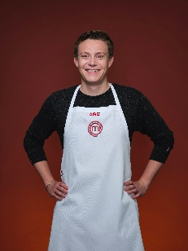 | ABE  Age: 22  City: New York, NY  Occupation: Student  Signature Cuisine: French Fusion

-more-
“MASTERCHEF: LEGENDS” TOP 15 – PAGE 2

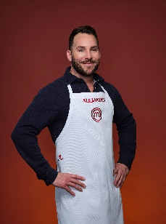 | ALEJANDRO  Age: 39  City: Atlanta, GA  Occupation: Professional Animal Trainer  Signature Cuisine: Mediterranean & Latin Fusion

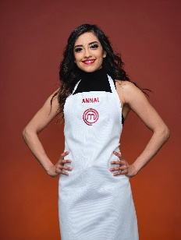 | ANNAI  Age: 25  City: Dallas, TX  Occupation: Legal Assistant  Signature Cuisine: Latin American Fusion Comfort Food

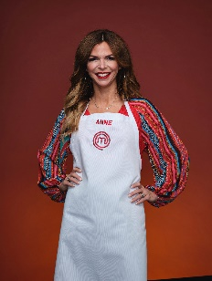 | ANNE  Age: 39  City: Kalamazoo, MI  Occupation: Small Business Owner  Signature Cuisine: Comfort Food

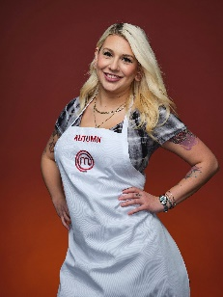 | AUTUMN  Age: 27  City: Boston, MA  Occupation: Bartender  Signature Cuisine: Japanese Italian Fusion

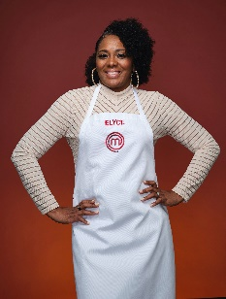 | ELYCE  Age: 39  City: Chicago, IL  Occupation: Salon Owner  Signature Cuisine: Upscale Comfort Soul

-more-

“MASTERCHEF: LEGENDS” TOP 15 – PAGE 3

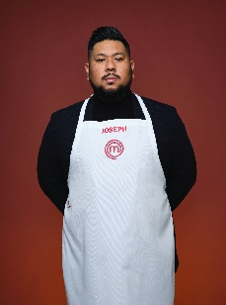 | JOSEPH  Age: 32  City: Houston, TX  Occupation: Environmental Engineer  Signature Cuisine: Asian

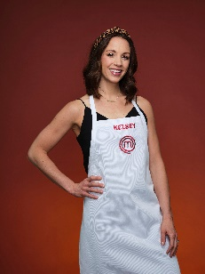 | KELSEY  Age: 32  City: Fishers, IN  Occupation: Physical Therapist  Signature Cuisine: American Comfort Food

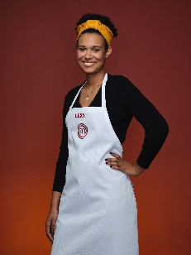 | LEXY  Age: 23  City: Zion, IL  Occupation: Stay-at-Home Mom  Signature Cuisine: Southern Comfort

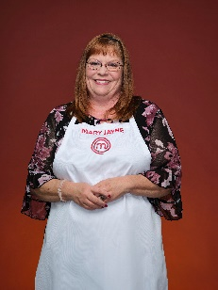 | MARY JAYNE  Age: 59  City: Austin, TX  Occupation: Hospice Nursing Assistant  Signature Cuisine: Old School Southern

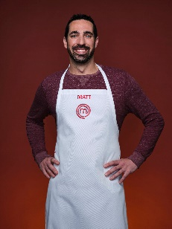 | MATT  Age: 36  City: Cromwell, CT  Occupation: Construction Worker  Signature Cuisine: International

-more-

“MASTERCHEF: LEGENDS” TOP 15 – PAGE 4

 | MICHAEL  Age: 47  City: Asbury Park, NJ  Occupation: Lifestyle Coach  Signature Cuisine: Italian with Seasonal Flavors

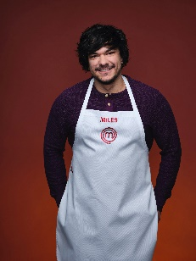 | MILES  Age: 31  City: Frisco, TX  Occupation: YouTube Gamer  Signature Cuisine: Elevated American

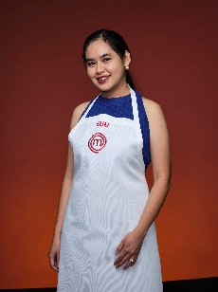 | SUU  Age: 30  City: Houston, TX  Occupation: Food Blogger  Signature Cuisine: Burmese

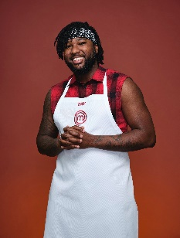 | TAY  Age: 29  City: Omaha, NE  Occupation: Radio Host  Signature Cuisine: Global Inspired Comfort Food

MASTERCHEF is produced by Endemol Shine North America and One Potato Two Potato, and is based on a format created by Franc Roddam. Elisabeth Murdoch, Natalka Znak, Danny Schrader, Gordon Ramsay, Pat Llewellyn, Ben Adler, Sharon Levy, DJ Nurre and Shyam Balsé serve as executive producers.
“Like” MASTERCHEF on Facebook at facebook.com/Masterchef/. Follow the series on Twitter @MasterChefonFOX and join the discussion with #MasterChef. See photos and videos on Instagram @MasterchefonFOX.

[EDITOR’S NOTE: For more information on MASTERCHEF, please visit www.foxflash.com.]

-FOX-

