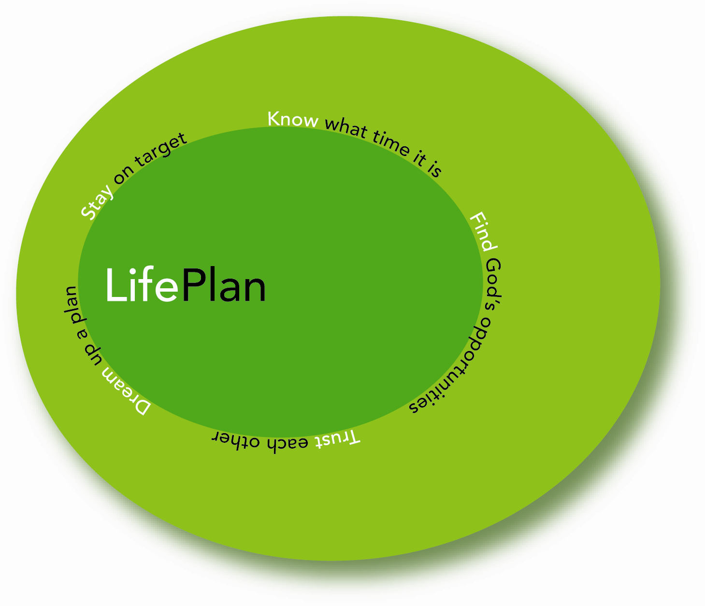
Congregational Survey

We would like to invite you to express your opinions in this survey. The results of this survey will help us as a church discover what we like and value presently about our church and what we hope could become part of our future together as a congregation.
http://www.fmc-canada.org/images/stories/church-develpment/documents/LifePlan/Tally%20of%20Congregational_Survey_July%202010.xls

Information
Gender:
Male / Female
Are you volunteering in this church?  Yes / No | Do you lead volunteers?  Yes / No
Are you a financial supporter?  Yes / No | Are you on the Board?  Yes / No

1. Circle up to six words or phrases that express what you value most about our church?
United | Flexible | Friendly | Good at Evangelism
Meets my needs | Conservative | Caring for the people in the church | Energetic
Visionary idea/plans | Generous with our talents | Prayer is a Priority | On Track
Contemporary | Caters to all generations | Church Planting Vision | Good Leadership
Well Organized | Spiritually Mature | Great Music | Task Focused
Growing (size) | Genuine | Cell/Small Groups | Open to New People
Focused on Neighborhood | Family Friendly Activities | Sense of Tradition | Out of step with the world
Clear Plan | Fun | People Here Help Me Grow | Opportunities to Use My Gifts
Location/Building | Solid Bible Teaching | Spirit Led People/Ministries | Our concern for the Poor
Quality Worship & Prayer Life | Great Pastor | Good Children’s Programs | Friendships
Good Youth Group | Generous with our time | Holy | Laid Back Attitude
Clear Communication Between Leaders & Congregation | Generous with our money | Free Methodist Emphasis | People often meet Jesus here
Practical Sermons | Cares About Missions | Train me how to serve others | Everyone Feels Welcome
I can bring my non-Christian friends here | Lots of different people involved | Good Coffee | ______________________

- Rate the importance you give to the following values that Christians over centuries have placed on the purpose of a local church.
"1" would indicate a low value in your opinion and a "6" would indicate an extremely important value.
Everyone needs to know Jesus and have an opportunity to use their spiritual gifts to reach  out. | 1 2 3 4 5 6
The church is strongest when it connects locally, nationally, and globally to accomplish its  mission. | 1 2 3 4 5 6
Churches and individuals within the church are supposed to grow and reach out to the  unreached. | 1 2 3 4 5 6
The church is primarily a place for developing believers. | 1 2 3 4 5 6
Lay people in the church are team players alongside the pastor. | 1 2 3 4 5 6
Life long learning is essential for knowing God intimately and being faithful. | 1 2 3 4 5 6
We glorify God and show His love to others when generosity is modeled in the local church. | 1 2 3 4 5 6
The church should lead the way in modeling holiness and social justice for all. | 1 2 3 4 5 6

3. In your opinion what six words or phrases best express concerns you have about our church.
Only meets our needs | Discouraged | Looks after itself
Unrealistic | Ingrown | Contemporary
Conservative | Tired members and leaders | Caters to our Community
Caters only to the young | Out of Step with the world | Focused on itself
Selfish | Prayerless | Poorly led
Institutionalized | Spiritually superficial | Unclear communication
Music | Fractured | Directionless
Task Focused | Uncaring | Infighting
Too outward focused | Traditional | ______________________

4. In your opinion, to what sort of people IS this church most attractive? Circle three.
Families | Youth | Young Adults
Children | Ethnic Groups | Free Methodists
Lower Income | Singles | Blue Collar
White Collar | Single Parents | Seniors
People who are searching for God | _________________________ | ___________________________

5. What sort of people do you wish our church WAS more attractive to? Circle three.
Families | Youth | Young Adults
Children | Ethnic Groups | Free Methodists
Lower Income | Singles | Blue Collar
White Collar | Single Parents | Seniors
People who are searching for God | __________________________ | __________________________

6. What sorts of things will we need to do as a church to become more attractive to these people?
Family friendly activities | More training to serve | A new location/building
New leadership | Solid Bible teaching | Opportunities to use my gifts
More concern for the poor | Quality worship and prayer life | More Fun
New pastor | Visionary ideas/plans | A clearer plan
Plant a church | More people involved | More generous with our talents
A better youth group | More focus on missions | Focus more on the neighbourhood
Be a place I can bring my non-Christian friends to | Clearer communication between leaders and congregation | A place where people meeting Jesus
More United | Free Methodist Emphasis | More evangelism
A laid back attitude | Spirit Led people/ministries | Practical sermons
Better coffee | More open to new people | More generous with our money
More Flexible | More Friendly | More Spiritually Mature
Cell/Small Groups | Meet my needs | More Conservative
More Caring for the people in the church | More generous with our time | Change in Music
Everyone Feels Welcome | More Energetic | Make Prayer a Priority
Better Children’s Programs | More Organized | Get back on track
More Contemporary | Cater more to all generations | More Focus on Growth (size)
More sense of tradition | Not so worldly | Stronger Friendships
Focus on Holiness | Focus on Helping People Grow | _______________________

- Please indicate your level of agreement or disagreement with the following statements by circling the number that most closely represents your opinion. "1" indicates strong disagreement and "6" indicates strong agreement.
The service should be orderly and traditional | 1 2 3 4 5 6
The service should be informal and contemporary | 1 2 3 4 5 6
The service should balance the needs of the members and the people we are trying to reach. | 1 2 3 4 5 6
It is important that new people become a part of this church. | 1 2 3 4 5 6
We need to plant churches to reach our community. | 1 2 3 4 5 6
God wants to move us into some uncomfortable areas. | 1 2 3 4 5 6
The comfort of people new to Christianity is more important than my comfort. | 1 2 3 4 5 6
It is more important to help Christians grow than to reach out to people who don't know Jesus. | 1 2 3 4 5 6
I think the pastor should be the one to set direction of the church. | 1 2 3 4 5 6
I think the congregation should set the direction of the church. | 1 2 3 4 5 6
The most important tasks of the church should be done by the pastor. | 1 2 3 4 5 6
I would like to see more women in leadership here. | 1 2 3 4 5 6
I think that we should take things as they come rather than planning and setting goals. | 1 2 3 4 5 6
Change is pretty easy for us as a congregation. | 1 2 3 4 5 6
It is more important that we move toward our goals than attempting not to hurt or offend  someone. | 1 2 3 4 5 6
We should regularly hear sermons on generosity of time, talent and money. | 1 2 3 4 5 6
It's important to ask for regular and sacrificial gifts in order to fulfill our mission. | 1 2 3 4 5 6
We need to regularly provide support and assistance to those who are in financial crisis outside  our congregation. (i.e., immediate neighbourhood, in our town, etc.) | 1 2 3 4 5 6
I think it is important that we reach out to people of cultures different from our own. | 1 2 3 4 5 6
It's important for our church to be active in supporting cross-cultural mission work. | 1 2 3 4 5 6
Our church needs to be actively involved in issues of concern to our community. | 1 2 3 4 5 6

On behalf of the pastor and board we would like to thank you for taking the time to fill in this survey. This information will become an essential part of the decision making and direction of the church. If you have any questions about this survey or this process in general please contact the office.

