677 Harbor Edge Cir, Memphis, TN
 XSG321@UTHSC.EDU
 865-335-1295

Dhuha Arkawazi

Experience
Pharmacy Technician • CVS • 2021
Supervisor: Tre Foster, Pharm.D.
- Assist patients in performing covid testing during the peak of COVID-19 pandemic. As well as educating patients on the importance of receiving the COVID-19 vaccinations.
- Responsible for communicating what the drug is prescribed for, drugs side effects, directions for use and what to do if a question regarding the medication arises later.
- Responsible for emphasizing the importance of drug adherence and addressing obstacles that may prevent patient drug adherence.
- Contact insurance companies on behalf of the patients to resolve any payment issues that may arise when picking up medication.

Education
DOCTOR OF PHARMACY • 2022 – PRESENT
University of Tennessee Health Science Center College of Pharmacy, Memphis, TN
BACHELOR IN PHARMACEUTICAL SCIENCES CANDIDATE • 2022 – PRESENT
University of Tennessee Health Science Center College of Pharmacy, Memphis, TN
MBA CANDIDATE • 2023 – PRESENT
University of Memphis, Memphis, TN
BACHELOR OF SCIENCE IN BIOCHMISTRY (minor in pre-pharmacy concentration) • 2019-2023
University of Tennessee, Knoxville, TN

skills
Bilingual • Arabic
AHA CPR and First Aid certified • 2022
eCard Code: 225417162609
APhA pharmacy based immunization certified • 2023
APha Provider #: 503800
OSHA Bloodborne Pathogens Training certificate • 2023

Achievement
Accepted in the pharmacy 3+1 program • 2021
University of Tennessee, Knoxville, TN

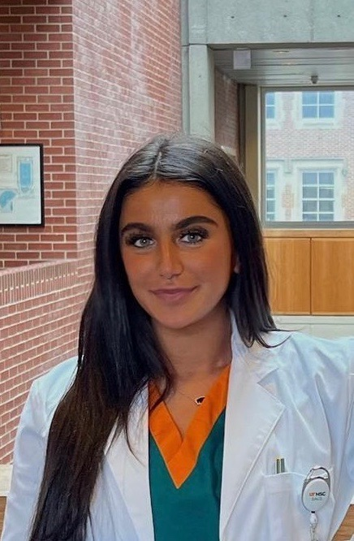

oBJECTIVE
Competent in the pharmacological aspect of health care and will use my expertise in pharmacokinetic and pharmacodynamic to maximize patients’ medication therapy. My effective bilingual skills will be useful in communicating with the Arabic immigrant population.

 | Xsg321@uthsc.edu

Objective
Replace this sentence with your job objective. To replace any tip text with your own, just select a line of text and start typing. For best results when selecting text to copy or replace, don’t include space to the right of the characters in your selection.

