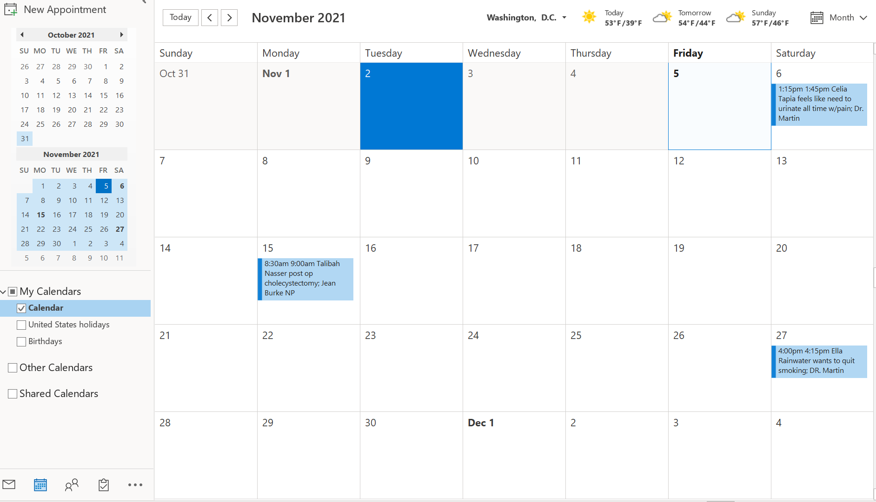
One advantage to using a computerized appointment scheduling system is that you have less of a chance to double book a patient on the schedule. Another Advantage is that more than one employee can be in the scheduling system at a time.
A disadvantage to using a computerized appointment scheduling system is if someone doesn’t keep up on the calendar and marking days off and or meetings. When you lose power and can’t access the schedule that is another disadvantage.
Double booking is one method of appointment scheduling. This method is when a provider chooses to place two patients in them same time slot. One benefit to using double booking you have a better chance of being fully productive in a days’ time.

