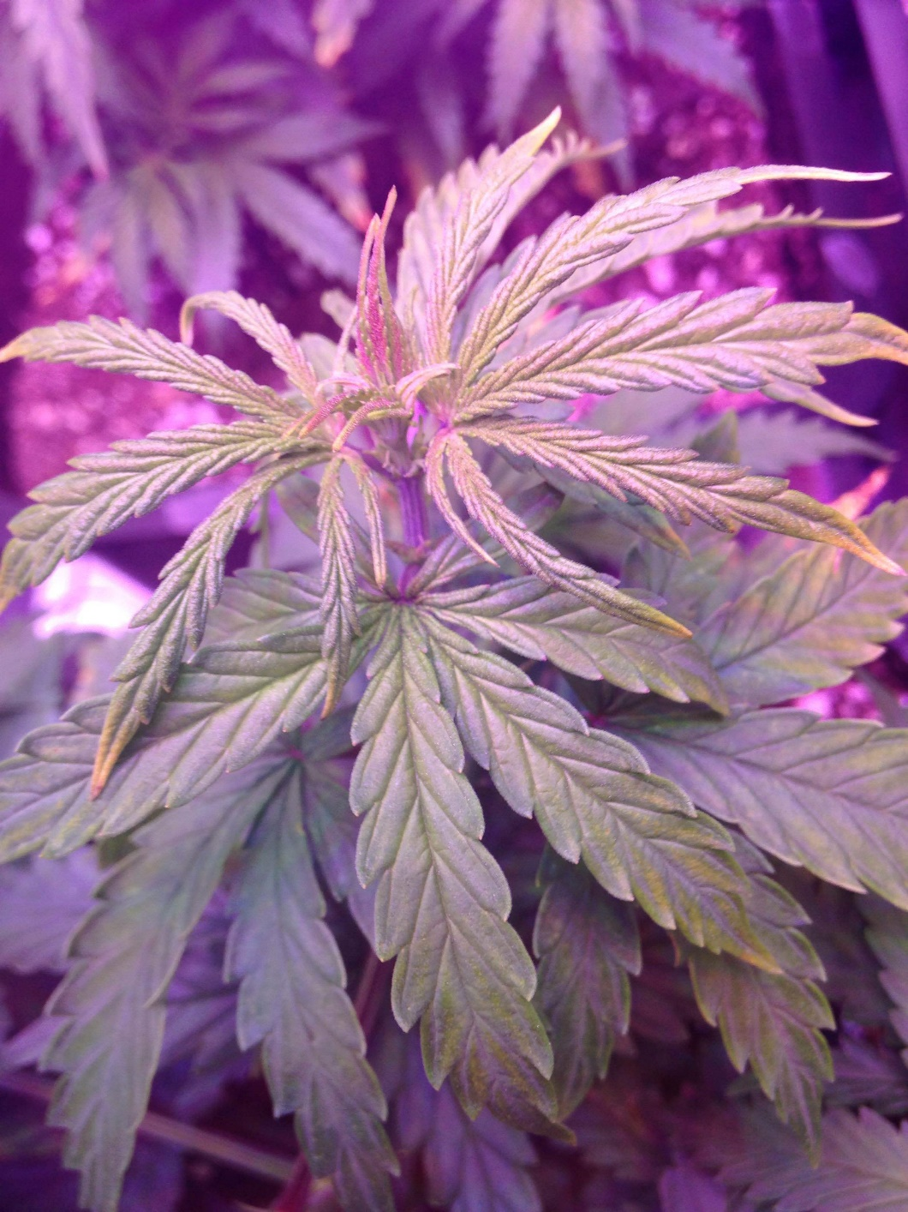
Legalizing Marijuana in the UNITED STATES

Valeno’ C. Gordon

Susie Roubideaux
ENGL302
December 10, 2022
Introduction
Daily, we see people suffering from numerous diseases such as Cancer, HIV/AIDS, MS, Epilepsy, ALS, and even chronic pain. If marijuana were legalized, the people I speak of would have better access to the drug. In research studies, about half of American participants have tried marijuana at least once. There is no chemical alteration in marijuana, unlike other legal or illegal substances. Marijuana does not compare to other legal substances such as alcohol, tobacco, or many medications. Despite this, law enforcement makes daily arrests that tear families apart because of a plant safer than alcohol in a nation dedicated to "life, liberty, and happiness." I stand for the legalization of marijuana and want to show how I believe the government does not look at how legalizing marijuana would bring more education about the drug, more revenue to each state, and allow the country to profit from a drug of natural substance.

Cannabis is a plant-based drug grown from seeds and can be smoked or eaten like tobacco. Cannabis is not only called marijuana but has many street names like weed, pot, bud, and herb. Because marijuana is a plant, dating its origin is difficult, but it has been dated to B.C., centuries ago. Since weed is considered an illegal toxic substance, it is well-studied on the streets, making it a well-known, profitable substance.
The lack of education surrounding marijuana and society's assumptions about the drug pose obstacles to marijuana becoming legalized. People often talk about marijuana becoming a gateway drug for other drugs to become a problem, but we hear in the U.S. fight opioid addiction every day. Approximately 0.5 million people die each year as a result of drug use. Among these deaths, more than 70% are caused by opioids, with overdoses accounting for over 30% of the deaths (United Nations Publications, 2018). Opioids, a drug that the FDA approved, have been legalized for chronic pain since 1911 and are considered an epidemic (Dyer, 2019). However, the government refuses to take the drug off the market. Marijuana has never been reported to any outlet to result in death or harm, yet people have been reported to have died as a result of taking opioids. This is a legal drug that can lead their bodies down dangerous paths and cause them to become addicted. Even more than marijuana, opioids have been shown to increase the likelihood of using other drugs.
Why are there concerns about the government legalizing marijuana? It appears that the fight is over Tetrahydrocannabinol (THC), a crystalline compound, the main active ingredient in marijuana that produces the "high" sensation. Marijuana plants give off a feeling that concerns people more than being legalized. Cannabis growers who use banned pesticides, divert waterways, and create different types of marijuana can cause more harm than good, according to the government.
What if marijuana were regulated? The legalization of marijuana will put an end to illegal growers and create more jobs for the industry. Making sure those same street pushers are moved from corners to stores for a real income. As a matter of fact, illegal growers usually have a deeper understanding of cannabis than the government. As a result, the government can benefit financially. In what way? Increased weed legalization will reduce government spending on correctional, judicial, and prosecutorial services. Taxes and licensing on marijuana could also generate extra revenue for the states. Monitoring cannabis businesses can ensure compliance with environmental and zoning laws (Petkovic, 2022).
Marijuana revenue taxes can be used in any way that states with legal marijuana choose. According to Oregon's 2021 revenue divisions for cannabis, cannabis accounted for $46.9 million in first-quarter revenue during the fiscal year 2021. This is a compelling example of the advantages of legalizing marijuana (Petkovic, 2022).
Example:
- 40% went to state schools
- 20% was credited to the Mental Health, Alcoholism, and Drug Services account
- 15% was paid to support the state police
- 10% is devoted to cities and counties for law enforcement
- 5% was given to the Oregon Health Authority for alcohol and drug abuse prevention
Now let us look at marijuana's health benefits and how it can benefit those with illnesses that marijuana can help. Cannabis has consistently been found to be less toxic, less addictive, and less likely to cause serious health problems than alcohol. In addition to chronic alcohol consumption, 2,200 Americans die from acute overdoses yearly, according to the (CDC) Centers for Disease Control and Prevention (Marijuana Policy Project, 2022). There has never been a confirmed cannabis overdose death (Polson, 2021), and no studies have shown that cannabis increases mortality. A law that steers consumers towards more dangerous substances seems counterproductive.
No doubt, legalizing medical marijuana has many benefits, but this one is the most crucial. The use of cannabis may enhance the chances of survival for patients battling deadly diseases with low survival rates. There is no doubt that this is a strong argument. In general, marijuana compounds are believed to boost our immune system, mainly through our own ECS (endocannabinoids). A more comprehensive study is needed, according to the CDC. My goal is to provide you with a list of current benefits. In a Canadian study, CBD was found to have anti-inflammatory properties. However, one should avoid smoking it after surgery (Avramovic, 2022).
Most Americans who favor legalization point out the drug's perceived medical benefits and believe it would allow law enforcement to focus on other crimes. Gallup surveyed 86% and 70% of Americans in the spring of 2019 and found these reasons to be very valid reasons for supporting the drug. Additionally, people have also found that medical marijuana is more beneficial to their healing progress when compared to other drugs, which is the main reason for legalizing the drug. The use of marijuana by people with cancer has been reported to help them. It has also been reported that marijuana is beneficial to people with many other diseases, including anxiety and depression, to name a few.
List of Diseases Reported:
- Cancer
- Epilepsy
- Alzheimer’s
- Arthritis
- PTSD
- ADHD
- Obesity
- Acne
- Insomnia
- Autism
- Depression
- Anxiety
- Addiction
- HIV
- Diabetes
In light of all that has been listed above about the benefits of marijuana, the government should take a deeper look at the benefits of cannabis. Rather than focusing on a drug that has caused less harm to society, they should focus on a drug that is causing harm and deaths.
Conclusion:
Ultimately, I believe that legalizing marijuana is beneficial in many ways. It will benefit the government in many ways, but it has a much more significant benefit in terms of the health benefits it brings to those who need it medically. There can be no doubt that the opposition to legalizing marijuana is truly a slap in the face. This is when you consider that drugs such as opioids, cigarettes, alcohol, and fentanyl kill people on a daily basis. Cannabis is the only drug that has the potential to be both safe, helpful, and beneficial to our country as a whole. Studying for yourself is the most effective way to gain knowledge of something. Please do not take my word for it, but make sure that you conduct your research so you can see that a drug people are torn away from their families for, or people who are dying due to ignorance or a lack of education, is not taken seriously. In order to combat the many diseases that impede people's daily lives, marijuana should be the first choice of drug for treating them.

References
6 facts about Americans and marijuana. (2021, August 23). Pew Research Center. https://www.pewresearch.org/fact-tank/2021/04/26/facts-about-marijuana/
Dyer, O. (2019). US opioid epidemic: FDA demands studies of whether opioids do control chronic pain. BMJ, l959. https://doi.org/10.1136/bmj.l959
A marijuana legalization model using benefits, opportunities, costs and risks (BOCR) analysis. (0001, January 1). Digital Object Identifier System. https://doi.org/10.4018/ijsds.2015040101
Marijuana Policy Project. (n.d.). Top 10 reasons to legalize and regulate cannabis. MPP. https://www.mpp.org/issues/legalization/top-ten-reasons-to-end-marijuana-prohibition/
Petkovic, B. (2022, February 26). Benefits of legalizing weed are beyond impressive in 2022. LoudCloudHealth. https://loudcloudhealth.com/resources/benefits-of-legalizing-weed/
United Nations Publications. (2018). World drug report 2018 (Set of 5 booklets).
What is marijuana? (2021, April 13). National Institute on Drug Abuse. https://nida.nih.gov/publications/research-reports/marijuana/what-marijuana
What is Tetrohydrocannabinol? | Delta 9 THC definition by Weedmaps. (2021, July 14). Weedmaps. https://weedmaps.com/learn/dictionary/tetrahydrocannabinol-thc.

