African American Women & Obesity
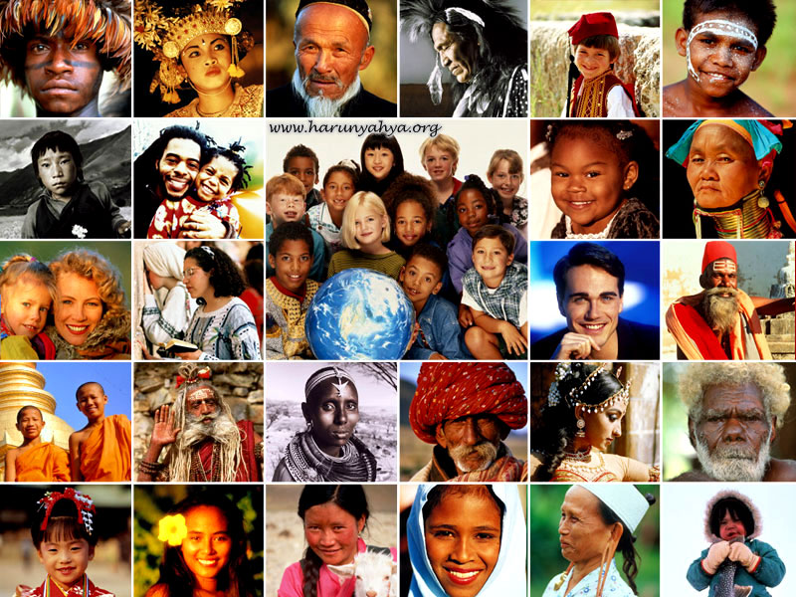

By: Cheryl Bruce | Evaluation Report

African American Women & Obesity
Evaluation Report
Introduction
In America, nearly 40 percent of adults are obese, resulting in health care costs of some $190 billion each year to manage preventable diseases. Black and Latino adults in the U.S. have disproportionately higher rates of obesity. Predominantly black neighborhoods have been systematically demarcated and devalued. African American women disproportionately has lower access to fresh food, higher access to fast food and other unhealthy options, and reduced access to opportunities for physical activity. Research shows that discrimination negatively affects individual health, with weight discrimination being associated with the decreased ability to fight inflammation, metabolize foods and regulate blood sugar. Given the racial disparity in obesity outcomes and chronic stress measures, added racial discrimination experienced by blacks has the potential to further amplify the physiological impacts of weight discrimination. This is my proposal as a healthcare worker, to reduce the disparity of African American women to help educate and offer them the resources to improve their health.

Summary of Health Service Issue
The pervasiveness of disparities affecting diverse racial/ethnic minority populations across the spectrum of health outcomes speaks loudly to the point that structural factors are also involved. The dialectic around health disparities continues to focus on equity and social justice and on the fallacy of interpreting as genetic the systemic, biologically relevant, and transmissible health effects of responses to institutionalized racism and social disadvantage. The higher mortality of African Americans from obesity-related conditions such as CVD, diabetes, and certain types of cancer and the risk of heart disease. If one concedes that disease and disability is an important part of the picture. There is strong evidence that obesity can worsen the health of both African American women and men. This evidence comes from studies that show increased rates of development of disease and disability in those with high BMI levels compared with leaner counterparts. The willingness to work with communities in the development and evaluation of potentially effective programs to help reduce the disparity in African American cultures.

Personal Bias(es)
My role as a healthcare worker in social services is to ensure obesity prevention can be accomplished. It is my goal to help reduce the disparity of obesity for African American Woman. Without the outreach programs to help reduce the disparity for obese, it can lead to medical problems. In this proposal, I am providing interventions for prevention, treatment, and rehabilitation using primary, evidence-based research and the recommendations of the U.S. Department of Health and Human Services U.S. Preventive Services. To represent the general effectiveness of obesity prevention and treatment programs, and the challenges of disparity that African American women face within their communities.

Education and Outreach
One effective program to help reduse disparity of obesity for African American women is called; “AACORN.” It is a program that brings research centers around the U.S. to promote community health, nutritional epidemiology, public health, clinical nutrition and dietetics, women's gender studies, exercise science and physical activity epidemiology, weight management intervention research, cardiovascular disease epidemiology and prevention, diabetes management and epidemiology, cancer control, and community‐based participatory research. AACORN includes a review of weight‐related research in African American communities and highlights of obesity‐related research initiatives at the Centers for Disease Control and Prevention. To prevent cardiovascular diseases, the metabolic syndrome, prothrombotic and procoagulant states, asthma, and sleep disorders, about the current understanding of biological, behavioral, and environmental determinants of obesity, and about clinical and community‐based approaches to obesity prevention and treatment.
https://www.msm.edu/Administration/MarketingandCommunications/MSMNews/MSMNewsDocuments/November2014/Nov10/Journal-Club-Reader-1112.pdf
The second program I researched to reduce disparity it is called; “LIFE Project.” The LIFE Project is a church-based, weight-loss intervention program that directly resulted from the input of rural African American women. LIFE was developed out of community residents expressed need for a weight-loss intervention program focusing on nutrition and physical activity education to help them avoid chronic conditions such as diabetes that are related to overweight and/or obesity. LIFE is a 10-day program in churches for African American obese women. Each session is approximately 90 minutes, with additional time allocated for discussion and sampling of healthy foods. The LIFE project expresses the need for an educational weight-loss intervention program. The healthcare providers educate the African American women in sessions about weight control and healthy diets. It also recognizes the link between personal lifestyle behaviors, the health care system, and individuals’ need to be able to talk to health care providers in order to manage their health and medical concerns.
https://www.ncbi.nlm.nih.gov/pmc/articles/PMC2852247/
The third program is called; “REACH Program.” It is the CDC’s Racial and Ethnic Approaches to Community Health (REACH) program that empowers the ethnic community to seek better health. Funding for local healthcare practices, and mobilized communities to implement evidence-based public health programs to reduce health disparities across a broad range of health conditions. It is part of the American Recovery and Reinvestment Act (ARRA); with additional funds from the Affordable Care Act, the 50 CDC-funded Communities Putting Prevention to Work (CPPW). These programs are to support statewide and community-based policy and environmental changes in nutrition, physical activity, and tobacco control, directly targeting factors that may harm people’s health.
https://minorityhealth.hhs.gov/npa/files/plans/hhs/hhs_plan_complete.pdf

The fourth program is called; American Public Health Association, APHA This is a public health organization that optimizes the conditions where people are born, grow, live, learn and age. They work with other organizations to address the factors that influences health including, employment, housing, education, healthcare, public safety and food access. They help reduce the disparities in communities to reduce racism of where social determinants are distributed. When barriers prevent individuals and communities from accessing these conditions and reaching their full potential. Inequities differ from health disparities which are differences in health status between people related to social or demographic factors such as race, gender, income or geographic region. Health disparities are one way we can measure our progress toward achieving health equity. APHA values all people of different cultures equally.
https://www.apha.org/topics-and-issues/health-equity
Conclusion
Obesity is a major health problem in the United States for the African American culture. Obesity disproportionately affects black adolescent girls and women, who have the highest prevalence of overweight among male and female Black, White, and Hispanics. These intervention programs are effective to help reduce this disparity in their communities. Promoting the programs will help give resources to the African American cultural. The programs will help provide nutritionist fresh foods and educate them to eat healthier. In doing so, this will help reduce the rates in their community from obesity that can lead to medical illnesses diabetes and heart disease. The programs teaches young children in the African cultural, this will prevent them from obesity later in life.
As a healthcare in human and social services, I am presenting this evaluation report to promote the funding for the African American culture, to provide support and to prevent disparity of obesity in their communities.

References
Kumanyika, Shiriki, PhD, MPH Volume 2: 4, October 2005 “Obesity, Health Disparities, and Prevention Paradigms: Hard Questions and Hard Choices”
https://www.cdc.gov/pcd/issues/2005/oct/05_0025.htm
Kumanyika SK, Whitt-Glover MC, Haire-Joshu D. What works for obesity prevention and treatment in black Americans? Research directions. Obese Rev. 2014;15 Suppl 4:204-212. doi:10.1111/obr.12213
https://pubmed.ncbi.nlm.nih.gov/25196414/
Kumanyika, K, Shiriki,: Gary, L.,Tiffany,; Lancaster, J., Kristie,; Samual-Hodge, D.,Carmen,; Wallace-Banks, Joanne,; Beech, M., Betting,; Hughes-Halbert, Chanita,; Karanja, Nieri,; Odoms-Young, M.,Angela,; Prewitt, T.,Elaine,; veronicaWhit-Glover, C.,Melicia “Achieving Healthy Weight in African‐American Communities: Research Perspectives and Priorities,” First published: 27 November 2012
https://www.msm.edu/Administration/MarketingandCommunications/MSMNews/MSMNewsDocuments/November2014/Nov10/Journal-Club-Reader-1112.pdf
Parker, G.,Veronica, Professor, School of Nursing, Clemson University Director, Center for Research on Health Disparities, Clemson University Clemson, SC; “The LIFE Project: A Community-Based Weight Loss Intervention Program for Rural African American Women” Author manuscript; available in PMC 2011 Apr 1.
https://www.ncbi.nlm.nih.gov/pmc/articles/PMC2852247/
Centers for Disease Control and Prevention (CDC). CDC Health Disparities and Inequalities Report – United States, 2011. MMWR 2011; 60 (Supplement): 1-114. “HHS Action Plan to Reduce Racial and Ethnic Health Disparities”
https://minorityhealth.hhs.gov/npa/files/plans/hhs/hhs_plan_complete.pdf
2020 © American Public Health Association APHA
https://www.apha.org/topics-and-issues/health-equity

