How should we make the federal to increase the minimum wage since everything is increasing?
Ubah Ismael
Bryant & Stratton College
J-ENGL302: Advanced Research and Writing
There are many changes taking place in the globe right now that we are all experiencing. However, there are minimal salaries in the United States of America for employees The current federal minimum wage makes it impossible to maintain oneself because of the real minimum wage decreasing, many workers no longer have enough money to make ends meet. To combat poverty, offer economic security, and benefit workers, government officials at all levels must work to boost the minimum wage. People are currently who commonly make the federal minimum wage or less, would gain disproportionately from this. A fair and inclusive economy is developed when the labor market conditions for those who are most at risk are improved.
The federal government is fiscally responsible to all the states and regions in the country. That said, states and regions do not receive equal grants and aid from the federal government. Economic research demonstrates that the allocation and distribution of federal. For example, “The economic goals of the United States government include maintaining high levels of employment, establishing stable prices for goods and services, and controlling the pace of economic activity. The United States government uses the tools of fiscal policy and monetary policy to achieve those goals. suggest that while poorer cities receive more money from anti-poverty funds, they receive less from other fiscal funds intended for maintenance and improvement to physical infrastructure. Even more the in increasing the minimum wage would help many people to have or saving for their families or even survive in life.
The US government's economic objectives include preserving high employment rates, stabilizing the cost of goods and services, and managing the rate of economic growth. The US government accomplishes these objectives through monetary and fiscal policy. Fiscal policy refers to the taxes imposed to fund the expenditures made by the federal, state, and local governments. The federal budget is supported and funded by fiscal policy, which also helps the federal government's social initiatives and encourages overall economic stability and growth. Contracts, grants, loans, and direct payments like Social Security are all included in federal spending.
The lower classes and even the middle class nowadays face many difficulties due to the harsh times the world has been through. As we look to the future, state, and local governments, who have been forced to become more financially independent due to the recession and changes in federal fiscal policy, have the responsibility of developing and implementing fiscal policies that protect and strengthen their cities and urban regions. Policymakers in the state government have a chance to make significant policy strides in a variety of areas, including assistance for working families, budget transparency, and long-term budget planning. When attempting to evaluate the income distribution in an economic system, wealth—defined as the worth of all an individual's possessions less all the debts the individual owes—is not always apparent. The explanation is that wealth can develop even when no money is coming in. For federal to increasing the minimum wages it takes a lot of work to even make one step. Increasing employee morale could easily result in more concrete advantages like higher employee retention and lower hiring and training expenses. Greater growth opportunities and a general decline in job-related stress could benefit employees who are more likely to stay with a company for a longer period.
However, State legislators must increase their respective minimum wages. Some states have taken it upon themselves to raise their minimum wages to more reasonable standards because of the federal government's failure to increase the federal minimum wage. Eleven states have raised their state minimum wages above the federal level as of January 1, 2022, including California, Connecticut, Delaware, Florida, Illinois, Maryland, Massachusetts, New Jersey, New York, Rhode Island, and Virginia. State-by-state discrepancies must be eliminated and state in the South need to work to raise their minimum wages after years of inaction.
This picture shows how many states are increasing the minimum wage in the next years coming.
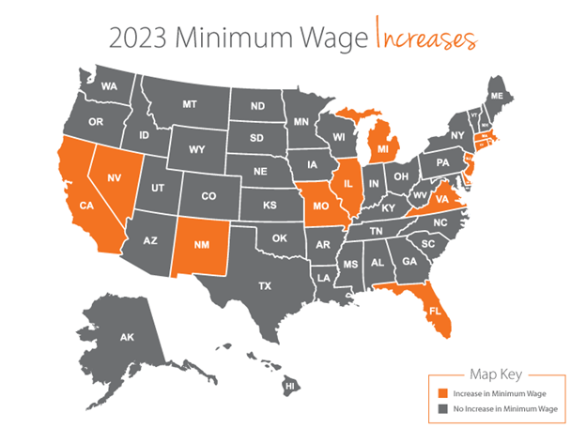
It can be challenging for businesses with workers in many states to stay on top of all the minimum wage changes. U’s states remain stick to the federal minimum wage, even though some are on a timetable for annual hikes to eventually reach $15 an hour. Although the $7.25 federal minimum wage has been unchanged since 2009, more than a dozen states will continue to raise their minimum pay for hourly workers beginning in 2023, including over half of the states. On top of that theses is a lot of daily expenses increasing like grocery, gas, and many more coming. With working minimum wage job is not going to cover everything in daily basis we need to live. In the coming years the minimum wages will only increase small percentage. And the expenses will increase higher percentage. This is not good for the million people who live in the United States and around the world. However, many workers no longer have enough income to make ends meet because of the real minimum wage declining: The existing federal minimum wage makes it impossible to support oneself. Government officials at all levels must endeavor to raise the minimum wage to combat poverty, provide economic security, and benefit workers. This would disproportionately benefit women and people of color who frequently earn the federal minimum wage or less. Improved labor market conditions for individuals who are most at risk contribute to the development of a fair and inclusive economy.

Reference
Flynn, Simone I. (2021) Urban Fiscal policy. https://discovery.ebsco.com/c/zbkays/details/yljrntp25j?limiters=FT%3AY&q=%E2%80%A2%09How%20should%20we%20make%20the%20federal%20to%20increase%20the%20minimum%20wage%20since%20everything%20is%20increasing%3F%20%20
Wages and Compensation Casteel, P.D (2021). https://discovery.ebsco.com/c/zbkays/details/qkwzbzbchz?limiters=FT%3AY&q=%20the%20federal%20to%20increase%20the%20minimum%20wage%20since%20everything%20is%20increasing%3F
Pete Rathbun. (2022). What Are the Pros and Cons of Raising the Minimum. Maverick. Reviewed. https://www.investopedia.com/articles/markets-economy/090516/what-are-pros-and-cons-raising-minimum-wage.asp

