Why does a business need financial management?

Statement of the Problem
The concept of financial management and why it is crucial to business is one of the main concerns in the business industry. help in demonstrating which goods or services are financially successful in business. It will be possible to determine to a greater extent whether business will have control over their financial management by looking at study data on the subject. Additionally, a lot of businesses are converting to online stores, and many more are opening up online shops. It is crucial to comprehend why businesses experience issues with their financial management. Measures and the relationship to the growth or decline in the business financial industry aid in improving the profitability of the business and help set up a fantastic financial plan. This is a highly interesting topic because many companies are leaving the market because they are losing a lot of money.

Data
The information used in this study came from a published investigation of the state-by-state financial management issues in the United States. Excel was used to perform both descriptive statistics and analysis on the data. Excel and other graphics projects were used to set up the data. Key data components including the mean, median, and standard deviation were established using descriptive statistics in Excel's Data Analysis section. The statistics indicated a measure of increase or decline related to the fact that businesses have lost a lot of money when our economy is experiencing problems.

Literature Review
The study on the subject of financial management issues concentrated on a company and the effects that being online has on economics. reviewed academic research on this subject.
The research that I believe is crucial to financial management is “As a result, reforms to the unit, particularly financial management, are required to adapt the unit to the market economy environment and achieve long-term development under the national policy and the market economy environment.” (Chen, Weidan, 2022). First, the researcher discovered that the sentence was speaking generally about market and financial management. However, “one is the research on qualitative financial risk classification and prediction, which mainly uses subjective and artificial evaluation systems such as decision-making evaluation and brainstorming to judge and analyze new things and problems through the summary of past individual or group experience, which often has certain limitations.” (Cheng, Huifang; Zhang, Xishuan, 2022). The researcher is providing the evidence that financial management issues can be resolved, helping to lower the risks that businesses will experience and the possibility that they will failure. Although, “the high degree of complexity and increased channel unreliability make companies resist the great challenge of financial management systems' ability to face uncertain events, corporate supply chains become increasingly vulnerable, and unreliability has become a common and indispensable phenomenon in many economic and management decision problems.” Cheng, Huifang; Zhang, Xishuan, 2022). In this researcher is basically show the challenges that business faces when the ability of financial management systems to handle uncertainty is a significant difficulty as business supply networks become more exposed and unreliability has become a prevalent and essential problem.

Goal Statement
My research ultimately aims to identify the best practices for effective financial management in small businesses. Can the political establishment also assist businesses with their needs? Since there are more people shopping online than ever before, businesses are losing out on a lot of possibilities and clients. I will compare the data from my research with that from the literature review research article listed in the literature review section by utilizing my research and Excel to analyze my research data.
Research Questions
There are two research questions for this research paper.
Research Question 1: Why does a business need financial management
Research Question 2: How can the small business get a strong financial stable
Methodology
Hypothesis. My hypothesis is that away that the government will fund the small business to have some financial help and get their business in the business industry
Testing my Hypothesis To test my theory, I'll mostly turn to my literature review and descriptive statistics.
Organizing my Data, I'll organize my info based on my research.
The information will be arranged by state about the businesses that are approaching financial difficulties. The states with the most business have the hardest time attracting clients, so my research and the data I'm looking for will be grouped accordingly.
Following that when I conduct research in each state to learn more about the financial
Calculating my Statistical Data. By using the Data Analysis Descriptive Statistics tool in Excel, the data analysis was carried out with that specific tool.
Identifying Conflicts. Each research topic will be accompanied by a discussion of any identified issues or solutions.
Use of Descriptive Statistics. The main method for recognizing the results from data analysis will be descriptive statistics.
Data Analysis
The descriptive statistics from my research data are shown below. Here is a sample of my data showing which states have the less business who faces a financial difficult.
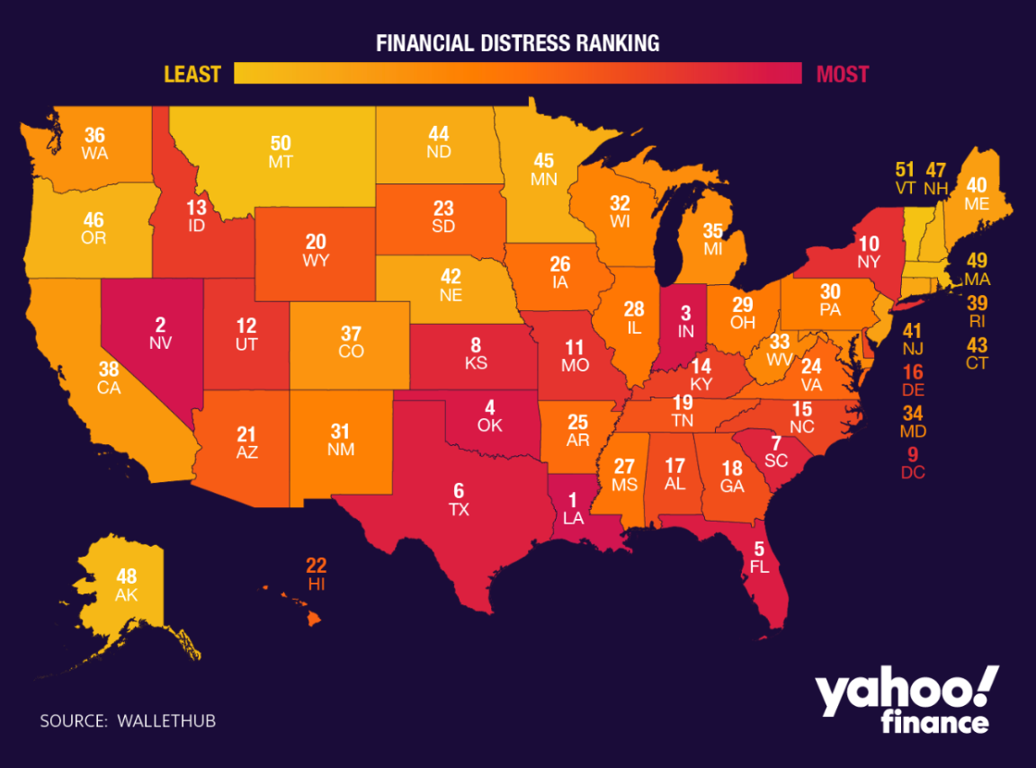

An illustration of how states are labeled is shown below. The states starting at one had more business losses and financial management measures that were difficult, and the cities with higher numbers up to how many businesses had to close due to financial hardship. The graph shows us how many businesses will fail due to financial reasons in less than a year.
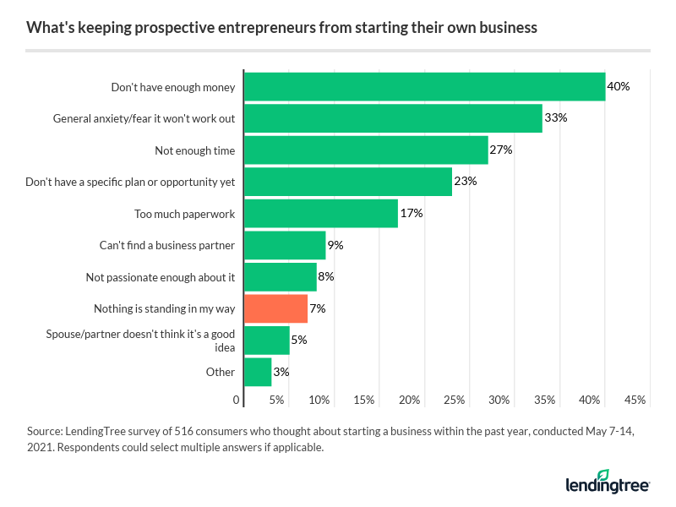

Conclusion
Whether your findings confirm or refute your hypothesis. The research data does reflect that there is a increase in some the number of business are facing financial.
The effect of these findings on your goal statement. My goal was to have a better understanding of why so many businesses are out of the business industry because of the lock of financial. Through my research, there is a better understanding of business are failing and losing a lot of money.
The related answers this data provides to your research question. My data analysis and research approach provided answers to both of my study questions.
How your findings inform the statement of problem you provide at the beginning. Through my research, I have a better understanding of how business is having difficulty and increase the business that are closing. However, through my literature review, the research showed that financial management issues can be resolved, helping to lower the risks that businesses by funding the systems' capacity to handle unforeseen circumstances, corporate supply networks become more exposed,

Reflection
As a Business general management and financial student, I will be able to use statistics to assess important data for the business organizations I intend to work with in the future.
With the help of Excel and statistics, I can now utilize very clear and accurate metrics to make decisions that are better and more well-informed. This builds on the business management and finance coursework I've done at Bryant & Stratton College. In addition, I utilized Google to look for data and the Virtual Library to find research to complete my assignment. I also performed the statistical analysis. This project has prepared me for the future by enabling me to use Excel and resources.

References

Chen, W. (2022 Reliability Optimization Analysis of Enterprise Financial Management System
https://discovery.ebsco.com/c/zbkays/details/upcxvkjxqn?limiters=FT%3AY&q=Chen%2C%20Weidan%20financial
Dan, SH., & Xiomara, M (2022). The Percentage of Businesses That Fail and How to Boost Your Chances of successfully.
https://www.lendingtree.com/business/small/failure-rate/

