ACCT230- Principles of Cost Accounting
Portfolio Project
Submission 3

Problem 1
Jim Tallon has obtained the following data relative to the Gibbs & Vaughan consulting job:
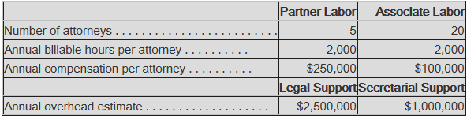
Assume that the Wilkes Barre job will require 50 partner hours and 20 associate hours, while the Scranton job will require 15 partner hours and 55 associate hours.
Required:
- a. Using a simplified costing system with one direct cost category for professional labor and one indirect cost category for support costs with professional labor hours as the allocation base, compute the bid price for the Wilkes Barre job and the Scranton job, assuming a 25% markup on cost. (Round to the nearest whole dollar.)
Professional labor rate= annual professional labor dollars/annual professional labor hours
(5 x $250,000) + (20 x $100,000)/ (5 x 2000) + (20 x 2000)
$1,250,000 + 2,000,000/10,000 + 40,000
$3,250,000/50,000 Professional Labor Rate = $65
Professional support rate= annual support cost/annual professional labor hours
2,500,000 + 1,000,000/50,000
3,500,000/50,000 Professional Support Rate = $70

Costing of Wilkes Barre job:
Hours Required Rate Total Cost
Professional labor cost 70 $65 $4,550
Overhead allocated 70 $70 $4,900
Total Cost $9,450
Add: Markup(25%) $2,362.50
Bid price $11,813

Scranton Job:
Costing of Scranton job:

Hours Required Rate Total Cost
Professional labor cost 70 $65 $4,550
Overhead allocated 70 $70 $4,900
Total Cost $9,450
Add: Markup(25%) $2,362.50
Bid price $11,813
b. Do you think that your results seem reasonable? Why?
Results are not reasonable because both the jobs require different proportion of partners hours and associate hours but since the total labor hours are same, they are allocated same cost.
- Using an activity-based costing system with two direct cost categories for partner labor and associate labor, and two indirect cost categories, one for legal support and one for secretarial support with cost allocation bases of professional labor hours and partner labor hours, respectively, compute the bid price for the Wilkes Barre job and the Scranton job, assuming a markup of 25% on cost.

Partner Labor $250,000/2,000 = $125 per hour
Associate Labor $100,000/2,000 = $50 per hour
Legal Support $2,500,000/50,000= $50 per hour
Administrative Support $1,000,000/10,000 = $100 per hour
Costing of Wilkes Barre job:
Hours Required Rate Total Cost
Partners Hours 50 $125 $6,250
Associate Hours 20 $50 $1,000
Total Labor Cost $7,250
Add: Legal Support cost 3500 5000 $8,500
Total Cost $15,750
Add: Markup(25%) $3,937.50
Bid price $19,688

Costing of Scranton job:

Hours Required Rate Total Cost
Partners Hours 15 $125 $1,875
Associate Hours 55 $50 $2,750
Total Labor Cost $4,625
Add: Legal Support cost 3500 1500 $5,000
Total Cost $9,625
Add: Markup(25%) $2,406.25
Bid price $12,031

- a. Compute the difference in bid price for each job between the simplified costing system and the activity-based costing system.
Wilkes Barre Job Scranton Job
Cost using the simplified method $5,813 $6031
Cost using activity-based method $17,500 $7,875
Difference (under) or overcosted with simplified system $(11,687) $(1,844)
b. Were the jobs undercosted, overcosted, or a combination of each? Which job had the greater differential, depending on which costing system was used, and why?
The two jobs were under cost. But the Wilkes Barre job had the greatest difference when I used the ABC method. It is because the Wilkes job had more partner labor hours.
Problem 2
The Eradicate Inc. segment produces and sells a line of insect repellants that is sold primarily in the summer months. Recently, the chief operating officer has become interested in possibly manufacturing a repellant, “Halt,” that can prevent a person from being attacked by use of a “pepper” repellant. The appeal of this product is that it would have year-round sales and would help stabilize the company's income.
The product, however, must be sold in a specially designed spray can that will be safe from being discharged accidentally. The product will be sold in cartons that hold 24 cans of the repellant. The sales price will be $96 per carton. The plant is now operating at only 65% of its total capacity, so no additional fixed costs will be incurred. However, a $100,000 fixed overhead charge will be allocated to the new product from the company's present total of fixed costs.
Using the current estimates for 100,000 cartons of “Halt” as a standard volume, the following costs were developed for each carton, including the cost of the can:
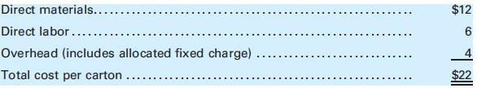
Eradicate Inc., has requested a bid from a manufacturer of specialty dispensers for a purchase price of an empty can that could be used for the new product. The specialty company offered a price of $5 for a carton of cans. If the proposal is accepted, Eradicate Inc. estimates that direct labor and variable overhead costs would be reduced by 10% and direct materials would be reduced by 20%.
Required:
- Should Eradicate make or buy the special cans?
Fixed Overhead /# of Cartons
100,000/100,000 = 1
4-1=3
Overhead =3
Inside Manufacturing Cost
Purchase Cost per Carton $0.00
Direct Material $12 12.00
Direct Labor $6 6.00
Overhead $3 3.00
Total Cost per Carton 21.00
Outside Purchase Cost
Purchase Cost Per Carton $5.00
Direct Materials $12 x 20%= 2.40 12-2.40= 9.60
Direct Labor $6 x 10%= .60 6-.60= 5.40
Overhead $3 x 10%= .30 3-.30= 2.70
Total Cost Per Carton 22.30
Eradicate would be better off making the special can themselves. They would save more money that way. The outside purchase cost is $1.30 more.
- What would be the maximum purchase price acceptable to Eradicate for the cans?
2.40 + .60 + .30 = $3.30

Problem 3
Leprechaun Enterprises Inc., is considering building a manufacturing plant in County Cork. Predicting sales of 100,000 units, Leprechaun estimates the following expenses:
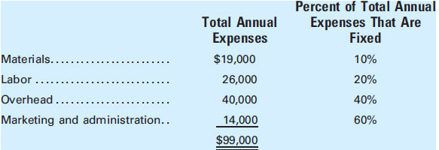
An Irish firm that specializes in marketing will be engaged to sell the manufactured product and will receive a commission of 10% of the sales price. None of the U.S. home office expense will be allocated to the Irish facility.
Required:
- If the unit sales price is $2, how many units must be sold to break even?
Annual Fixed Variable
Materials 19,000 x 10%= 1,900 19,000-1,900= 17,100
Labor 26,000 x 20%= 5,200 26,000-5200= 20,800
Overhead 40,000 x 40%= 16,000 40,000-16000= 24,000
Marketing and Administration 14,000 x 60%= 8,400 14,000-8400=5,600
Commission ($2 x $100,000) x 10% $200,000 x .10= $20,000
99,000 31,500 87500
Unit Variable Cost = Total Variable Costs/Unit Sales 87,500/10,0000= .875
Unit Variable Cost: $.875 per unit
Break Even Sales Volume= Total Fixed Cost/Unit Contribution Margin
31,500/$2-.875
Break Even Sales: 28,000 units
- Calculate the margin of safety ratio.
Margin of Safety= Sales Revenue – Break Even Sales Revenue
= (100,000) x $2) – (28,000 x $2)
=200,000 – 56,000 = 144,000
Margin of Safety=144,000
Margin of Safety Ratio= Margin of Safety/Sales
= 144,000/200,000
Margin of Safety Ratio: 72%

- Calculate the contribution margin ratio.
Contribution Margin Ratio= Contribution Margin/Sales
= Contribution Price per Unit – Sales Price per Unit x 100
= [(2-.875) / 2] x 100
= (1.125 / 2) x 100
Contribution Margin Ratio: 56.3%

