Fallacies
Brooklynn Painter
Logic and reasoning
Ms. Gapola
09/10/21
My paper is about Affirming a Disjunct, which is the fallacy that occurs when we assume that in an either/or statement (disjunction) if one of the statements (disjuncts) is true the other must be false. This will be shown not only on my actual paper but also in the truth table that I will display at the bottom of this page. I believe that this fallacy is one of the most common ones out of all of the ones we studied in this class.

The argument I chose for this fallacy is that I can not work a double shift both Saturday and Sunday. This means if I work a double on of the days, I do not work a double on the other. This shows me that if one statement is true, the other is false.
In Logic, the disjunction or “either/or” statement is true any time either side of the statement is true as well as when both sides are true. Therefore, one side being true does not automatically make the other side false. Unless otherwise stated, it is as though there is as an implied “or both” on the end of the sentence. For example: “I will clean the kitchen or the basement. I cleaned the kitchen. Therefore, I will not clean the basement.” In this case, it is true that since I cleaned the kitchen I kept my promise even if I don’t go on to clean the basement. However, what is more important is that my statement is STILL TRUE if I clean the kitchen AND the basement. So, although you may not expect the basement to be cleaned if the kitchen is cleaned my statement does not become false if I do both. If we want to exclude the possibility that both things can happen we would have to say “I will clean the kitchen or the basement, but not both.”

Logical Forms:
P or Q. I cannot work a double shift both Saturday and Sunday. P.. I am not working a double shift on Saturday.
Therefore, not Q. Therefore, I am working a double shift on Sunday
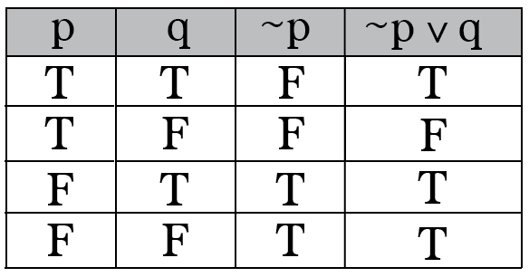
In conclusion, this argument is valid because if one thing then not the other is a pretty straight forward argument. I think this allows for people to logically know their work schedule for example because they know that if they work a double on one day, they will not on the other day. This project was a hard one. I don’t think I have ever struggled so much with something so my advice for the future classes is to try and so the lectures twice and keep going back until you truly understand everything.

References
- The Tragedy of Contract and the Naturalistic Fallacy at the Workplace. Academic Journal By:
JONGHOON BAE. Seoul Journal of Business. Jun2020, Vol. 26 Issue 1, p1-19. 19p. DOI:
10.35152/snusjb.2020.26.1.001.
- Steps to strengthen ethics in organizations: research findings, ethics placebos, and what works. Editorial & Opinion English) ; Abstract available. By: Pope KS, Journal of trauma & dissociation : the official journal of the International Society for the Study of Dissociation (ISSD) [J Trauma Dissociation], ISSN: 1529-9740, 2015; Vol. 16 (2), pp. 139-52; Publisher: Routledge; PMID:
25602131, Database: MEDLINE Complete PubMed
- Book Reviews : THE FALLACY OF FLEXIBILITY: WORKPLACE REFORM IN THE QUEENSLAND OPEN
CUT COAL INDUSTRY By Michael Barry, Bradley Bowden and Peter Brosnan. Allen & Unwin, St
Leonards, 1998, xii + 231 pp., $35 (paperback). Academic Journal By: Heiler, Kathryn. Journal of
Industrial Relations , Jun1999, Vol. 41 Issue 2, p332-335, 4p. Publisher: Sage Publications, Ltd..,
Database: Complementary Index
- Fallacies found in workplace stereotypes. Periodical Westchester County Business Journal. 10/30/2000, Vol. 39 Issue 44, p16. 1/4p. Reading Level (Lexile): 1360. , Database: Regional
Business News.

